SCT Barrel Module FDR Document
SCT Barrel Module : Electrical Performance
]
Abstract
This document summarises the measured electrical readout performance of barrel modules in the laboratory, in beam tests at CERN and KEK and in the SCT system test at CERN.
Prepared by : | Checked by : | Approved by :
J.Carter, L.Eklund, G.Moorhead, M.Morrissey, J.Pater, P.Phillips, Y.Unno, M.Vos
Distribution List

Table of Contents

1 Scope of the document 3
2 performance goals 3
3 available electrical modules 3
4 results from individual modules 5
4.1 Noise and Noise Occupancy at 1fC Threshold for Unirradiated Modules 5
4.2 Uniformity of Threshold 6
4.3 Module Stability 7
4.4 Timewalk 8
4.5 Noise and Noise Occupancy at 1fC Threshold for Irradiated Modules 8
5 module Test-beam results 14
5.1 Charge Collection and Signal:Noise Ratio 146 System Test and first results 18 5.2 Efficiency at 1fC Threshold 15 5.3 Resolution 17
6.1 General Description 18
6.2 Grounding and Shielding in the System Test 18
6.3 First Results from the Barrel System Test 217 Summary 23

Scope of the document
This document summarises results on the electrical performance of barrel modules read out with the ABCD2T, ABCD3T and the current ABCD3T-A versions of the SCT binary ASICs. It includes
- Noise occupancy versus binary threshold and extracted noise for modules read out individually in the laboratory, both before and after irradiation to a fluence of 3x10¹⁴ pcm⁻² 24 GeV/c protons.
- Tracking efficiency, charge collection and resolution measurements for both non-irradiated and irradiated modules as measured in test beams at CERN and at KEK.
- First results from an assembly of 10 modules mounted together on a barrel sector in the SCT system test at CERN.

Performance goals
The anticipated performance of SCT barrel modules as recorded in the Inner Detector TDR in 1997 was:
- Signal:noise of about 14:1 pre-irradiation, reducing to about 11.5:1 after 10 years of operation in ATLAS (Figure 11-36, page 435)
- Noise occupancy < 5x10⁻⁴
- Tracking efficiency > 99%
Much has changed in the intervening 4 years, including the detector type (p-in-n rather than n-in-n) and specification, and the evolution of the ABCD ASIC. Nevertheless, the noise occupancy and tracking efficiency specifications remain as the electrical performance goals of the barrel modules.

available electrical modules
The number of electrical barrel modules so far constructed by the SCT has been limited by the supply of ASICs. For this reason data are included from modules constructed with previous versions of the ASIC (SCT-BM-FDR-5.4) - the ABCD2T and ABCD3T, as well as the current ABCD3T-A. The modules from which results have been obtained are listed in Table 1.

Module ID | ASIC type | Detector type | Irradiated | Data
 |  |  |  | Lab | Test beam | System Test
K3103 | ABCD2T | HP <111> | No | √ | √ (KEK) | √
K3104 | ABCD2T | HP <111> | No | √ |  | √
K3111 | ABCD2T | HP <111> | No | √
K3112 | ABCD2T | HP <100> | No | √ | √ (CERN) | √
K3113 | ABCD2T | HP <100> | Detectors | √ | √ (CERN)
RLT5 | ABCD2T | HP <111>  325μm thick | No | √ | √ (CERN)
RLT4 | ABCD2T | HP <111>  325μm thick | Yes | √ | √ (CERN)
RLT9 | ABCD2T | HP <111> | Detectors | √ | √ (CERN)
RLT10 | ABCD2T | HP <100> | Detectors | √ | √ (CERN)
RLK6 | ABCD2T | HP <111> | No | √ | √ (CERN)
Scand1 | ABCD2T | Sintef <100> | No | √ | √ (CERN) | √
20220170100004 | ABCD3T | HP <111> | No | √ |  | √
20220170100011 | ABCD3T | HP <100> | No | √ | √ (KEK) | √
20220170100022 | ABCD3T  (thinned and metallised) | HP <100> | No | √ | √ (KEK) | √
20220170100003 | ABCD3T | HP <100> | Yes | √ | √ (KEK)
20220170100026 | ABCD3T | HP <100> | No | √ |  | √
20220170100001 | ABCD3T | HP <111> | Yes | √
20220170100008 | ABCD3T  (attached with non-conducting glue) | HP <111> | No | √ |  | √
20220170100009 | ABCD3T | HP <111> | No | √ |  | √
20220170100020 | ABCD3T-A | HP <100> | Yes | √
20220170100037 | ABCD3T-A | HP <100> | Yes | √
20220170100016 | ABCD3T-A | HP <111> | No | √
20220170100018 | ABCD3T-A | HP <111> | No | √
20220170100019 | ABCD3T-A | HP <111> | No | √
20220170100035 | ABCD3T-A | HP <100> | No | √
20220170100036 | ABCD3T-A | HP <100> | No | √

Table 1: SCT Barrel Electrical Modules Constructed and Tested as at 2nd May 2001

results from individual modules
The ASICs are powered with the prototype SCT low voltage power supply, SCTLV2, and readout electrically via an SCT CLOAC-MuSTARD-SLOG system1.

Noise and Noise Occupancy at 1fC Threshold for Unirradiated Modules
The noise and noise occupancy are quoted for the modules with ABCD3T and ABCD3T-A ASICs. Non-linearity of the ABCD2T calibrates gives rise to some uncertainty in determining absolute noise values for these modules.
The noise of the ASIC decreases as the temperature is reduced The standard laboratory measurements are made with the hybrid temperature at about 27ºC. At this temperature, the measured noise for the ABCD3T modules is in the region of 1400-1700 ENC. This is illustrated in Figure 1, which shows the average noise values for each of the 12 readout ASICs on nine of the ABCD3T(-A) modules.

Figure 1: Measured noise (ENC) on each of the 12 ASICs of nine of the modules made with ABCD3T or ABCD3T-A ASICs. The temperature of the hybrid was about 27ºC. Each curve is labelled with the four least significant digits of the corresponding module number.
At the SCT operating temperature of ~0ºC on the hybrid, the noise is reduced to typically about 1350 ENC for the ABCD3T modules for cold operation. This corresponds to an expected signal:noise value of better than 14:1, thus satisfying the pre-irradiation performance goal of section 2. Signal:noise values for modules as measured in a test beam are consistent with this expectation, and presented in section 5.
The noise of each individual readout channels of an ABCD3T-A module, operated warm, is shown in Figure 2. A uniform noise distribution is seen, apart from a single channel on the module that is bonded to only a 6 cm length of detector.
The SCT design goal is to set the ASIC single-strip binary readout threshold at 1fC, to ensure high tracking efficiency for particles traversing the silicon at inclined angles, depositing charge on more than one readout strip. The noise occupancy of the individual unirradiated modules at this threshold, even when operated warm, is ~10⁻⁵ (that is, << 10⁻⁴), which is satisfactory for the SCT (section 2). This is illustrated in Figure 3.

Figure 2: Measured noise values (ENC) on all channels of ABCD3T-A module 20220170100018

Uniformity of Threshold
Good channel to channel uniformity of the nominal 1fC threshold is essential for operation of a binary readout system. This is ensured through the ASIC threshold correction circuit, where each channel is provided with a trim DAC of 4 bit resolution with four selectable ranges (see SCT-BM-

FDR-5.4). The first range (0 mV – 60 mV) is used pre-irradiation, which gives a maximum channel to channel variation of 4mV (or ~ 0.08 fC). This is to be compared with the noise value of ~ 0.25 fC. The effect of this channel to channel threshold spread is to give a contribution to the noise occupancy at 1fC equivalent to less than a 1% increase in the intrinsic channel noise.

Figure 3: Mean noise occupancy of all channels of ABCD3T-A module 20220170100018, measured warm. The noise occupancy at 1fC threshold is 1.31x10⁻⁵.

Module Stability
Figure 4 shows example plots of occupancy versus threshold for all individual channels from the first readout side of the ABCD3T-A module 20220170100018. We take the smoothness and regularity of these curves as a very sensitive test of the intrinsic stability of a module. The data of Figure 4 show good regularity. In general, with the ABCD3T(-A) ASICs and 220nF V_{cc} and V_{dd} decoupling capacitors on the hybrid (see SCT-BM-FDR-5.3), some small irregularities are seen in these ‘S-curves’ for typically up to four chips on a module, predominantly on the second readout side. This is illustrated in Figure 5, showing this second readout side for the module 20220170100018, where some irregularities appear for the last two ASICs. It should be noted that these effects occur below 0.5fC threshold, and create no apparent instability in the modules under normal operating conditions.

Timewalk
The ASIC requirement (see SCT-BM-FDR-5.3) is that the timewalk should be <16 ns. Here timewalk is defined as the maximum time variation in the crossing of the time stamp threshold over a signal range of 1.25 to 10 fC, with the comparator threshold set to 1fC. Figure 6 shows measured data for the ABCD3T-A module 20220170100018. The top row of curves shows time in strobe delay units versus injected charge (fC) for each ASIC and the bottom row the timewalk distribution in nsec of the channels of each of the readout chips of the first side. The specification is satisfied for all channels.

Noise and Noise Occupancy at 1fC Threshold for Irradiated Modules
Results are so far available for two ABCD3T modules that have been fully irradiated at the CERN PS to a fluence of 3x10¹⁴ pcm⁻² 24 GeV/c protons (modules 20220170100001 and 3). For these, the measured ASIC noise value when operated cold, with the hybrid around 0ºC, averages about 2050 ENC.
As will be illustrated through the test beam data of section 5, the charge collection efficiency of the irradiated silicon is close to 100% at bias voltages above about 400V. Thus the signal:noise value found for fully irradiated barrel modules is in the region of 10:1 at the SCT operating temperature. This is lower than the target (because of the higher noise). However, noise occupancy at 1fC threshold as measured in the test beam is about 3x10⁻⁴. It is thus anticipated that the 1fC threshold can be maintained post-irradiation, to provide maximum tracking efficiency after 10 years of ATLAS operation.
After the maximum fluence, the ASICs may be operated with a very safe margin using the coarsest trim DAC range, trim range 3. After irradiation this range is decreased (typically 0 mV – 190 mV) giving maximum channel to channel variation at the 12mV bin level. This gives a contrbution to the noise occupancy equivalent to a ~ 4% increase in noise.
In the ABCD3T, all trim DAC ranges could not be selected reliably after irradiation. This was corrected in the ABCD3T-A version of the chip (see SCT-BM-FDR-5.4). The ABCD3T-A modules 20220170100020 and 20220170100037 have been irradiated in the PS in April 2001, and both have fully functional trim circuitry after exposure to the full dose of 3x10¹⁴ pcm⁻² 24 GeV/c protons. Figure 7 illustrates the functionality of all the trim DAC ranges for the second readout side of module 20220170100020. All channels can infact be aligned using trim range 2. The corresponding trim DAC settings and the resultant trimmed thresholds are shown in Figure 8.

Figure 4: Curves of occupancy versus threshold superimposed for every readout channel of the first readout side of an ABCD3T-A module. Every fourth channel (32 in total) of each ASIC appears in each of the boxes.

Figure 5: Curves of occupancy versus threshold superimposed for every readout channel of the second readout side of an ABCD3T-A module. Every fourth channel (32 in total) of each ASIC appears in each of the boxes.

Figure 6: Timewalk curves for the first readout side of an ABCD3T-A module.
Figure 7: Trim DAC setting versus threshold for each of the 6 ASICs (horizontally) of the second readout side of module 20220170100020 after irradiation to 3x10¹⁴ pcm⁻² for each of the 4 trim DAC ranges (vertically).

Figure 8: Trim DAC setting versus channel number (upper two rows) and trimmed threshold versus channel number (lower two rows) for module 20220170100020 after irradiation to 3x10¹⁴ pcm⁻². The right hand plots show the distribution of the variable for each ASIC on the second readout side of the module

module test-beam results
The modules as indicated in Table 1 have been tested in the H8 beam at CERN in August 2000 and in the KEK test beam in December 2000. The CERN test beam has the advantage of high momentum particles, a 1.56T magnetic field and the possibility of rotating the angle of the face of the silicon with respect to the incident tracks over the ±20º range relevant to barrel modules within ATLAS. However, only modules made with ABCD2T chips were available at the time of this test beam. The KEK test beam provides data from ABCD3T modules.
Both irradiated and non-irradiated modules have been measured in the beam tests. The modules are all kept cold, with the hybrids operating at about 0ºC. A beam telescope is used at both CERN and KEK to define the track positions at the module planes. SCT prototype power supplies are used, together with the MuSTARD readout system
Some principal results are briefly summarised in the following sections:

Charge Collection and Signal:Noise Ratio
The median charge of three modules, obtained from the 50% efficiency point in threshold scans, as a function of detector bias voltage from KEK data is shown in Figure 9.

Figure 9: Median charge (fC) versus bias voltage for the ABCD3T modules 20220170100011, 22 and the irradiated module 20220170100003 (solid circles, mod3)).

The detectors of the two unirradiated modules have depletion voltages of ~80V, and are normally operated at ~150V bias. The irradiated module is operated at ~400V bias, at which point it is seen that the collected charge on a single strip is similar to that for unirradiated modules. This result has also been measured with our detectors readout by (unirradiated) analogue electronics in the laboratory during our detector QA procedures.
Any uncertainties in the performance of the calibration circuitry can be eliminated by looking at the signal:noise values of these modules as measured in the KEK test beam. This is shown, again as a function of bias voltage, in Figure 10. The signal:noise values discussed in section 4 above are to be seen.
Figure 10: Signal:noise as a function of bias voltage for the same three modules as in Figure 9. Again, mod 3 is the irradiated module.

Efficiency at 1fC Threshold
The efficiency of the modules at the nominal operating threshold of the SCT is typically measured to be > 98% at the operational bias voltages over the full range of particle incident angles, with or without a magnetic field. This is illustrated by data from the CERN beam test. In Figure 11, the efficiency for an unirradiated module is shown as a function of angle, and in Figure 12 that of an irradiated module. (The maximum efficiency recorded is a function of tracking cuts, and plateau values in excess of 99% can be obtained).
These data give confidence that the modules will operate with high efficiency at 1fC threshold within the ATLAS environment.

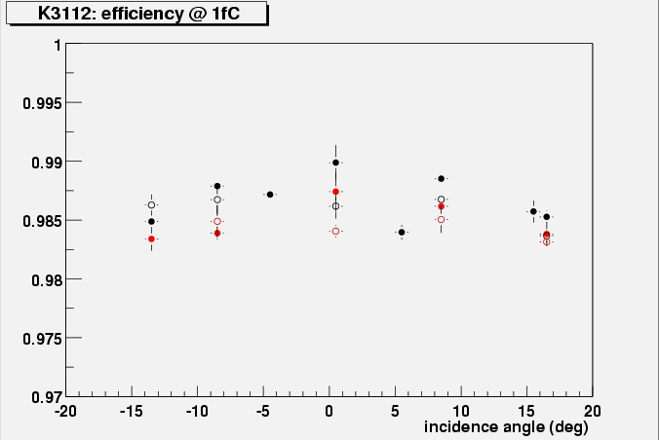
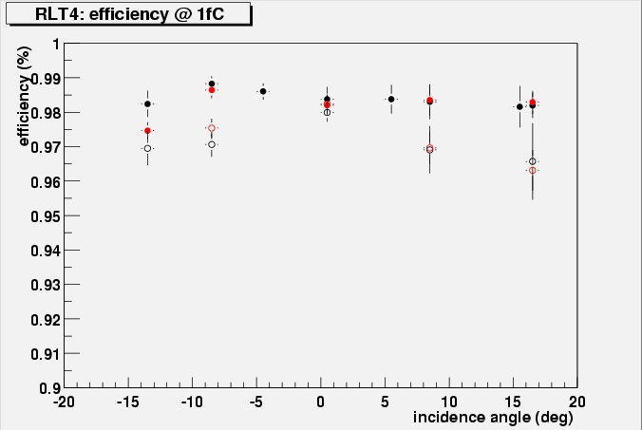
Figure 11: Measured efficiency of the unirradiated module K3112 at 1fC threshold as a function of the beam incident angle. The red symbols are with the magnetic filed of 1.56T, the black with zero field. The open circles are with a bias voltage of 120V, the full circles with 200V bias.
Figure 12: Measured efficiency of the fully irradiated module RLT4 at 1fC threshold as a function of the beam incident angle. The red symbols are with the magnetic filed of 1.56T, the black with zero field. The open circles are with a bias voltage of 300V, the full circles with 450V bias.

Resolution
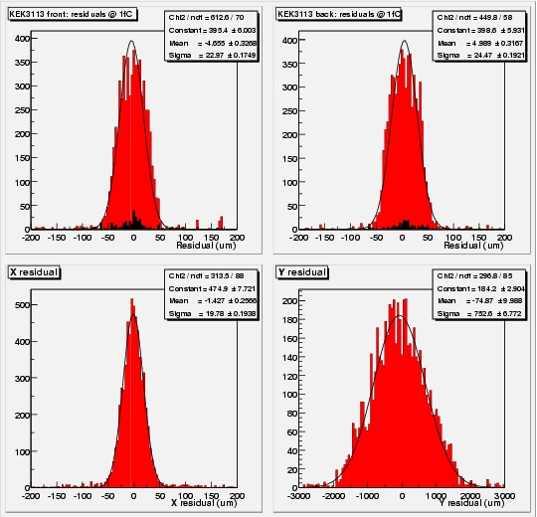
The measured resolutions are consistent with the expectation of the 80μm binary strip pitch (ie 23μm). This is illustrated from the CERN beam test in Figure 13 for tracks at normal incidence, with the magnetic field on. The resolution for inclined tracks is slightly better because two strip clusters occur with greater frequency.
Figure 13: Reconstructed track residuals with the unirradiated module K3113. The top two plots show the u, v residuals of the two sides of the module (inclined at ±20mr), with the expected values of about 23 μm. The lower two plots show the reconstructed residuals in the x, y directions.

system test and first results

General Description
The goal of the system test is to run as many modules as possible in a physical configuration which is as close as possible to the planned ATLAS SCT configuration, thereby testing the performance of the modules in such a system and comparing it to their stand-alone performance.
Modules are mounted on a sector of a Carbon-fibre-Corex-sandwich cylinder with dimensions very near to those of the innermost ATLAS SCT barrel. The sector can accommodate up to 48 modules, in four rows of 12.
Modules are powered and read out via prototype SCT barrel 'opto-harnesses', which transmit power to the modules, decode the optical clock and commands, transmit these signals electrically to the modules, and transform the data from the modules into optical signals for transfer to the readout electronics. Each opto-harness serves up to six modules, as in the final system.
The ASICs and opto-components are powered by the SCT prototype VME power supplies (SCTLVs); and the detectors are biased with the companion prototype high voltage units (SCTHVs).
The modules are read out using a CLOAC-SLOG-MuSTARD-OPTIF system, with the OPTIF1 providing the electrical-optical interface. A further VME module is used to read module hybrid temperatures. The ROOT-based SCTDAQ software package is used, running on a Windows-NT PC which is connected to the VME crates via a National Instruments interface card.
Control and monitoring of all voltages and currents is currently carried out through the DAQ software, although a prototype DCS system is used to monitor environmental temperature and humidity.
All patch panels and power tapes used are true to the planned final ATLAS design, except for extra provisions on the patch panels to allow testing of various coupling schemes. The conventional cables used between PPB2 and the power supplies are 30 metres long The patch panel PP3 and the cables from PP3 to the power supplies, foreseen for the experiment, have not yet been simulated in the system test.
A schematic diagram of the system test can be seen in Figure 14 and photographs of the barrel sector can be seen in Figures 15 and 16.

Grounding and Shielding in the System Test
The system test bases its grounding and shielding scheme on the proposal outlined in ATLAS SCT / Pixel Grounding and Shielding Note2. The main elements as applied in the system test are described below, with any differences noted.
To control stray capacitance between the cooling pipe and the silicon detector backplane, shunt shields are placed between the modules and the cooling pipe. These shunt shields consist of copper on kapton; with the copper soldered to Analogue Ground on the 'dogleg' (the portion of the opto-harness to which the module is connected).
Figure 14: A schematic layout of the SCT barrel system test

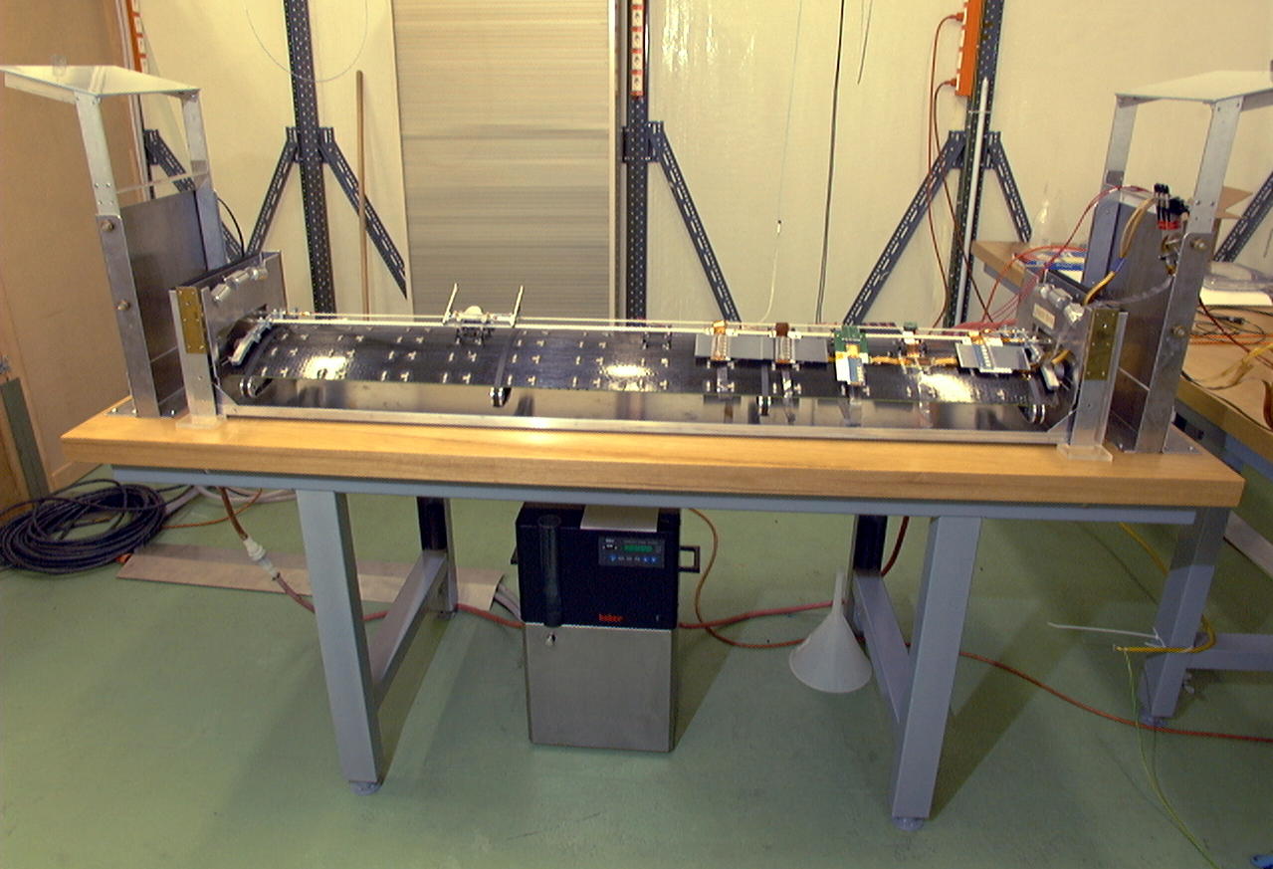

Figure 15: A photograph of the system test barrel carbon-fibre mounting structure
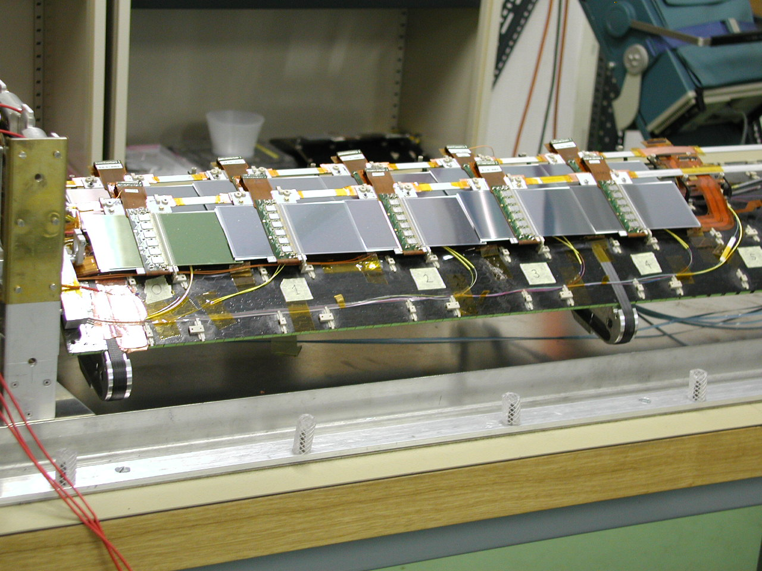

Figure 16: A photograph of barrel modules mounted on the carbon-fibre structure

The cooling pipes are connected together at both ends of the sector via an aluminium support bracket. This bracket is screwed onto the sector, providing electrical contact to the carbon fibre skin. Note that the cooling pipes are continuous, with no electrical break in the centre. The metalwork which supports the sector is also made of aluminium and is connected electrically to the sector by its contact with the carbon fibre skin. An aluminium cover (with square cross-section), used to provide a dry and light-tight atmosphere whilst running, is in electrical contact with the support structure. It should be noted that the cover is not electrically or geometrically similar to the planned ATLAS SCT thermal shield; a cover that will simulate the thermal shield is currently being produced.
Routing from the harness to PPB1, the six 'thin’ power tapes from a harness are wrapped together with aluminium-on-kapton shielding which is DC-connected to the metalwork surrounding the sector. At PPB1, digital and analogue grounds are AC-connected (with 2.7 μF) to the cable shielding.
From PPB2 to PPB1, the system test is not very like the ATLAS SCT; there is no surrounding metal (e.g. heat spreader plates, cooling supply tubes) to connect to as is recommended in the note referenced above. For the 10-module tests reported below, one set of six 'thick' power tapes running from PPB1 to PPB2 were wrapped with aluminium-foil shielding which was connected to grounds at PPB1 in the same way as described above for the thin tapes; the other harness' thick tapes were not shielded.
Common-mode chokes are used between PPB2 and the conventional cables. These chokes are intended for use at PPB3 but as stated above PPB3 is not (yet) represented in the system test. Note that the conventional cable shield should be commoned through, but this is not yet implemented.
The low- and high-voltage power supplies have floating grounds.
An alternative grounding and shielding scheme, which involves DC connections between all metal in the system and DC connection of the module grounds to the cooling pipe, is working well in the SCT-endcap system test but remains to be tested in the barrel system test.

First Results from the Barrel System Test
When a module arrives at the system test, it is accompanied by the results from a standard characterisation as performed at the module building cluster. The first step in integrating the module into the system test is to repeat this standard characterisation on the 'electrical test bench' in the system test lab, to verify that the module has not suffered in transit. The electrical test bench is considerably simpler than the full system test as it bypasses the optical communication, and uses only very short power and signal cables. Therefore a module may be expected to give its best performance when running stand alone 'on the bench'.
Once the module is verified to be in good working order, it is mounted on the system test sector (with all grounding and shielding connections made), and the standard characterisation sequence is repeated, powering only that one module. This performance is compared to that on the bench and any differences are noted and investigated if possible. When this comparison is complete, the module is considered ready to be included in multi-module tests.
There are currently ten modules in the system test, as seen in Table 1. Eight of these are considered ‘good’ modules; the other two (20220170100004 and 9) are included on the sector to maximise the overlap of powered modules for these first results, until further modules are available. With the exception of module 20220170100008, all the modules showed approximately the same noise values (within about 100 ENC) when running alone on the sector as they did on the

bench. Module 0008 showed approximately 200 ENC more noise on the sector. This may be of significance, since this is the only module made with the ASICs attached to the hybrid via non-conducting glue. Conducting glue will be used for all ATLAS barrel modules.
A typical multi-module test which can be done is to measure the gain and noise with many modules running in parallel. This has been performed, using a three-point gain calculation, with the ten modules on the sector. For this test there were two harnesses on the left-hand half of the sector, mounted immediately adjacent to one another, with each harness holding five modules. From left to right on the front harness were Scand1, K3112, K3104, 0011 and K3103; and on the back harness were 0004, 0009, 0008, 0026 and 0022. The measured noise values of all ASICs on the modules, with all 10 modules in operation at a hybrid temperature of about 27⁰C, are shown in Figure 17. With the exception of module 0008, as discussed above, the noise values lie in the anticipated range. The noise difference between this 10 module operation and that measured when a module is tested individually on the sector is shown in Figure 18 for each ASIC. The differences are seen to be rather small. The last ASIC (which is nearest the cooling pipe on the side of the module facing the sector) is somewhat noisier for the 10-module run for some of the modules. For module 0026 it should be noted that the high-voltage return line was broken and had to be repaired temporarily with a cable; the according influence on the noise behaviour is difficult to predict.
Detailed investigations are now in progress, and it is expected that further barrel modules will soon be added to the sector. The first results presented here are clearly encouraging.

Figure 17: The measured module noise for each ASIC with 10 modules operating together on the barrel system test sector

Figure 18: The change in the module noise on the sector between 10 module and individual module operation for each ASIC

Summary
The SCT barrel modules satisfy the electrical performance goals of the ATLAS Inner Detector TDR, with the exception of a slightly higher final post-irradiation noise value. The modules operate in a stable fashion, with good efficiency and low noise occupancy at 1fC threshold. The first results from a collection of 10 modules running together in the SCT system test are encouraging.
The available data therefore indicate that the design of the barrel module, and all its components, adequately meet the electrical performance requirements of ATLAS.

1 http://sct.home.cern.ch/sct/sctdaq.html
1 http://s.home.cern.ch/s/sct/public/sctdaq/sctdaq.html
2 http://scipp.ucsc.edu/groups/atlas/elect-doc/SCT_GND_SHIELD2.pdf

