system test and first results

General Description
The goal of the system test is to run as many modules as possible in a physical configuration which is as close as possible to the planned ATLAS SCT configuration, thereby testing the performance of the modules in such a system and comparing it to their stand-alone performance.
Modules are mounted on a quarter sector of a Carbon-fibre-Corex-sandwich disk with dimensions very near to that of the ATLAS SCT disk (do we have a number for the disk). The sector can accommodate up to 33 modules; 13 outer, 10 inner and 10 middle modules. Figure 1 shows the outer and inner module mounting positions on the front of the disk, while figure 2 is of the back of the disk where the middle modules are mounted. Separate cooling circuits are used for the three module types. The inner modules are served via a CuNi pipe 4mm OD with 70µm wall thickness, while the middle and outer modules have aluminium pipes 3.6mm ID/ 4.0mm OD. The cooling blocks are machined Al blocks with copper plating at the pipe block join. The block was soft soldered to the cooling pips. On the outer cooling circuit 4 of the high cooling blocks are CC with a Cu plate (positions 3,5,7, and 9 counting from the left as you look at the disk). The third CC block had a final gold flash to prevent oxidation.

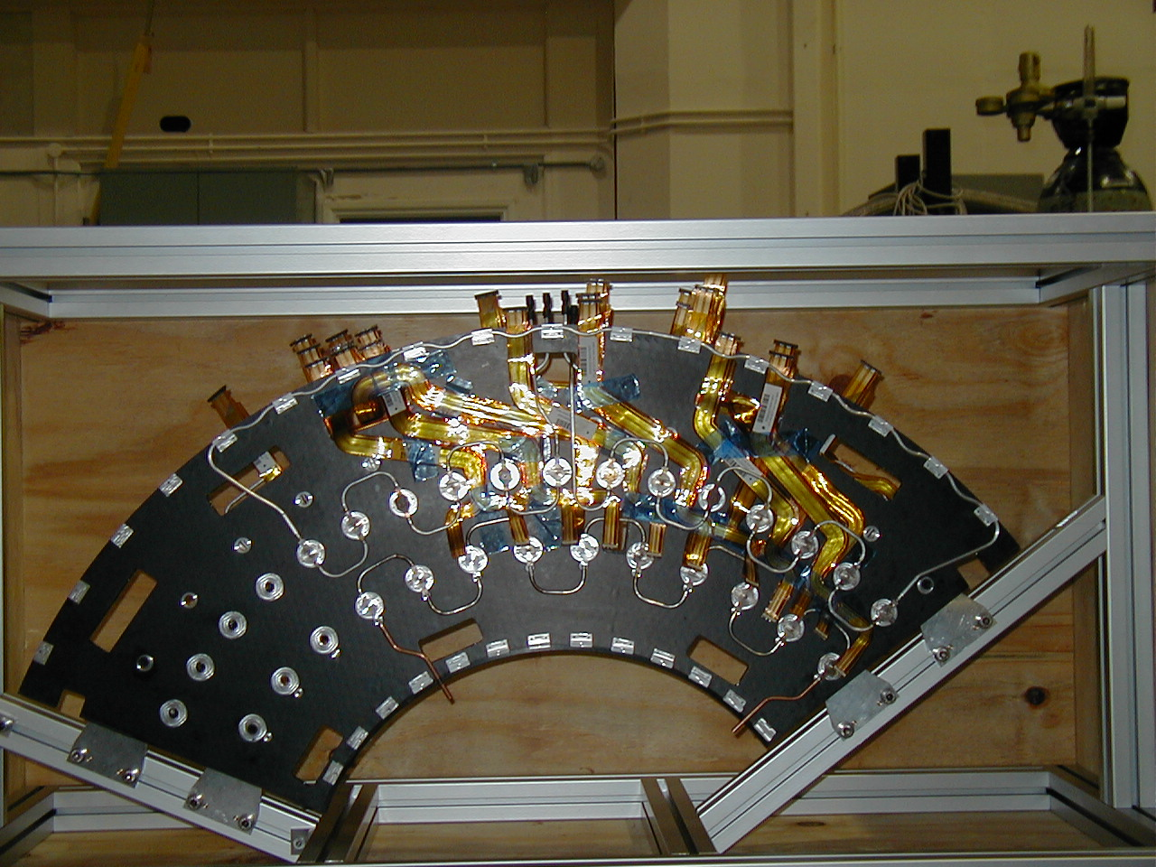
Figure 1 - Front View
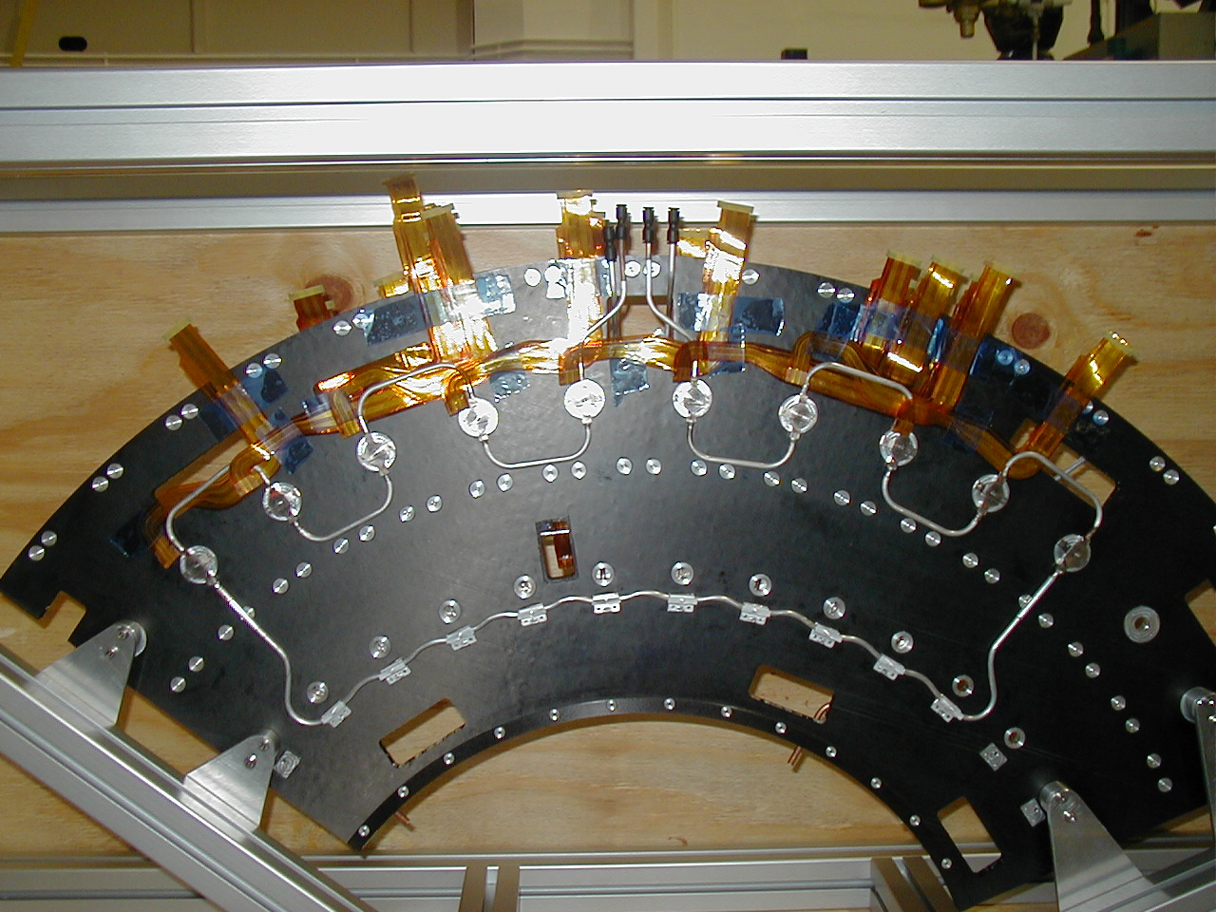
Figure 2 - Back View

The low mass wiggly power tapes were produced at Ljubljana. They were made from the ‘old’ design of x mm wide with Al tracks. Because of the expense of producing different shapes of tape, only 9 different designs were produced. Therefore 9 positions have the correct tape layout and the remaining positions have tapes which have been ‘made to fit’ as best as possible. The wiggle tapes contain all the power, select, reset and temperature monitor lines for the module. The communication of data to and from the module is performed via the optical plug-ins in the forward optical harness.
The SCT prototype VME power supplies (SCTLV3s) power the ASICs and opto-components; and the detectors are biased with the companion prototype high voltage units (SCTHVs).
The modules are read out using a CLOAC-SLOG-MuSTARD-OPTIF system, with the OPTIF1 providing the electrical-optical interface. The hybrid temperature is readout via the SCTLV3 modules. The ROOT-based SCTDAQ software package is used, running on a Windows-NT PC which is connected to the VME crates via a National Instruments interface card.
Control and monitoring of all voltages and currents is currently carried out through the DAQ software, although a prototype DCS system is used to monitor environmental temperature and humidity.
All patch panels and power tapes used are true to the planned final ATLAS design, except for extra provisions on the patch panels to allow testing of various coupling schemes. The conventional cables used between PPF2 and the power supplies are 30 metres long. Between PPF2 and PPF1 2.5m long kapton tapes with 100μm thick Al tracks (check to make sure not 70um Cu) are used. From PPF1 the tapes are 3.1m long with 50μm Al tracks. Both sets of kapton tapes are covered with aluminium foil, the connection so this are detailed in the grounding and shielding section.
A schematic diagram of the system test can be seen in Figure 3.

1 http://s.home.cern.ch/s/sct/public/sctdaq/sctdaq.html

