system test and first results

General Description
The goal of the system test is to run as many modules as possible in a physical configuration which is as close as possible to the planned ATLAS SCT configuration, thereby testing the performance of the modules in such a system and comparing it to their stand-alone performance. Experiments are performed to assertain the robustness of the grounding schemes used against extra noise pick-up from the experiments environment.
Modules are mounted on a quarter sector of a Carbon-fibre-Corex-sandwich disk with dimensions very near to that of the ATLAS SCT disk (do we have a number for the disk). The sector can accommodate up to 33 modules; 13 outer, 10 inner and 10 middle modules. Figure 1 shows the outer and inner module mounting positions on the front of the disk, while figure 2 is of the back of the disk where the middle modules are mounted. Separate cooling circuits are used for the three module types. The inner modules are served via a CuNi pipe 4mm OD with 70µm wall thickness, while the middle and outer modules have aluminium pipes 3.6mm ID/ 4.0mm OD. The cooling blocks are machined Al blocks with copper plating at the pipe block join. The block was soft soldered to the cooling pips. On the outer cooling circuit 4 of the high cooling blocks are CC with a Cu plate (positions 3,5,7, and 9 counting from the left as you look at the disk). The third CC block had a final gold flash to prevent oxidation.

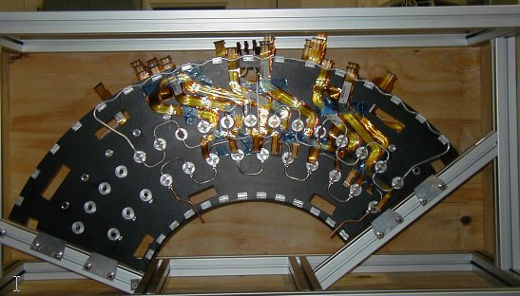
Figure 1 – Sector Front View
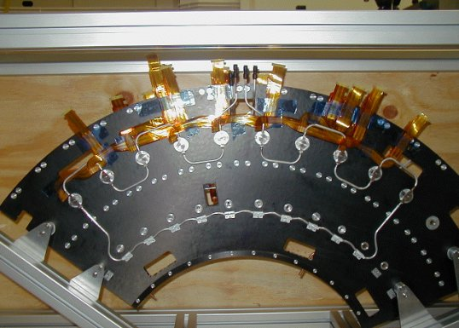
Figure 2 - Sector Back View

The low mass wiggly power tapes were produced at Ljubljana. They were made from the ‘old’ design being ??mm wide with Al tracks. Because of the expense of producing different shapes of tape, only 9 different designs were produced. Therefore 9 positions have the correct tape layout and the remaining positions have tapes which have been ‘made to fit’ as best as possible. The wiggle tapes contain all the power, select, reset and temperature monitor lines for the module. The communication of data to and from the module is performed via the optical plug-ins in the forward optical harness.
The SCT prototype VME power supplies (SCTLV3s) power the ASICs and opto-components; and the detectors are biased with the companion prototype high voltage units (SCTHVs).
The modules are read out using a CLOAC-SLOG-MuSTARD-OPTIF system, with the OPTIF1 providing the electrical-optical interface. The hybrid temperature is readout via the SCTLV3 modules. The ROOT-based SCTDAQ software package is used, running on a Windows-NT PC connected to the VME crates via a National Instruments interface card.
Control and monitoring of all voltages and currents is currently carried out through the DAQ software, although a prototype DCS system is used to monitor hybrid temperature, environmental temperature and humidity and control the cooling unit.
All patch panels and power tapes used are as close as possible to the planned final ATLAS design, except for extra provisions on the patch panels to allow testing of various coupling schemes. The conventional cables used between PPF2 and the power supplies are 30 metres long. Between PPF2 and PPF1 2.5m long kapton tapes with 100μm thick Al tracks (check to make sure not 70um Cu) are used. From PPF1 the tapes are 3.1m long with 50μm Al tracks. No PPF3 exists in the present arrangement.
A schematic diagram of the system test can be seen in Figure 3.

Figure 3 - A schematic layout of the SCT forward system test
VME
National
Instruments
PC-VME
Interface
CLOAC:
Generates master
clock, trigger and
reset
SLOG:
Generates slow
commands, merges
with fast commands
CLOAC
FANOUT
MUSTARD:
Receives and
decodes data
OPTIF:
Bi-phase Mark
Encoding + optical
data receiver
SCTHV:
High Voltage
power supply
SCTLV:
Low Voltage
power supply,
merges with HV
Conventional Cable (30m)
Opto-harness
Temperature and
Humidity Probes
~25m optical
fibres
PPF2
PPF1
Opto plug-in
ATLAS SCT Forward Module
Thick power
Tapes (3.1m)
Thin power tapes (2.5m)
Wiggle tapes

Grounding and Shielding in the System Test
The system test bases its grounding and shielding scheme on the proposal outlined in ATLAS SCT / Pixel Grounding and Shielding Note2 and ATLAS SCT – End-cap Grounding and Shielding3. The main elements as applied in the system test are described below, with any differences noted. Two grounding schemes are being investigated. They differ in the way the modules are referenced with respect to each other.
Common-mode chokes are used between PPF2 and the conventional cables. These chokes are intended for use at PPF3 but PPF3 is not represented in the system test. Note that the conventional cable shield is commoned through the chokes.
From PPF2 to PPF1 the 6 “thick” kapton tapes per PPF2 are bundled together and wrapped with aluminium foil.
At PPF2 the shield is connected, via jumpers, to the aluminium foil wrapped around the kapton tapes and taken to PPF1. PPF1 is electrically shielded inside an aluminium box, connected to the kapton aluminium foil shield. PPF1 is equipped with jumpers to allow AC connections (with 2.7 μF) between VDD and VCC to the cable shielding. These jumpers have been present for all tests so far. From PPF1 to PPF0 the “thin” kapton tapes are bundled together in sets of 3, with each set wrapped in aluminium foil. The shield connection continues via the aluminium foil around the “thin” kapton tapes to the sector housing.
The sector is housed in a copper box to represent the thermal shield at the SCT. It should be noted that the cover is not electrically or geometrically similar to the planned ATLAS SCT thermal shield. Combined with blackout cloth and a dry nitrogen supply the copper box provides a dry and light-tight atmosphere whilst running.
The sector is held in an aluminium support structure inside the copper box. The carbon fibre of the disk is electrically connected to the support structure via copper tape.
The kapton tape bundles split on entering the copper box on route to PPF0 while the aluminium foil wrapper stops at the copper box. For both grounding schemes the shield of PPF0 is connected to a 50μm thick angular aluminium foil stuck to the outer edge of both faces of the disk. The foils are connected together and to the carbon fibre of the disk with conductive epoxy and copper tape. On each disk face the angular foil is connected via three radial foils to angular foils running just above the cooling blocks, (2 foils on the disk front and 1 on the back), with foil tabs down to each cooling block. Connections are made between the foil and the cooling block using either conductive epoxy or the cooling block’s fixing screws. In this manner all the cooling blocks are connected, via the aluminium foil, to the outer angular foil and thus the shield of PPF0. The shield at PPF0 is also connected to the aluminium support structure via short pieces of copper tape.
The first ground scheme to be investigated prescribed the control of stray capacitance between the cooling pipe and the silicon detector backplane by the use of shunt shields placed between the modules and the cooling block. The shunt shield is an integral part of the K5 module consisting of a copper foil at the cooling point of the module connected directly to Analogue Ground of the module. Electrically insulating foam with good thermal properties is mounted onto the cooling block face to insulate the module from the cooling block. Therefore the module ground and the cooling block are not in intimate electrical contact with each other. The shield connection at PPF0 is connected to Digital Ground, via jumpers fitted to PPF0. The SCT low voltage power supply has shield DC connected to Digital ground.
The second scheme requires the module grounds to be held together as tightly as possible. The module shunt shield is shorted so that the module ground is DC connected to the cooling block. The electrically insulating foam is removed from the face of the cooling block. To have a direct connection from the module Analogue ground to the block an additional a metal covered kapton washer, connected to AGND of the module at the module connector, is glued onto the module’s peek washer. The holding nut on the cooling block now insures a short between module analogue ground and the cooling block. At PPF0 the shield is connected to an aluminium foil that is routed with the “thin” kapton tape between PPF0 and the copper box. The low voltage power supply has shield connected via a 10nF capacitor to VME ground.

First results for the Forward system test.
When a module arrives at the system test, it is accompanied by the results from a standard characterisation as performed at the module building cluster. The first step in integrating the module into the system test is to repeat this standard characterisation on the 'electrical test bench' in the system test lab, to verify that the module has not suffered in transit. The electrical test bench is considerably simpler than the full system test as it bypasses the optical communication, and uses only very short power and signal cables. Therefore a module may be expected to give its best performance when running stand alone 'on the bench'.
Once the module is verified to be in good working order, it is mounted on the system test sector (with all grounding and shielding connections made), and the standard characterisation sequence is repeated, powering only that one module. This performance is compared to that on the bench and any differences are noted and investigated if possible. When this comparison is complete, the module is considered ready to be included in multi-module tests.
There are currently six modules (two middle and four outer modules) in the system test, detailed in Table 1. All the modules showed approximately the same noise values (within about 100 ENC) when running alone on the sector as they did on the bench.

Module | Type | Hybrid | Institute
K5-300 | Middle | Cicorel | Freiburg
K5-301 | Middle | Cicorel | Freiburg
K5-302 | Outer | Cicorel | Freiburg
K5-303 | Outer | Cicorel | Valencia
K5-400 | Outer | Dyconex | Freiburg
K5-402 | Outer | Dyconex | Freiburg
Table 1 - Modules at System Test
A typical multi-module test is to measure the gain and noise with many modules running in parallel. This has been performed, using a three-point gain calculation and noise occupancy scans, with the modules on the sector. Detailed multi-module studies have only been performed with the shunt-shieldd grounding scheme implemented. At present either the two middle modules or the four outer modules have been operated together, but not all six at once. For example the 4 outer modules were mounted in positions O10 to O13 (O11 and O13 being high blocks) as shown in figure 4. The modules were communicated with via a single opto-harness. Details are given in table 2.

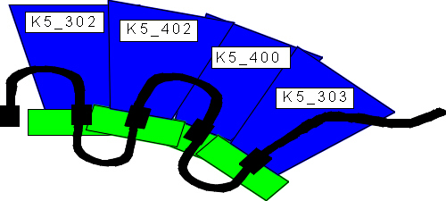
Figure 4 - modules & cooling pipes
Module | Cooling block | Opto plug-in | Temperature (C)
K5-302 | O10 | 3 | 34
K5-402 | O11 | 4 | 37
K5-400 | O12 | 5 | 35
K5-303 | O13 | 6 (only link1 working) | 37
Table 2 – Multi-module tests on 4 outer module

The measured noise values of all ASICs on the modules, with all 4 modules in operation at a hybrid temperature of about 36⁰C, are shown in Figure 5. With the exception of the first chip on module K5-303 the noise values lie in the anticipated range.
No ‘dead seagulls’ were seen in the distribution of noise across the modules when operated on the sector. Such ‘dead seagull’ noise distributions were seen previously and attributed to correlated noise sources.
A scan of Noise occupancy as a function of threshold, in charge, was performed. Good agreement in noise between the 3point gain and the Noise Occupancy runs were obtained.
(comment of level of NO wrt design requirements)
Noise occupancy as a function of time was measured with the threshold set to 1fC on all modules. The duration of a noise occupancy measurement was about 1 minute, with a 2 minute interval been measurements. 100 measurements were made. A decrease in noise was observed as a function of time, this was also seen in the barrel system test. There are no peaks detected in the noise occupancy as a function of time plots. Had peaks been present (also observed in the barrel due to the pick-up by the system of the switching currents of the air-conditioning) this would be indicative of inadequate shielding.
The Correlated noise data taking macro has been run for the 4 modules. The noise calculated from the correlated noise measurement agreed with those from the 3pt gain scan, while the amount of correlated noise found was low and consistent with zero.
Detailed multi-module runs have not at present been performed with the common grounding scheme.
Figure 5 - ENC from 3point gain

Noise injection studies with shunt shield grounding option

1 http://s.home.cern.ch/s/sct/public/sctdaq/sctdaq.html
2 http://scipp.ucsc.edu/groups/atlas/elect-doc/SCT_GND_SHIELD2.pdf
3 ATL-IS-EN-XXXX

