system test and first results

General Description
The system test simulates a section of one of the SCT forward disks in all its details of mounting, cooling, supply and shielding. Details on the sector prototype can be found in [6].
The sector can accommodate up to 33 modules; 13 outer, 10 inner and 10 middle modules. Figure 9 shows the outer and inner module mounting positions on the front of the disk; Figure 10 shows the back of the disk where the middle modules are mounted. The mounting positions are denoted O1-O13 for outer and I1-I10 for inner positions starting at the far left of Figure 9. The middle position are denoted M1-M10, counting from the right of Figure 10.
The disk is held at each end via metal bolts to an aluminium support frame, shown in Figures 9 and 10. The carbon-fibre disk is therefore in electrical contact with the support frame. The sector is housed in a copper box to represent the thermal enclosure of the SCT. It should be noted that the cover is not electrically or geometrically similar to the planned ATLAS SCT thermal enclosure. Combined with blackout cloth and a dry nitrogen supply, the copper box provides a dry and dark atmosphere, with a relative humidity of 20% or less, whilst running.
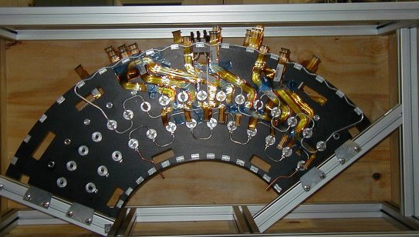
Separate cooling circuits are used for the three module types. The inner modules are cooled via a CuNi pipe 4mm OD with 70µm wall thickness, while the middle and outer modules have aluminium pipes 3.6mm ID/ 4.0mm OD. The cooling blocks are machined Al blocks with copper plating at the pipe block join. The blocks were soft soldered to the cooling pipes. On the outer cooling circuit 4 of the high cooling blocks are CC with a Cu plate (positions O3, O5, O7, and O9). The third CC block had a final gold flash to prevent oxidation. An ethanol-water mixture is pumped through the pipes; a commercial chiller controls the temperature of this cooling mixture.

Figure 9 - Sector front view
The low mass “wiggly” power tapes were produced at Ljubljana, Slovenia. They were made from the ‘old’ design, with Al traces, with widths varying from 21mm at the outer diameter of the disk narrowing to 14mm at the module. Because of the expense of producing different shapes of tape, only 9 different designs were produced. Therefore 9 positions have the correct tape layout and the remaining positions have tapes that have been ‘made to fit’ as well as possible. The wiggly tapes contain the power, select, reset and temperature monitor lines for the modules. The communication of clock, commands, and data to and from the module is performed via the optical plug-ins in the forward optical harness. Each harness serves either 5 or 6 modules. At the edge of the disk the harness connects to 25m long fibres, which transmit the data to the DAQ system, as illustrated in Figure 11.
The SCT prototype VME power supplies (SCTLV3s) power the module’s ASICs and opto-components. The detectors are biased with the companion prototype high voltage units (SCTHVs). The individual channels of each power supply are floating with respect to each other. It should be noted that the return lines of the ASIC analogue and digital lines and the detector bias line are connected together at the disk in a fashion dependent on the particular grounding and shielding scheme implemented, which are described later.
The modules are read out using a CLOAC-SLOG-MuSTARD-OPTIF system, with the OPTIF [4] providing the electrical-optical interface. The DAQ used is in place of the final read-out drivers, (ROD). The hybrid temperature is readout via the SCTLV3 modules. A ROOT-based SCTDAQ software package is used, running on a Windows-NT PC connected to the VME crates via a National Instruments interface card.
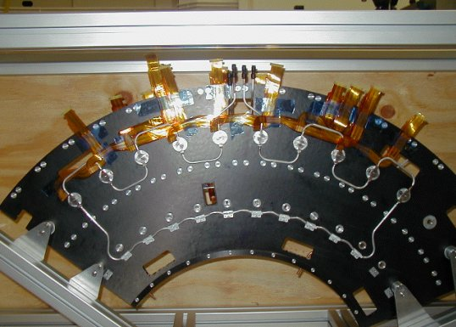

Figure 10 - Sector back view

Control and monitoring of all voltages and currents is carried out through the DAQ software. A prototype DCS system is used to monitor hybrid temperature, environmental temperature and humidity and to control the cooling unit.
All patch panels used are as close as possible to the planned final ATLAS design, except for extra provisions to allow testing of various coupling schemes. From the power supplies, 30m long conventional cables run to PPF2 via a common mode choke. These chokes are intended for use at PPF3 but PPF3 is not represented in the system test. Between PPF2 and PPF1, 2.5m long kapton tapes with 100μm thick Al tracks are used. The kapton tapes between PPF1 and PPF0 are 3.1m long with 50μm thick Al tracks. A schematic diagram of the system test is shown in Figure 11.
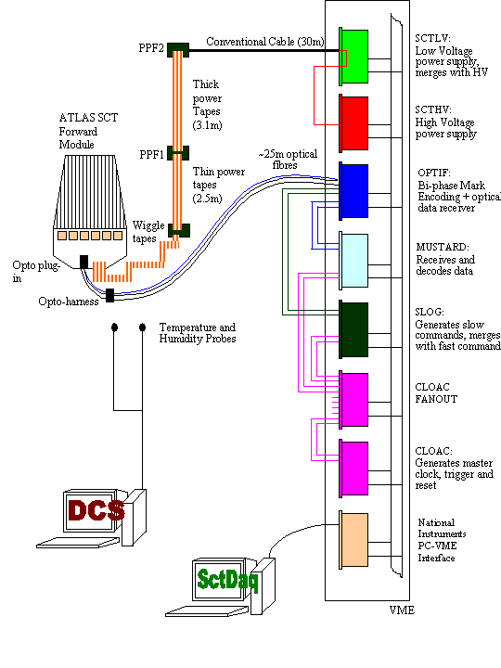
Figure 11 - A schematic layout of the forward SCT system test

Grounding and Shielding in the System Test
The system test bases its grounding and shielding scheme on the proposals outlined in [7,8,9]. These differ in the way the modules are referenced with respect to each other. The main elements as applied in the system test are described below, with any differences noted. Variations to this scheme are being investigated to seek improved performance. At the SCT low voltage power supply the conventional cable shield is AC connected via a 10nF capacitor to Digital ground.
At PPF2 the conventional cable shields pass through the chokes and are commoned at the kapton-tape side of PPF2. From PPF2 to PPF1 the 6 “thick” kapton tapes per PPF2 are bundled together and wrapped with aluminium foil. At PPF2 the shield is connected, via jumpers, to the aluminium foil wrapped around the kapton tapes and taken to PPF1. PPF1 is electrically shielded inside an aluminium box, which is connected to the kapton aluminium foil shield. PPF1 is equipped with jumpers to allow AC connections of all lines to the shield. VDD and VCC are AC coupled to their respective return lines via 4.7uF capacitors. HV and HV return are AC coupled with a 10nF capacitor. All power and return lines (including Pin bias and Vcsel lines), sense lines and the select line are AC coupled to the shield via 1uF capacitors. No connection (AC or DC) is made between the HV and HV return lines to the shield at PPF1. From PPF1 to PPF0 the “thin” kapton tapes are bundled together in sets of 3, with each set wrapped in aluminium foil. The shield connection continues via the aluminium foil around the “thin” kapton tapes through the sector housing to PPF0. The shield is held in good electrical contact with the copper box at the entry point. The disk’s aluminium support structure, inside the copper box, is electrically connected to the disk’s carbon fibre skin via copper tape and via supporting screws into the structure of the disk.
Figure 3 Schematic layout of the forward SCT system test
The shield at PPF0 is connected to a 50μm thick annular Al foil ring, one on each face of the disk at the outer radius. These rings are connected together and to the carbon fibre of the disk with conductive epoxy and copper tape. On each disk face the annular foil is connected via three radial foils to annular foils running just above the cooling blocks, (2 foils on the disk front and 1 on the back), that have foil tabs connected to each cooling block. Connections are made between the foil and the cooling block using either conductive epoxy or the cooling block’s fixing screws. In this manner all the cooling blocks are connected, via Al foil, to the outer annular foil and thus the shield at PPF0. At PPF0 the shield is connected to DGND, via jumpers fitted to PPF0. The shield at PPF0 is also connected to the aluminium support structure via short pieces of copper tape.
The prototype K5 modules used in the system test have an integrated shunt shield at the module mounting point. This is shorted so that the module power returns are DC connected to the cooling block at the module mounting point. A schematic representation of the on-disk-grounding scheme is shown in Figure 12.
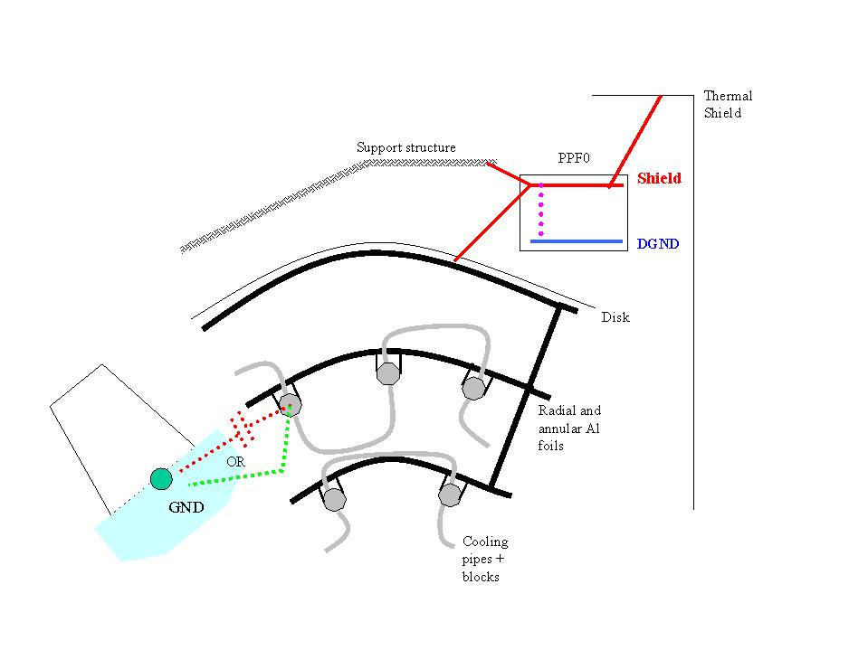
Figure 12- Detail of on disk and PPF0 grounding and shielding scheme
(red dots - shunt shield variation, green dots - DC variation, purple dots – default connection removed in DC variation)

Figure 13 illustrates the main features of the grounding and shielding scheme. The red dotted line represents the shield; while only the VDD and DGND lines are shown in reality both analogue and digital lines pass through a choke and are AC coupled to the shield at PPF1.
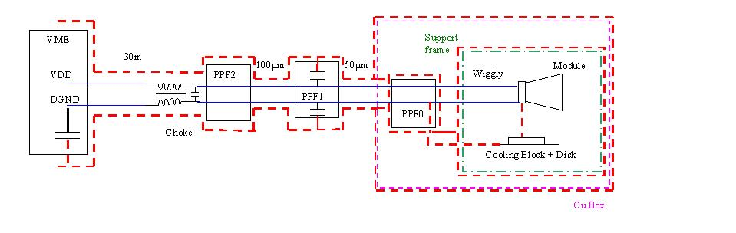
Figure 13 - Grounding and shielding scheme that utilises DC connection between the AGND of each module and its cooling block, and a DC connection between shield and DGND at PPF0.
Variations to the grounding and shielding scheme include the use of a shunt shield between the module AGND and the cooling block, implemented at the cooling block. The module ground and the cooling block are not in intimate electrical contact with each other. The shield connection at PPF0 to DGND is maintained. Thus the cooling circuit is connected to the modules digital return via a long path consisting of the wiggly tapes and PPF0. At PPF1 the HV line is AC coupled to the shield via a 10nF capacitor and the HV return line is shorted to the shield.
The second variation requires the module grounds to be held together as tightly as possible and referenced to the cooling circuit. The DC connection between shield and DGND at PPF0 is removed, resulting in a single connection of module ground to shield via the cooling circuit.
All the variations of the ground and shielding schemes investigated gave equally good performance for the system in the absence of artificially generated noise sources; the results are discussed in section 1.3. Section 1.4 reports on the first measurements made with an artificial noise source injected into the system.

First results for the Forward system test.
When a module arrives at the system test it is verified to be in good working order, and mounted on the system test sector. A standard characterisation sequence is performed powering only that one module. Its performance is compared to the results from the module’s construction site and any differences are noted and investigated if possible. The module is now considered ready to be included in multi-module tests.
So far, six modules (two middle and four outer modules) have been used in the system test; detailed in Table 1. All the modules showed approximately the same noise values (within about 100 ENC) when running alone on the sector as they did on the bench.
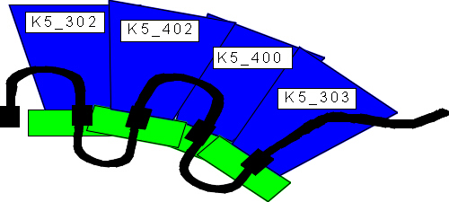

Figure 14 - modules & cooling pipes in a 4 outer multi-module run
A typical multi-module test is to measure the gain, noise and noise occupancy with many modules running in parallel. This has been performed, using a three-point gain calculation and noise occupancy scans, with the modules on the sector. At present either the two middle modules or the four outer modules have been operated together, but not all six at once. For example the 4 outer modules were mounted in positions O10 to O13 (O11 and O13 being high blocks) as shown in Figure 14. The modules were communicated with via a single opto-harness. Details are given in Table 2.

Module | Cooling block | Opto plug-in | Temperature (C)
K5-302 | O10 | 3 | 34
K5-402 | O11 | 4 | 37
K5-400 | O12 | 5 | 35
K5-303 | O13 | 6 (only link1 working) | 37
Table 2 – Multi-module tests on 4 outer modules

The measured noise values of the ASICs on the modules, with either all 4 outer modules or the 2 middle modules operating together are shown in Figures 15a and 15b. The input noise was corrected for the correct calibrate capacitor value and for a hybrid temperature of 2C. The input noise is consistent with the values obtained when the modules were electrically readout in a test-box.
A scan of noise occupancy as a function of threshold was performed; illustrated in Figure 16 for one module. Good agreement in the noise measured by the 3point gain and the noise occupancy runs were obtained. Figure 17 shows the noise occupancy measured for the 4 outer modules when operated individually and together on the sector and in a test-box. It should be noted that this data does not include the calibrate capacitor correction value, except for the test-box data of module k5_402. The noise occupation was within specification with a measured value below 5x10⁻⁴.
Noise occupancy as a function of time was measured with the threshold set to 1fC on all modules. The duration of a noise occupancy measurement was about 1 minute, with a 2 minute interval been measurements. 100 measurements were made. Figure 18 shows the observed decrease in noise of one module as a function of time. This effect, which has also been observed in barrel modules, has been attributed to the change in the inter-strip capacitance of the detector as a function of time after the initial bias is applied to the device. The time constants are detector dependent and for some modules can be as long as an hour. This imposes no implications on the running of the SCT. However, the system test has to be left biased for at least an hour for comparative studies of noise performance. There were no peaks detected in the noise occupancy versus time plots. Had peaks been present this would be indicative of inadequate shielding.
An initial run of a correlated noise data taking macro for the 4 outer modules with one million triggers and a 0.8fC threshold was taken. This resulted in a low number of events and therefore large statistical uncertainties in the value of the correlated noise. However, the noise calculated from the correlated noise measurement agreed with those from the 3pt gain scan, while the amount of correlated noise found was low and consistent with zero.
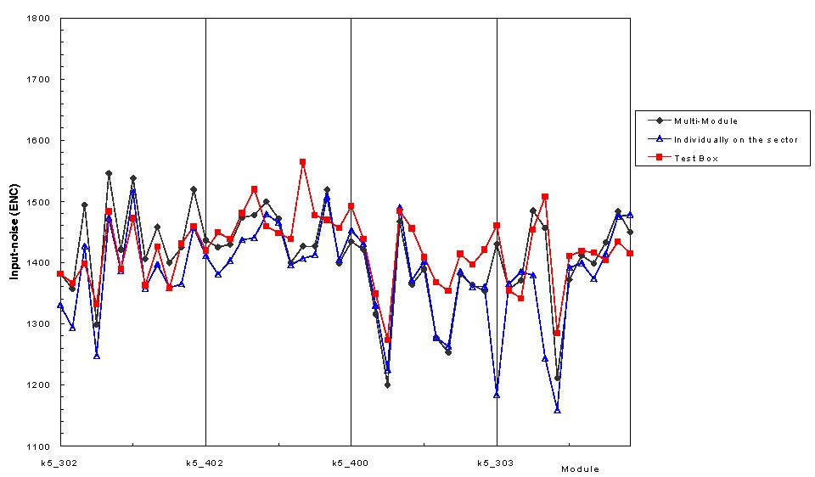
15_a
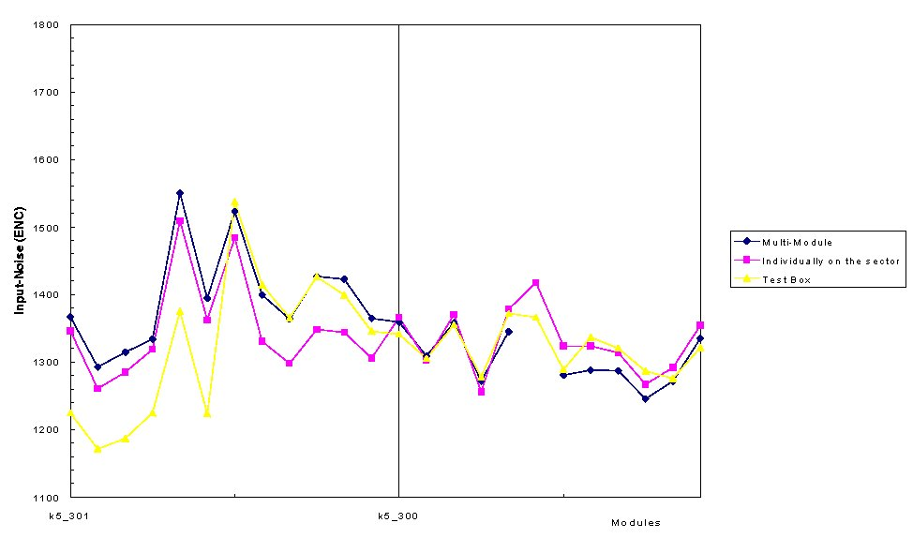
15_b
Figure 15 - Comparison of the measured noise (e⁻ ENC) of each ASIC per module measured on the system test sector when the modules were operated individually and as part of a multi-module run and with electrical readout in a test box: (a) outer modules (b) inner modules.
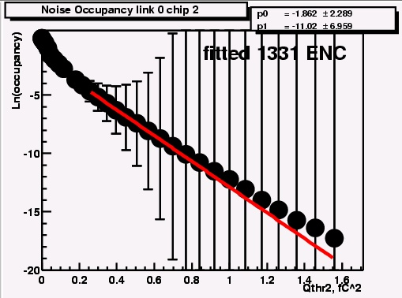
Figure 16 - An example of Ln Noise Occupancy as a function of threshold squared (fC²) measured in a multi-module run
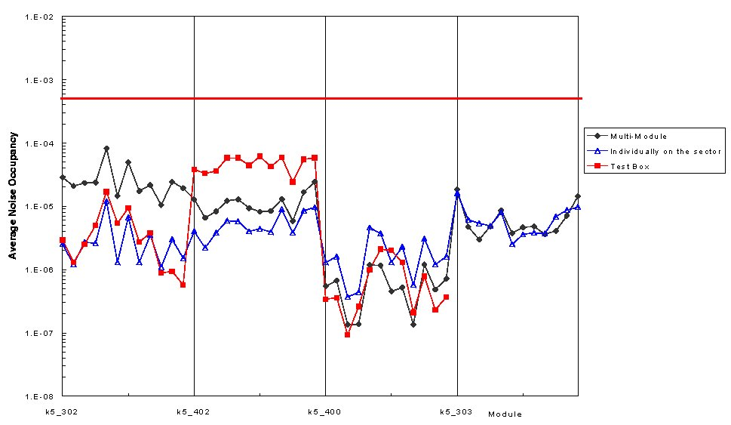

Figure 17 – Comparison of the noise occupancy per chip measured with all4 outer modules operated together on the sector, individually on the sector on in a test box. The red line indicates the limit imposed by the specifications.
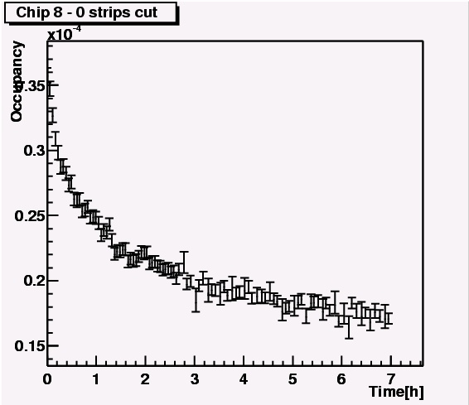
Figure 18 - Noise Occupancy as a function of time.

Noise injection studies.
Experiments are ongoing to investigate the robustness of the grounding and shielding against injected noise. Noise is injected either into the cooling pipes on the disk or the thick power tapes (between PPF2 and PPF1) with the use of ferrite rings to induce an AC current into the system. The ring was placed around the tapes between PPF2 and PPF1 or around a cable connected to the cooling pipes outside the copper enclosure. Both the magnitude and frequency of the injected signal were altered and the effects noted.
Single threshold scans with a 2fC injected charge pulse were taken. The noise was obtained on a strip-by-strip basis from the threshold scan s-curves. Assuming a fixed gain of 55mV/fC the noise as ENC in electrons was determined. The average noise per chip was then computed. Each set of measurements was comparative in nature and therefore a reference set of data was taken without noise injection followed by the measurements with the noise source. The difference between the two sets was plotted.
Figures 19 and 20 illustrate the dependence on the noise pick-up as a function of frequency, for injection into the tapes and the cooling pipes, respectively. A strong peak in sensitivity between 6-10MHz was observed, as expected from the front-end band-pass characteristics. Increasing the magnitude increased the injected signal size, which is shown in Figure 21 for an 8MHz AC noise signal injected into the kapton tapes.
The structure in the noise is module position dependent and it is greater where the modules overlap each other and overlap the cooling pipes, and power tapes. Module k5_402, which is in a lower module position, shows increased sensitivity to noise pick-up probably due to its closer proximity to the cooling pipes and power tapes. A difference in the amplitude and distribution of the excess noise is observed between the tape and pipe injection methods. While noise rejection was observed to be better with the default grounding option compared to the two variations described above.
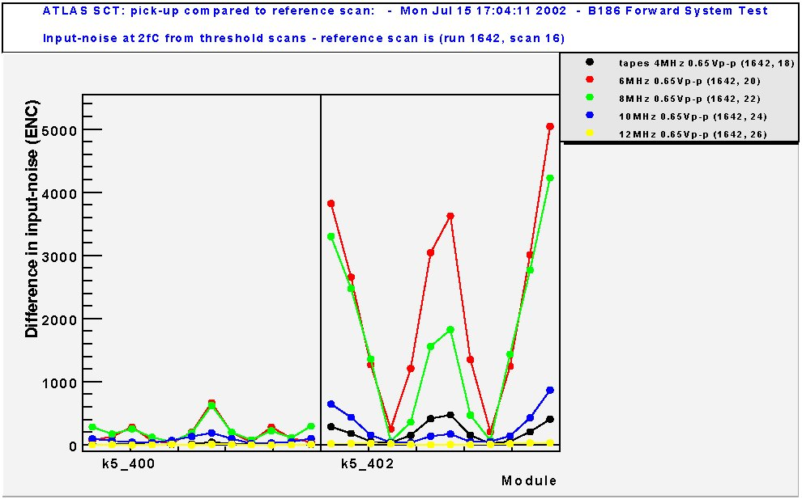
Figure19 – Excess input noise (e- ENC) due to noise injection into the kapton tapes, as a function of signal frequency
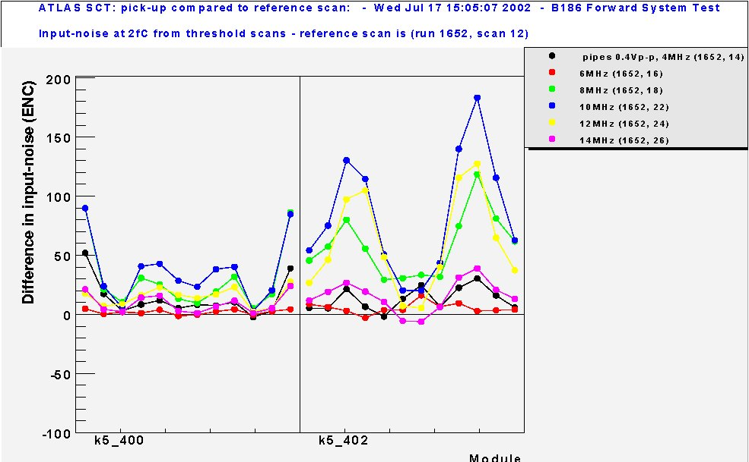
Figure 20 - Excess input noise (e- ENC) due to noise injection into the cooling, as a function of signal frequency.
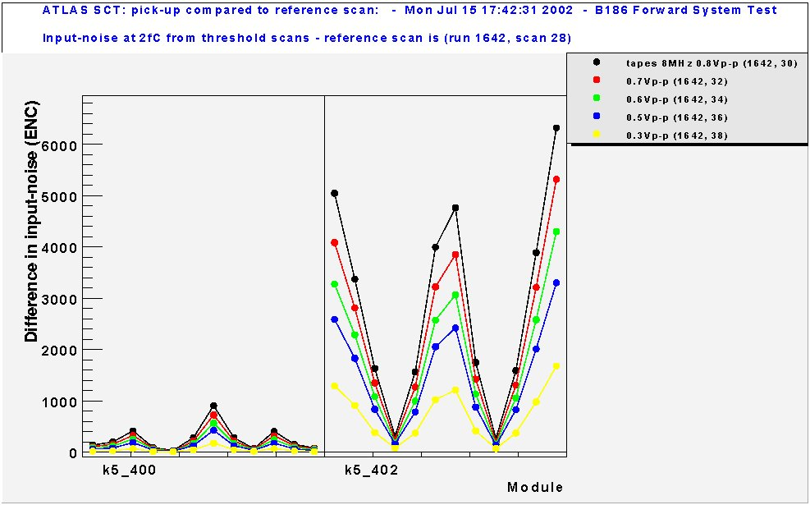
Figure 21 – Excess input noise (e- ENC) due to an 8MHz AC noise signal injected into the kapton tapes, as a function of signal magnitude.
It should be noted that these measurements are very preliminary and on going. Further improvements in the grounding and shielding schemes are continuing to yield improvements in noise rejection and further study is on going.
In conclusion the system test has shown that the modules are within specification when operated together (although in very limited numbers at present) without the deliberate injection of noise into the system. No conclusive answer to the exact ground and shielding scheme and therefore to the requirement or otherwise of shunt shield can be made at present.

