 | SCT End-cap System Test Sector Prototype
ATLAS Project Document No: | Institute Document No. | Created: 11/10/01 | Page: 1 of 8
ATL-IS-AN-0005 |  | Modified: 18/10/0110/18/2001 10:34:00 AM | Rev. No.: Draft 2

SCT End-cap System Test Sector Prototype

A full quarter disc prototype was built by the End-cap community in 2000/2001 which was designed to hold up to 33 modules for the system test. The production of the sector was used to test out several manufacturing and assembly processes. This document describes the sector and the work that was done to produce it.

Prepared by:  Debbie Greenfield, Roy Sulley, Chris Stephens, RAL | Checked by: | Approved by:
Distribution List
ATLAS SCT End-cap Engineering Working Group

History of Changes
Rev. No. | Date | Pages | Description of changes
Draft 1  Draft 2 | 11.10.01  18.10.01 |  | First Draft for discussion  Incorporated comments from Roy Sulley and Chris Stephens

Table of Contents

1 Introduction 4
2 Disc Preparation 4
3 Cooling Circuits 5
3.1 Al Pipe/Al Block 5
3.2 CuNi Pipe/CC block 5
4 Cooling Circuit Assembly 6
5 Power Tapes 6

Introduction
A system test sector was delivered to CERN in June 2001. The original aim of this prototyping exercise was to provide the system test with a mechanically, thermally and electrically accurate sector which could be used to test up to 33 forward modules. However, it was decided to take advantage of the work to prototype the following manufacturing processes:
- Disc insert assembly
- Disc machining
- Cooling block and pipe production
- Cooling to disc assembly (including precision placement)
This document describes the work that was performed on this prototype and the lessons that were learnt.

Disc Preparation
The disc sector was produced from an existing prototype at NIKHEF. This disc was further away from the flatness tolerance that is expected from the final discs and, therefore, provided a greater challenge for the insertion of inserts and precision machining.
The prototype disc that was used was a full disc. The flattest section was selected and then a third sector was cut from it. A third sector is needed to provide a full quarter of services as some of the services on one quarter of the disc originate from the adjacent quarter sector. When the sector was cut from the full disc, the removal of the supporting rings meant that the disc sector ‘sprung’ further out of flatness.
A substantial amount of work was done to determine the best methods for placing the inserts and holding the disc during machining. The result was accurately placed inserts which were machined to a good level of flatness. The assembly method which was developed as a result of this work is given in ref []. The final assembed machined disc with inserts is shown in Figure 1.

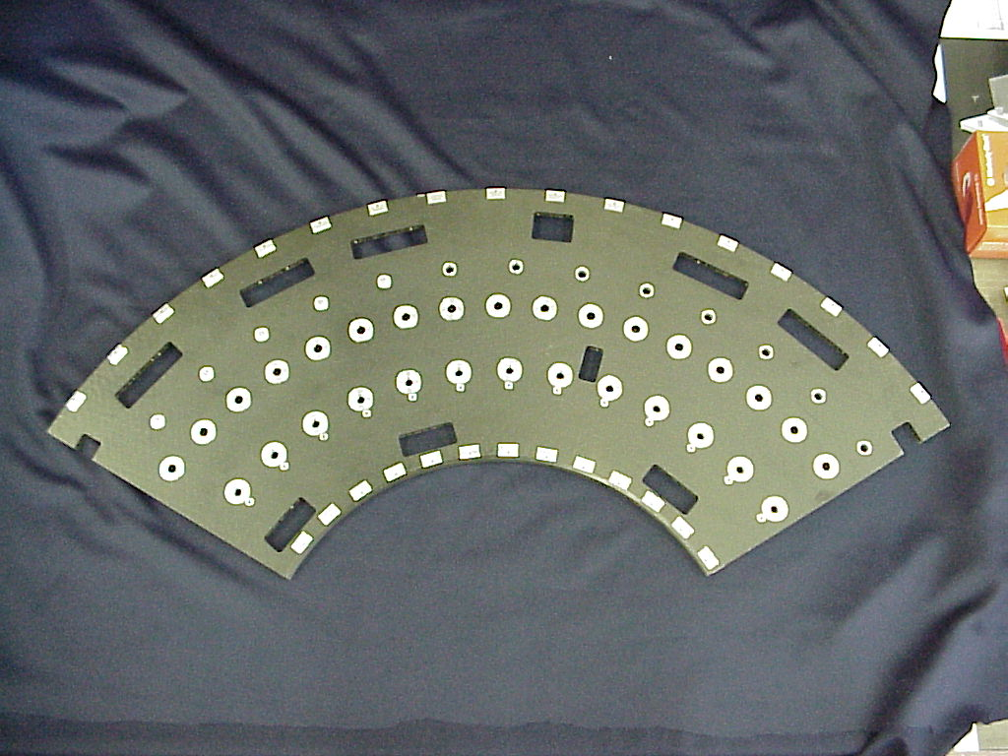
Figure 1 Disc sector with inserts after machining

Cooling Circuits
Advantage was taken of this prototype to try out different pipe and block materials which were still being considered at that time. This helped in the finalising the choice of materials and joining techniques.

Al Pipe/Al Block
The outer and middle rings were constructed with aluminium pipe and aluminium blocks. The pipe was 3.6mm ID/ 4.0mm OD. The pipes were bent by Lancaster University using techniques which had been developed on the previous quarter disc cooling prototype. This technique is now well understood and reproducible.
Both the pipes and the main cooling blocks were selectively copper plated and were then joined using soft solder. This is a well understood process and works well.
The second point cooling blocks were attached using thermal epoxy. There was a problem later discovered with the module mounting pin size on these blocks and they had to be removed from the sector, remachined and then reattached. During the removal process it was possible to view the layer of epoxy and it was clear that it was a very consistent layer which had filled the space with no voids and with good adherence.
Unfortunately, there was a problem with the Al pipe and block solution. When the pipes were leak tested, small holes were discovered in several places along the pipe. It is thought that these arise from the copper plating process. If this process could be very well controlled and the pipe well protected in the areas where the plating is not being applied then it is likely that this problem could be avoided. In addition, a coating would need to be applied to the area at the end of the cooling block where the interface between the Cu plating and the Al pipe is exposed.

CuNi Pipe/CC block
The inner ring was constructed with CuNi pipe and CC cooling blocks.
The CuNi pipe used was 4mm OD with 70µm wall thickness. The pipe was bent at RAL. The pipe was filled with water and carefully frozedn using liquid nitrogen. It appeared that warming a little above this temperature gave optimum bending conditions,. The pipe bender, able to bend up to 180º, also incoporates a jig which locates the current bend in relation to the previous bend, in terms of pitch between bend centres. Variations in angle of bend are removed manually when put ino the jig for the nexty bend. This jig also ensures all bends are co-planar. The section was constructed out of 4 pieces of pipe which were then soft soldered together. The limitation was the amount of pipe which could be frozen in the nitrogen bath. The section can be seen in Figure 2.
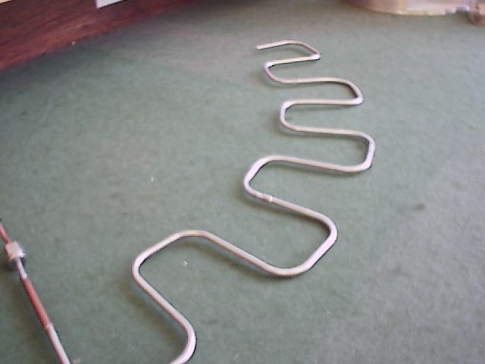
Figure 2 Inner circuit – CuNi pipe

Several CC high cooling blocks were machined by an outside machining company. These were selectively Cu plated and were then softsoldered to the CuNi pipe. Most of the blocks were just Cu plated which oxidises very quickly and was difficult to clean before soldering. One of the blocks was treated with a final gold flash. This was found to be much better. The low cooling blocks were made out of Al and attached with thermal epoxy. The assembled circuit can be seen in Figure 3. The CC block with the final gold flash can be seen on the left.

Cooling Circuit Assembly
The outer cooling circuit was used to test the assembly method which had been developed at RAL. This method is described in ref []. Figure 4 shows the sector on the rotary table with block being positioned via the precision placement arm.

Power Tapes
The low mass wiggly power tapes were produced at Ljubljana. They were made from the ‘old’ design of x mm wide with Al tracks. Because of the expense of producing different shapes of tape, only 9 different designs were produced. Therefore 9 positions have the correct tape layout and the remaining positions have tapes which have been ‘made to fit’ as best as possible. The tapes were all hand assembled to the disc. The tapes assembled to the disc are shown in Figure 5 and Figure 6.

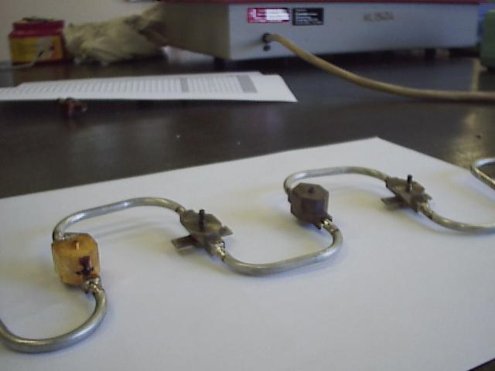
Figure 3 Assembled inner circuit with high CC cooling blocks

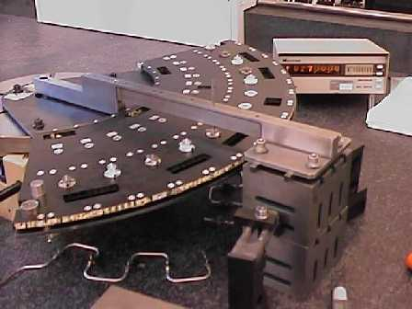
Figure 4 Blocks being assembled to disc using precision rotary table and positioning arm
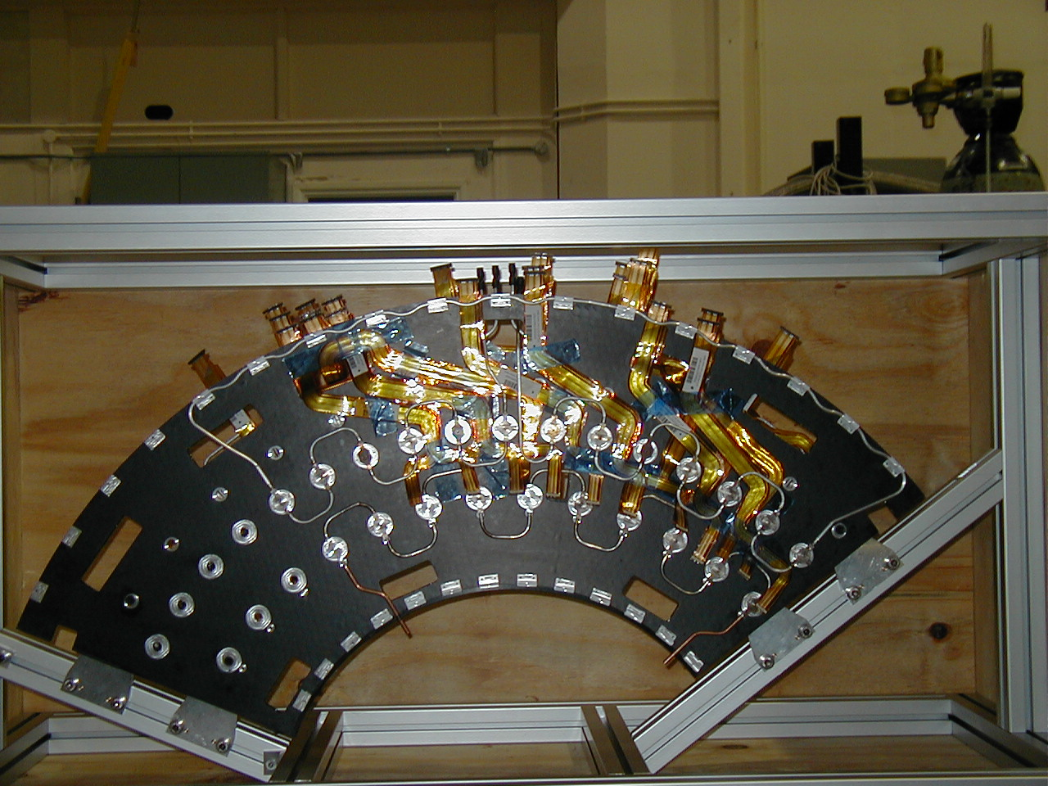
Figure 5 Final assembled sector – front view
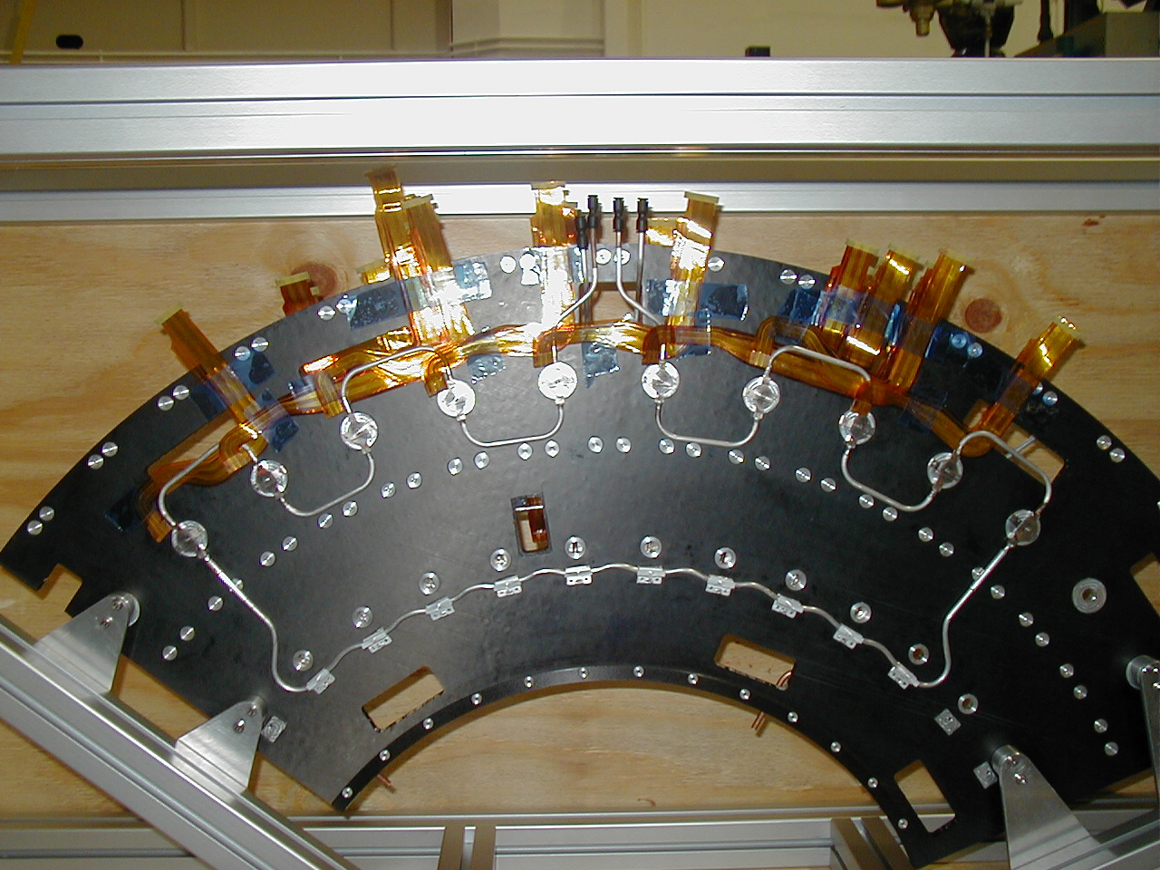
Figure 6 Final assembled sector – back view

ATL-IS-AN-0003, SCT End-cap Disc Preparation for Services, Nigel Hessey, Hans Band
ATL-IS-ER-0022, Disc Services Assembly Tooling, Steve Temple

