system test and first results

General Description
The goal of the system test is to run as many modules as possible in a physical configuration which is as close as possible to the planned ATLAS SCT configuration, thereby testing the performance of the modules in such a system and comparing it to their stand-alone performance. Experiments are performed to ascertain the robustness of the grounding and shielding schemes used against extra noise pick-up from the experimental environment.
The system test simulates a section of one of the SCT forward disks in all its details of mounting, cooling, supply and shielding.
The sector can accommodate up to 33 modules; 13 outer, 10 inner and 10 middle modules. Figure 9 shows the outer and inner module mounting positions on the front of the disk, while figure 10 is of the back of the disk where the middle modules are mounted. The mounting positions are denoted O1-O13 for outer and I1-I10 for inner positions starting at the far left of figure 1. While the middle position are denoted M1-M10, counting from the right of figure 10.
The disk is held at each end via metal bolts to an aluminium support frame, shown in figures 9 and 10. The carbon-fibre disk is therefore in electrical contact with the support frame. The sector is housed in a copper box to represent the thermal shield at the SCT. It should be noted that the cover is not electrically or geometrically similar to the planned ATLAS SCT thermal shield. Combined with blackout cloth and a dry nitrogen supply the copper box provides a dry and dark atmosphere, with a relative humidity of 20% or less, whilst running.
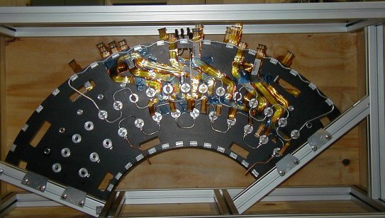
Separate cooling circuits are used for the three module types. The inner modules are served via a CuNi pipe 4mm OD with 70µm wall thickness, while the middle and outer modules have aluminium pipes 3.6mm ID/ 4.0mm OD. The cooling blocks are machined Al blocks with copper plating at the pipe block join. The blocks were soft soldered to the cooling pips. On the outer cooling circuit 4 of the high cooling blocks are CC with a Cu plate (positions O3,O5,O7, and O9 counting from the left as you look at the disk). The third CC block had a final gold flash to prevent oxidation. An ethanol-water mixture is pumped through the pipes with the temperature being controlled by a commercial chiller.

Figure 9 - Sector front view
The low mass wiggly power tapes were produced at Ljubljana. They were made from the ‘old’ design being ??mm wide with Al tracks. Because of the expense of producing different shapes of tape, only 9 different designs were produced. Therefore 9 positions have the correct tape layout and the remaining positions have tapes which have been ‘made to fit’ as best as possible. The wiggle tapes contain all the power, select, reset and temperature monitor lines for the modules. The communication of data to and from the module is performed via the optical plug-ins in the forward optical harness. Each harness serves either 5 or 6 modules. At the edge of the disk the harness connects to 25 m long fibres, which transmits the data to the DAQ system, illustrated in figure 11.
The SCT prototype VME power supplies (SCTLV3s) power the module’s ASICs and opto-components. The detectors are biased with the companion prototype high voltage units (SCTHVs). The individual channels of each power supply are floating with respect to each other. It should be noted that the return lines of the ASIC analogue and digital lines and the detector bias line are connected together at the disk in a fashion dependent on the particular grounding and shielding scheme implemented, which are described later.
The modules are read out using a CLOAC-SLOG-MuSTARD-OPTIF system, with the OPTIF[4] providing the electrical-optical interface. The DAQ used is in place of the final read-out drivers, (ROD). The hybrid temperature is readout via the SCTLV3 modules. A ROOT-based SCTDAQ software package is used, running on a Windows-NT PC connected to the VME crates via a National Instruments interface card.
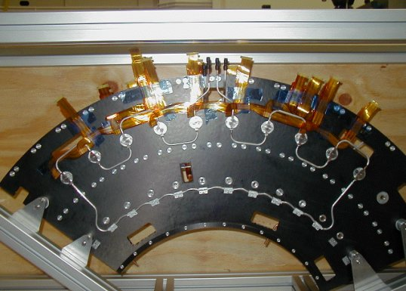

Figure 10 - Sector back view

Control and monitoring of all voltages and currents is carried out through the DAQ software, although a prototype DCS system is used to monitor hybrid temperature, environmental temperature and humidity and control the cooling unit.
All patch panels and power tapes used are as close as possible to the planned final ATLAS design, except for extra provisions on the patch panels to allow testing of various coupling schemes. From the power supplies 30 m long conventional cables run to PPF2 via a common mode choke. These chokes are intended for use at PPF3 but PPF3 is not represented in the system test. Between PPF2 and PPF1 2.5 m long kapton tapes with 100μm thick Al tracks are used. The kapton tapes between PPF1 and PPF0 are 3.1m long with 50μm thick Al tracks. A schematic diagram of the system test is shown in Figure 11.
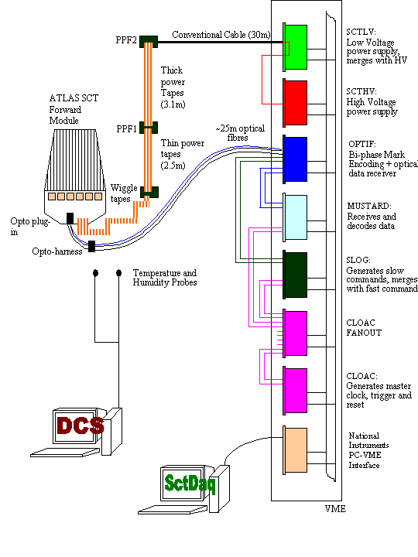
Figure 11 - A schematic layout of the forward SCT system test

Grounding and Shielding in the System Test
The system test bases it’s grounding and shielding scheme on the proposals outlined in [7,8,9]. The main elements as applied in the system test are described below, with any differences noted. Two grounding & shielding schemes are being investigated. They differ in the way the modules are referenced with respect to each other.
At the SCT low voltage power supply the conventional cable shield is AC connected via a 10nF capacitor to Digital ground.
At PPF2 the conventional cable shield passes through the chokes and are commoned at the kapton tape side of PPF2. From PPF2 to PPF1 the 6 “thick” kapton tapes per PPF2 are bundled together and wrapped with aluminium foil. At PPF2 the shield is connected, via jumpers, to the aluminium foil wrapped around the kapton tapes and taken to PPF1. PPF1 is electrically shielded inside an aluminium box, connected to the kapton aluminium foil shield. PPF1 is equipped with jumpers to allow AC connections. VDD, VCC and HV are decoupled to their respective return lines via 4.7uF capacitors. All power and return lines (including Pin bias and Vcsel lines), sense lines and the select line are decoupled to the shield via 1uF capacitors. From PPF1 to PPF0 the “thin” kapton tapes are bundled together in sets of 3, with each set wrapped in aluminium foil. The shield connection continues via the aluminium foil around the “thin” kapton tapes through the sector housing to PPF0. The shield is held in good contact with the copper box as it enters it.
Figure 3 Schematic layout of the forward SCT system test
The disk’s aluminium support structure, inside the copper box, is electrically connected to the disk’s carbon fibre skin via copper tape and via supporting screws into the structure of the disk.
For both grounding schemes the shield of PPF0 is connected to a 50μm thick angular aluminium foil stuck to the outer edge of both faces of the disk. The foils are connected together and to the carbon fibre of the disk with conductive epoxy and copper tape. On each disk face the angular foil is connected via three radial foils to angular foils running just above the cooling blocks, (2 foils on the disk front and 1 on the back), with foil tabs down to each cooling block. Connections are made between the foil and the cooling block using either conductive epoxy or the cooling block’s fixing screws. In this manner all the cooling blocks are connected, via the aluminium foil, to the outer angular foil and thus the shield of PPF0. The shield at PPF0 is also connected to the aluminium support structure via short pieces of copper tape. The detail of the on-disk-grounding scheme is shown in figure 12.
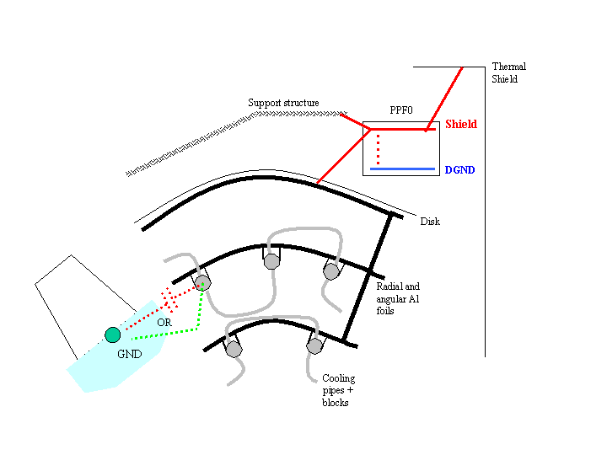
Figure 12- Detail of on disk and PPF0 grounding and shielding scheme
(red dots - shunt shield option, green dots - DC option)
The first grounding & shielding scheme to be investigated (Scheme SS) prescribes the control of stray capacitance between the cooling pipe and the silicon detector backplane by the use of a shunt shield placed between the module and the cooling block. The shunt shield is an integral part of the K5 module consisting of a copper foil at the cooling point of the module connected directly to Analogue Ground, (AGND), of the module. Electrically insulating foam with good thermal conduction properties is mounted onto the cooling block face to electrically insulate the module from the cooling block. Therefore the module ground and the cooling block are not in intimate electrical contact with each other. For this grounding scheme the shield connection at PPF0 is connected to Digital Ground, via jumpers fitted to PPF0. Thus the cooling circuit is connected to the modules digital return via a long path consisting of the wiggly tapes and PPF0.
At PPF1 the HV line is decoupled to the shield via a 10nF capacitor and the HV return line is shorted to the shield. Figure 5 illustrates the main features of this grounding scheme.
The second scheme (Scheme DC) requires the module grounds to be held together as tightly as possible. The module shunt shield is shorted so that the module power returns are DC connected to the cooling block at the module mounting point. The electrically insulating foam remains on the face of the cooling block. To have a direct connection from the module grounds to the block an additional metal covered kapton washer, connected to AGND of the module at the module connector, is glued onto the top of the module’s peek washer. The metal holding nut on the cooling block insures a DC connection between the module power returns and the cooling block. The main features of this scheme are shown in figure 6.
In figures 5 and 6 the red dotted line represents the shield, only the VDD and DGND lines are shown but in reality both analogue and digital lines pass through a choke and are decoupled to the shield at PPF1.
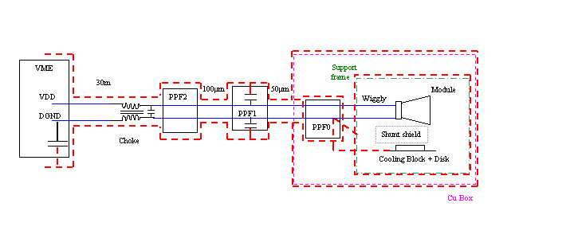
Figure 1 - Grounding and shielding scheme that utilises the shunt shield
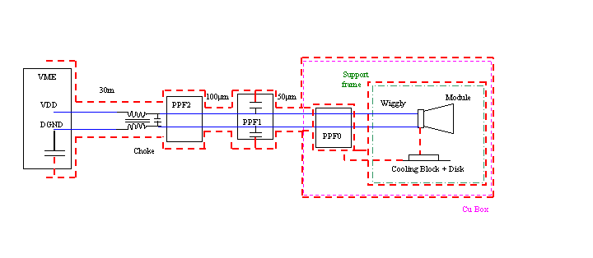
Figure 2 - Grounding and shielding scheme that utilises DC coupling between the AGND of each module

First results for the Forward system test.
When a module arrives at the system test, it is accompanied by the results from a standard characterisation as performed at the module building cluster. The first step in integrating the module into the system test is to repeat this standard characterisation on the 'electrical test bench' in the system test lab, to verify that the module has not suffered in transit. The electrical test bench is considerably simpler than the full system test as it bypasses the optical communication, and uses only very short power and signal cables. Therefore a module may be expected to give its best performance when running stand-alone 'on the bench'.
Once the module is verified to be in good working order, it is mounted on the system test sector (with all grounding and shielding connections made), and the standard characterisation sequence is repeated, powering only that one module. This performance is compared to that on the bench and any differences are noted and investigated if possible. When this comparison is complete, the module is considered ready to be included in multi-module tests.
There are currently six modules (two middle and four outer modules) in the system test, detailed in Table 1. All the modules showed approximately the same noise values (within about 100 ENC) when running alone on the sector as they did on the bench.
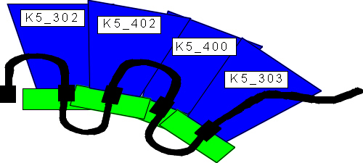

Figure 15 - modules & cooling pipes in a 4 outer multi-module run
A typical multi-module test is to measure the gain, noise and noise occupancy with many modules running in parallel. This has been performed, using a three-point gain calculation and noise occupancy scans, with the modules on the sector. At present either the two middle modules or the four outer modules have been operated together, but not all six at once. For example the 4 outer modules were mounted in positions O10 to O13 (O11 and O13 being high blocks) as shown in figure 15. The modules were communicated with via a single opto-harness. Details are given in table 2.

Module | Cooling block | Opto plug-in | Temperature (C)
K5-302 | O10 | 3 | 34
K5-402 | O11 | 4 | 37
K5-400 | O12 | 5 | 35
K5-303 | O13 | 6 (only link1 working) | 37
Table 2 – Multi-module tests on 4 outer modules

The measured noise values of all ASICs on the modules, with all 4 modules in operation at a hybrid temperature of about 36⁰C, are shown in Figure 16. With the exception of the first chips on module K5-303 the noise values lie within the anticipated range.
No ‘dead seagulls’ were seen in the distribution of noise across the modules when operated on the sector. Such ‘dead seagull’ noise distributions were seen previously, with K3 modules on the early system test sector, and attributed to correlated noise sources.
A scan of Noise occupancy as a function of threshold, in charge, was performed, as illustrated in Figure 17. Good agreement in noise between the 3point gain and the Noise Occupancy runs were obtained. The noise occupation was within specification with a measured value below 5x10⁻⁴, shown in Figure 18.
Noise occupancy as a function of time was measured with the threshold set to 1fC on all modules. The duration of a noise occupancy measurement was about 1 minute, with a 2 minute interval been measurements. 100 measurements were made. Figure 19 shows the observed decrease in noise as a function of time, this was also seen in the barrel system test. This effect has been attributed to the change in the inter-strip capacitance of the detector as a function of time after the initial bias is applied to the device. The time constants are detector dependent and for some modules are as long as an hour. This imposes no implication to the running of the SCT. However, the system test has to be left biased for at least an hour for comparative studies of noise performance. There were no peaks detected in the noise occupancy as a function of time plots. Had peaks been present (observed in early barrel system test data due to noise pick-up by the system of the switching currents of the air-conditioning) this would be indicative of inadequate shielding. A Correlated noise data taking macro has been run for the 4 modules. The noise calculated from the correlated noise measurement agreed with those from the 3pt gain scan, while the amount of correlated noise found was low and consistent with zero.
No difference has been observed in the performance of the system for the two ground and shielding schemes for measurements performed with no intentional injection of noise into the system.

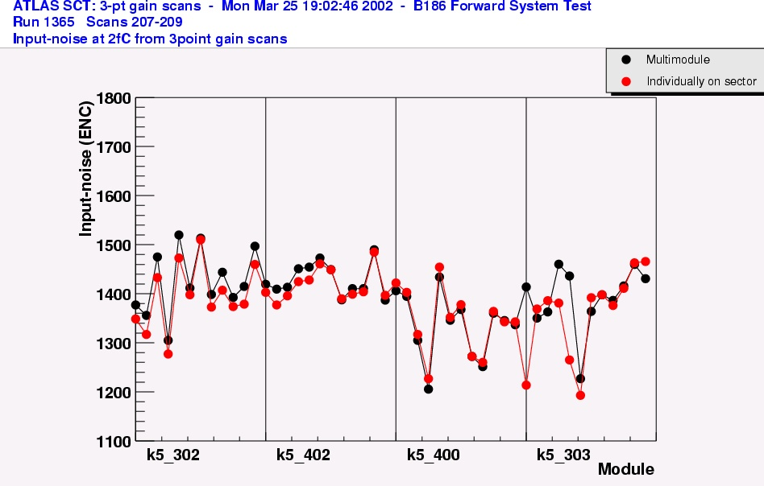
Figure 16 - Comparison of the measured noise (e⁻ ENC) of each ASIC per module measured on the system test sector when the modules were operated individually and as part of a multi-module run.
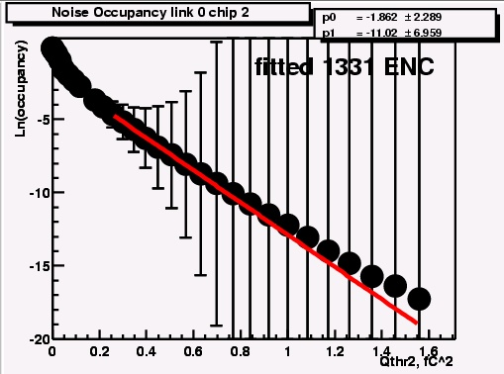
Figure 17 - An example of Ln Noise Occupancy as a function of threshold squared (fC²) measured in a multi-module run

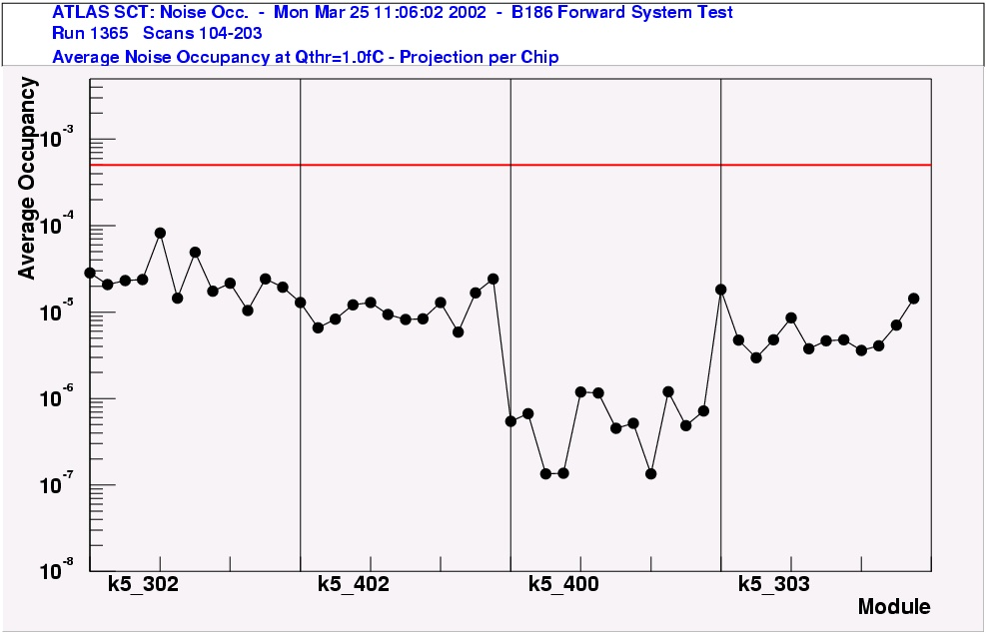
Figure 18 - Noise occupancy per chip measured with all four module operated together on the sector.
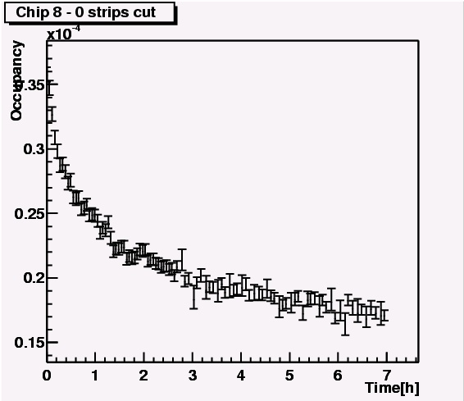
Figure 19 - Noise Occupancy as a function of time.

Noise injection studies with the two grounding and shielding options
Experiments are ongoing to investigate the robustness of the two grounding and shielding options against injected noise. Noise was injected either into the cooling pipes on the disk or the thick power tapes (between PPF2 and PPF1) with the use of a ferrite ring. A small signal sine waveform generator passed a current through a wire rapped around the ferrite. In the cooling pipe injection case a small signal is induced into a second wire rapped around the ferrite. This wire was connected via a lemo cable to one end of the cooling pipe inside the copper box. The cooling pipes other end was connected to the lemo shield and returned to the ferrite. A 2Ohm resistor was placed in series with the lemo cable to cause a current flow. This also enabled the monitoring of the injected signal on a scope. To inject signals into the power tapes the ferrite was placed around the power tapes over the shielding between PPF2 and PPF1 and close to PPF1. Both the magnitude and frequency of the injected signal was altered and the effects noted.
The measurements taken were a single threshold scan with a 2fC injected charge pulse. The noise was obtained on a strip-by-strip basis from the fit to the threshold scan s-curves. Assuming a fixed gain of 55mV/fC the noise as ENC in electrons was determined. The average noise per chip was also computed. Each set of measurements was comparative in nature and therefore a reference set of data was taken without noise injection followed by the measurements with the noise source. The difference between the two sets was plotted either strip or chip wise.
The dependence on the noise pick-up as a function of frequency showed a strong peak round 6-10MHz, as expected from the front-end band-pass. Increasing the magnitude increased the injected signal size. To obtain reliable fits to the s-curves the injected noise was set to a frequency of 6MHz with a 10Vpp magnitude on the signal generator.
The noise distributions across three outer modules with a noise signal injected into the cooling pipes are shown in Figure 20 for the two grounding schemes. It can be seen that the two grounding schemes give approximately the same results. The structure in the noise is module position dependent and it is assumed to be greater where the modules overlap each other and the cooling pipes and power tapes. The middle module on the plot shows increased sensitivity to noise pick-up due to its closer proximity to the cooling pipes and power tapes (this is a lower module position).
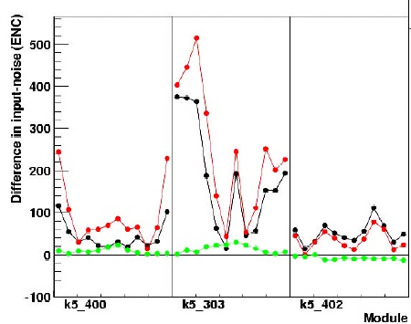
Figure 20 - Difference in input noise (e⁻ ENC) measured with a 6MHz 10Vpp injection signal into the cooling pipes for both grounding schemes. Black dots – Shunt shield, Red dots – Shunt shield shorted, Green dots – no injection
The rejection of noise from injection into the tapes was seen to be better with the shunt shield option as shown in Figure 21. Again the structure is module position dependent.
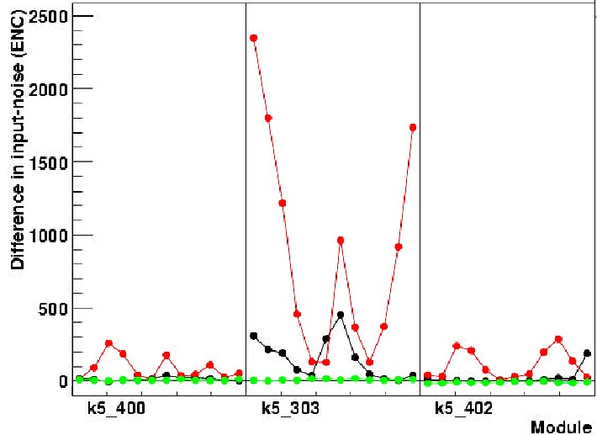
Figure 21 - Difference in input noise (e⁻ ENC) measured with a 6MHz 10Vpp injection signal into the thick kapton power tapes for both grounding schemes. Black dots – Shunt shield, Red dots – Shunt shield shorted, Green dots – no injection
It should be noted that these measurements are very preliminary and on going. Further improvements in the integrity of the grounding and the shunt shield shorting method are continuing to yield improvements in noise rejection for both grounding and shielding schemes.
In conclusion the system test has shown that the modules are within specification when operated together (all be it in very limited number at present) without the deliberate injection of noise into the system. The ability of the grounding and shielding scheme implemented to reject external noise sources deliberately injected into the system is still not adequate. No conclusive answer to which of two proposed schemes should be adopted can be made at present.

