

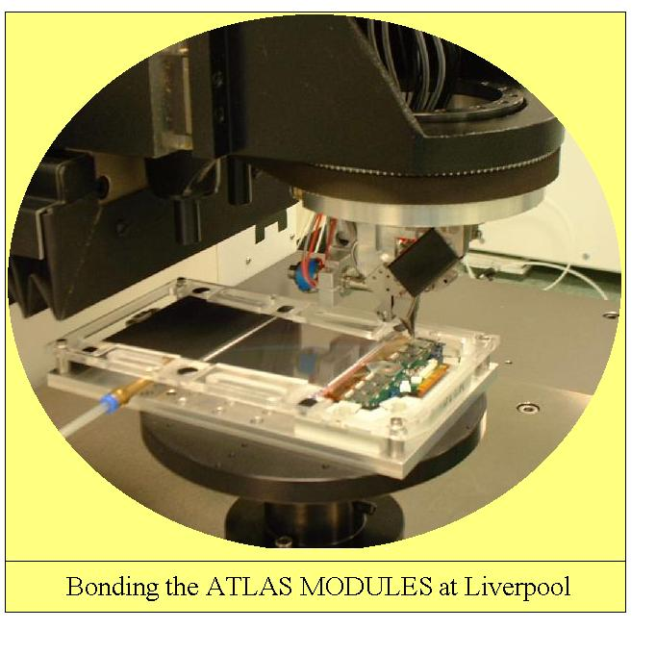

mpw@liv.ac.uk
Getting ready for bonding an Atlas Module.
Power up the wire bonder and move bonding head to Park Position.
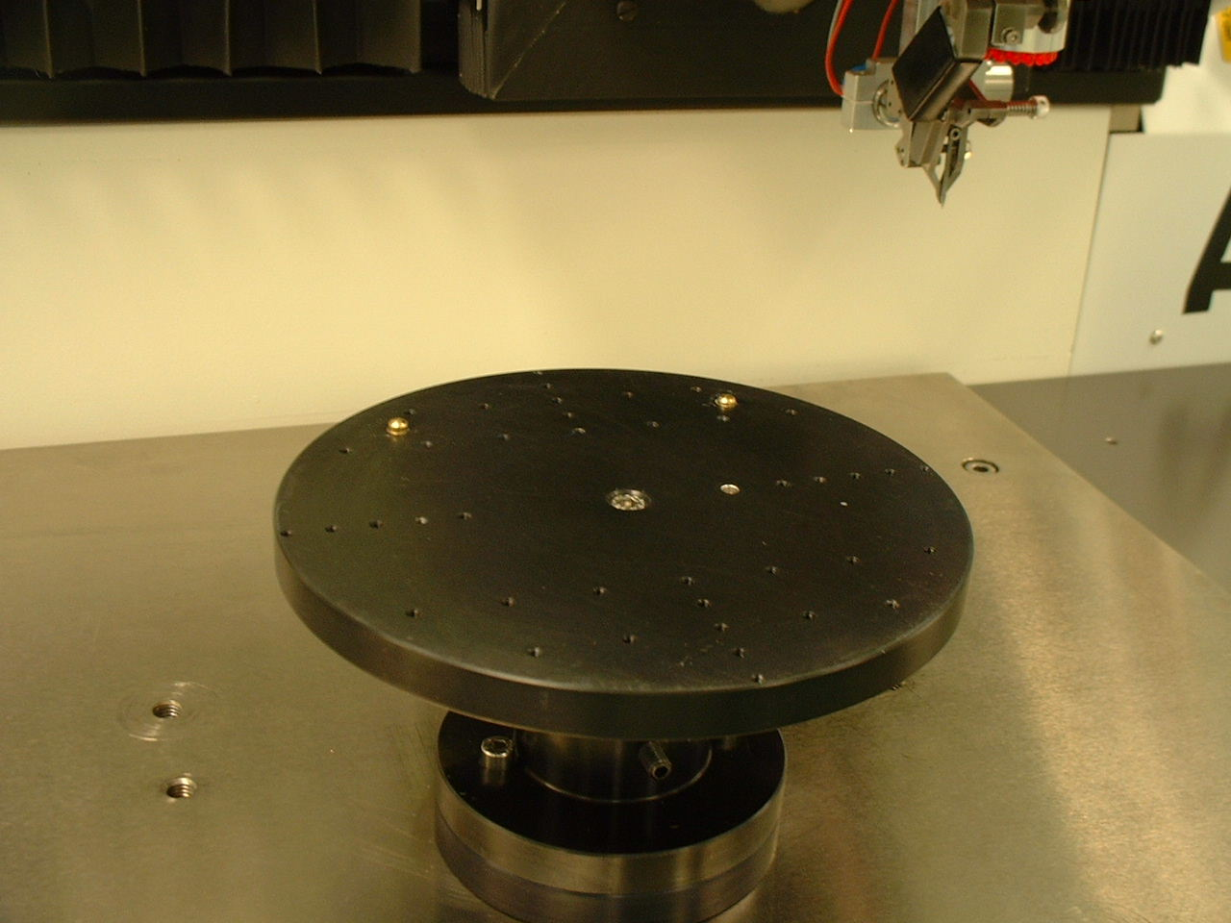
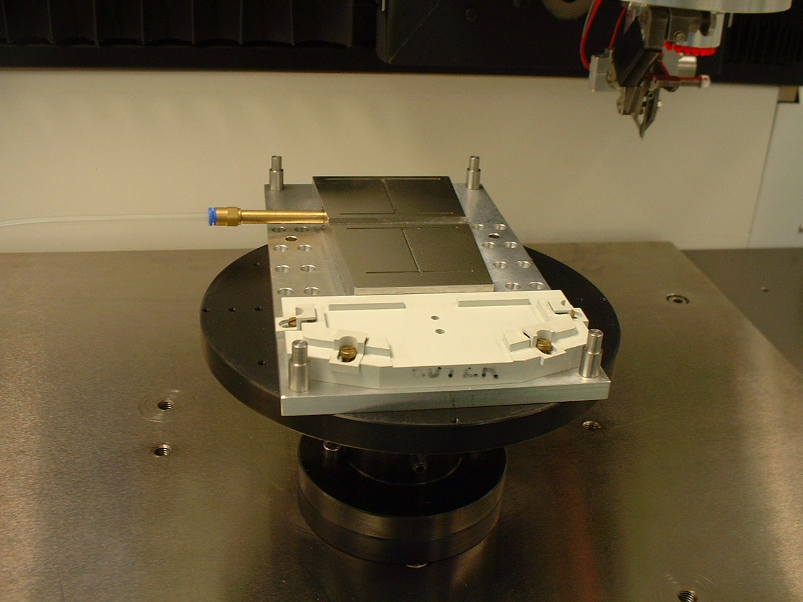
There are two dowel pins on the work holder. These are for the bonding jig location all programs have the coordinates XYO relative to these pins.

Dowel location pins. Jig mounted on the work holder.
Move all clamps back on Hybrid support (Noryl). Place a piece of clean room paper on both sections of the vacuum plate, then attach the vacuum pipe. Leaving the vacuum turned off.
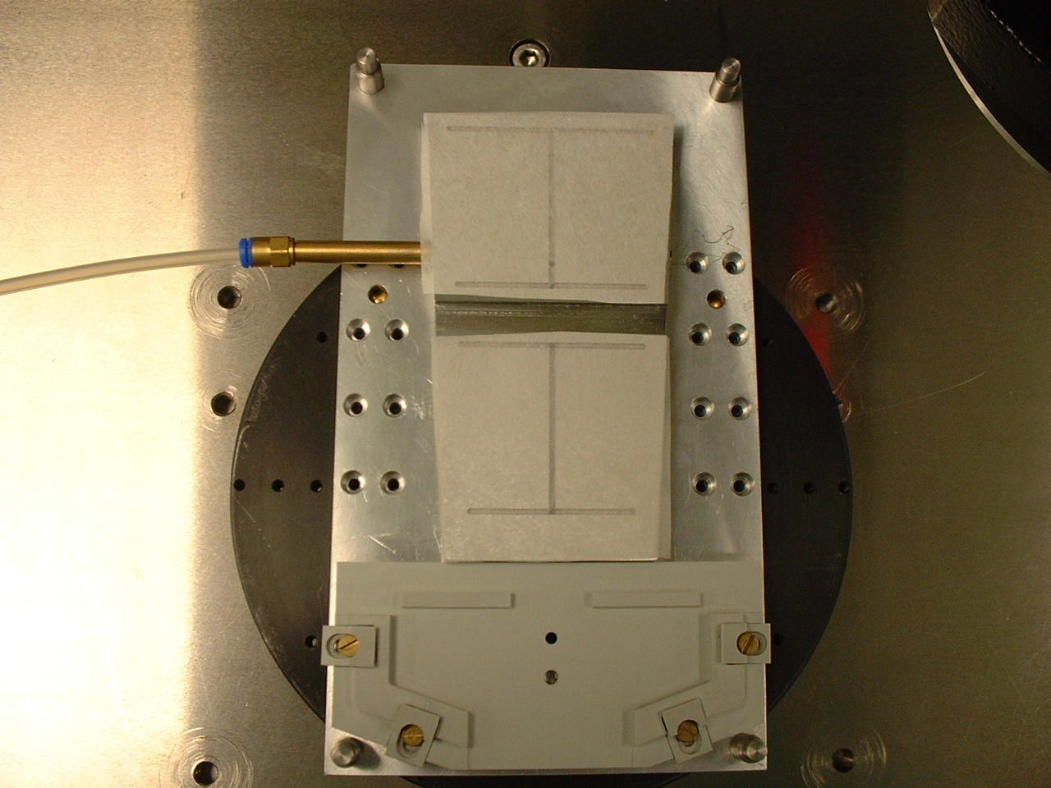
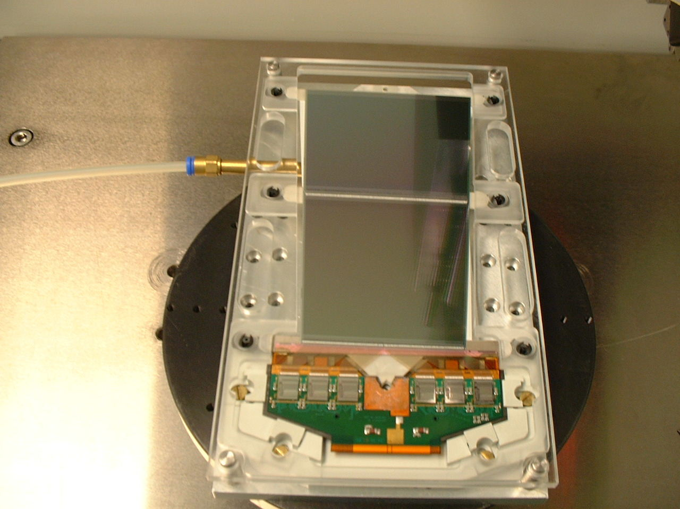

Mount module. Move clamps into clamping position and tighten; now the vacuum can be turned on.
Before loading the program RECORD the Module number, Wire Spool number and the number of bonds the Wedge has performed –this number is under the wedge counter in options-. This will allow a cross check later if there is any problems and will also give an indication of how much wire is left on the spool.
Each module has 4,632 wires at approximately 5mm per wire. This means there is a wire usage of 23 Metres. The wire spools are 100 Metres in length and therefore it would be useful to set the wedge counter to 18,500 Maximum usage. This will “flag” the machine when the wire is about to run out. With the 8 Metres remaining you can bond two sets of low loops and high loops before the wire runs out.
Remove the module from the bonder. Move the bonder to thread position examine the wedge if OK then rethread the wire and reset the wedge counter If the wedge needs replacing. Replace the wedge and recalibrate the tool then thread the wire and reset the wedge counter.
Bonding the K5 outer Module.
The bonding of the outer module has been broken up into six bonding programs as follows:-
Program Name | Function
outlochp | Low bonds from chips to fan-in
outhichp | High bonds from chips to fan-in
outk5fdl | Low bonds from fan-in to Detector
outk5fdh | High bonds from fan-in to Detector
outk5mlo | Low bonds from Detector to Detector
outk5mhi | High bonds from Detector to Detector
These programs are used for both sides of the hybrid.
Before executing the program always perform a touchdown height on all reference systems, as the glue thickness may vary and the safety heights are programmed at 100um to allow low loops.
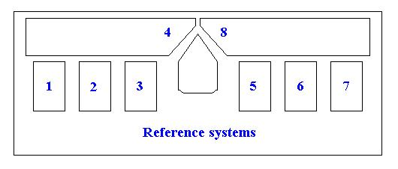
Load outlochp

The reference systems are as above the eye points for systems 1,2,3,5,6,7 are all the same as shown below.
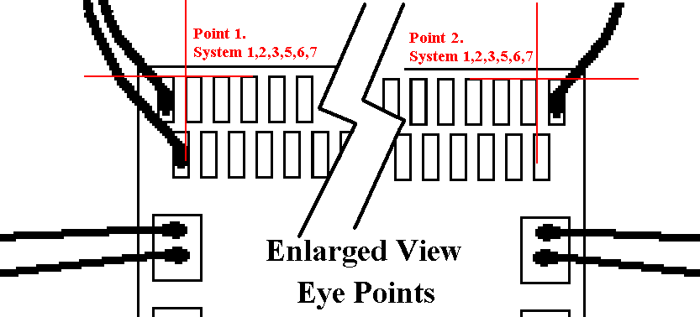

The above image shows an enlarged view of the asic chip. The first and last bond pads are grounds and should already be bonded to the hybrid.

The eye points for the fan-in are the furthest points away from each other as shown below
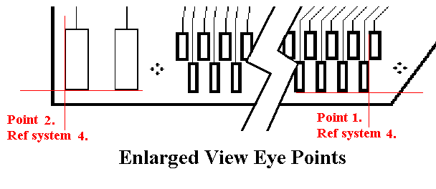

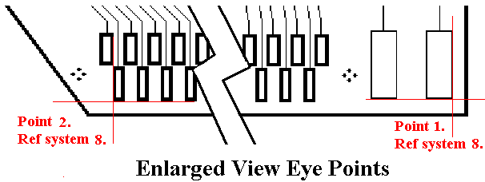

The program you have loaded (outlochp )and then aligned the eye points as shown above has all the parameters set as shown on the following pages. There are 385 wires in this program they are all the low bonds from the 6 asic chips to the 2 fan-ins.
Press bond chip on completion you can either load new sub straight and bond another hybrids asics or you can move to next program.
Load outhichp
The reference systems are exactly the same as the previous program but the eye points are as follows (for sys 1,2,3,5,6+7).
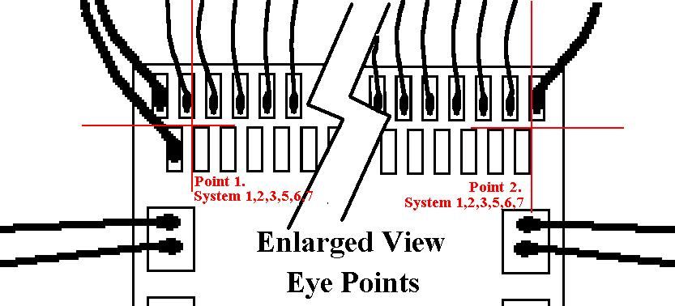

The eye points for reference systems 4 and 8 are as follows.
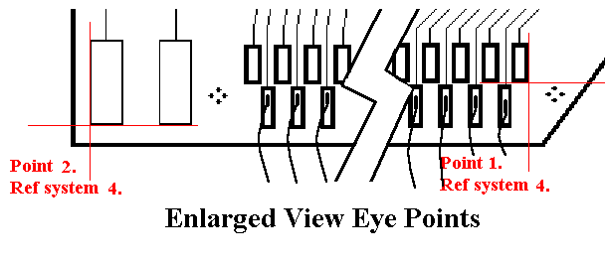

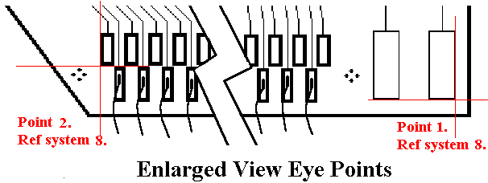

The program you have loaded (outhichp )and then aligned the eye points as shown above has all the parameters set as shown on the following pages. There are 385 wires in this program they are all the high bonds from the 6 asic chips to the 2 fan-ins.
Press bond chip on completion you can either load new sub straight and bond another hybrids asics or you can move to next program.
Load outk5fdl
This program is for the low bonds for the two fan-ins to the detector. The reference systems are as shown below:
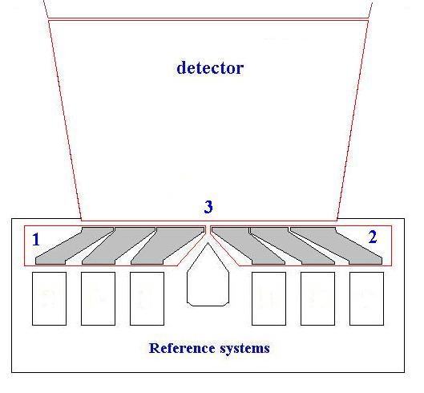

The eye points are at the furthest points apart on each reference system thus the detector points are twice that of the fan-ins.
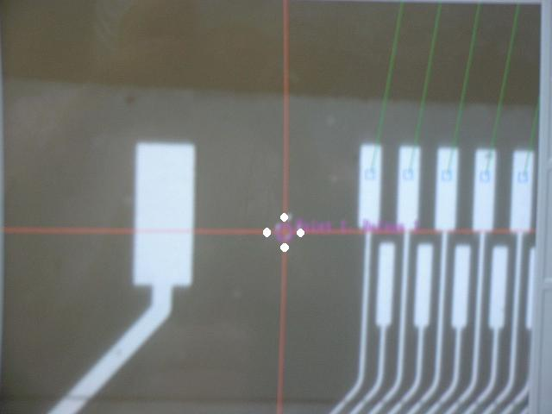
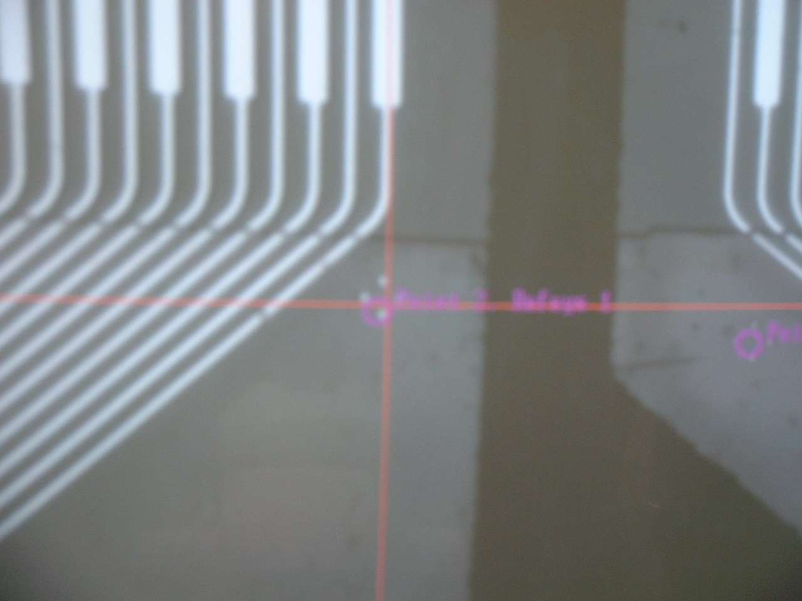

Reference System 1, Point 1. Reference System 1, Point 2.

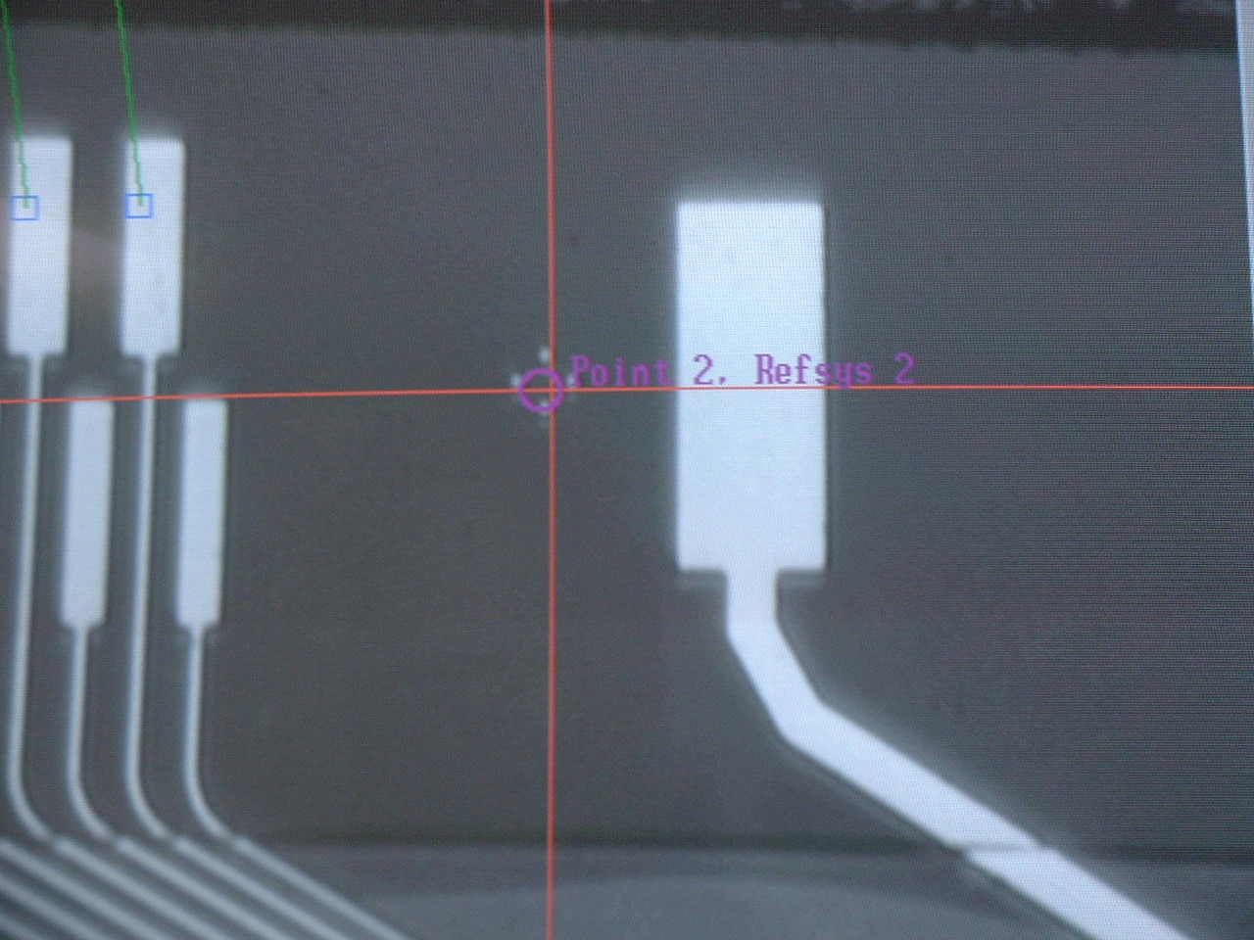

Reference System 2, Point 1. Reference System 2, Point 2.
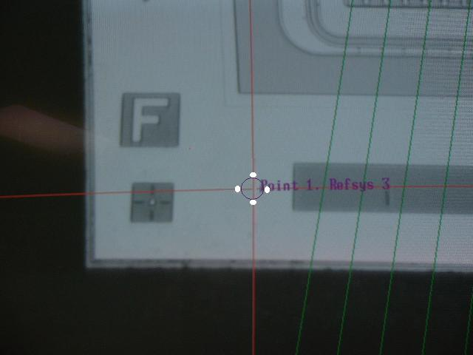
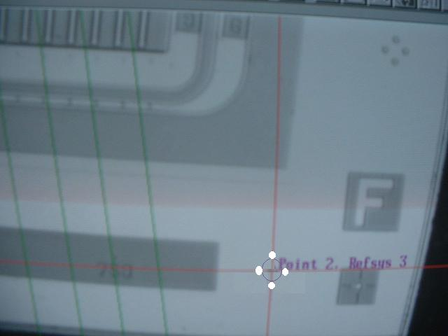

Reference System 3, Point 1. Reference System 3, Point 2.

Load outk5fdh
The eye points for the hi bonds are exactly the same as for the low bonds in program (outk5fdl)

Load outk5mlo
This is the program for the low loops for the detector to detector; the Reference systems are shown as follows:
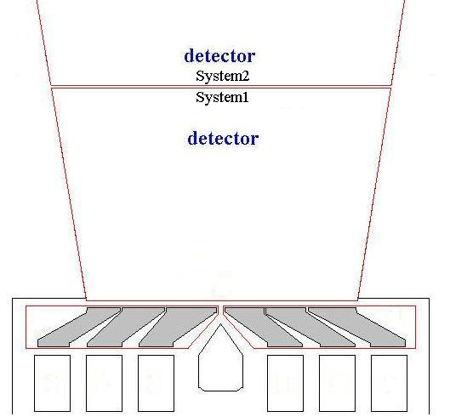

The eye points for the program areas follows:
