SCT End-cap Grounding + Shielding
Tuesday 9th April 2002

Sketches from Stephen Haywood’s notebook.
They should be taken with a pinch of salt and correspond to a snap-shot of the ideas at the meeting.

Shorting of a Shunt-shield in Module
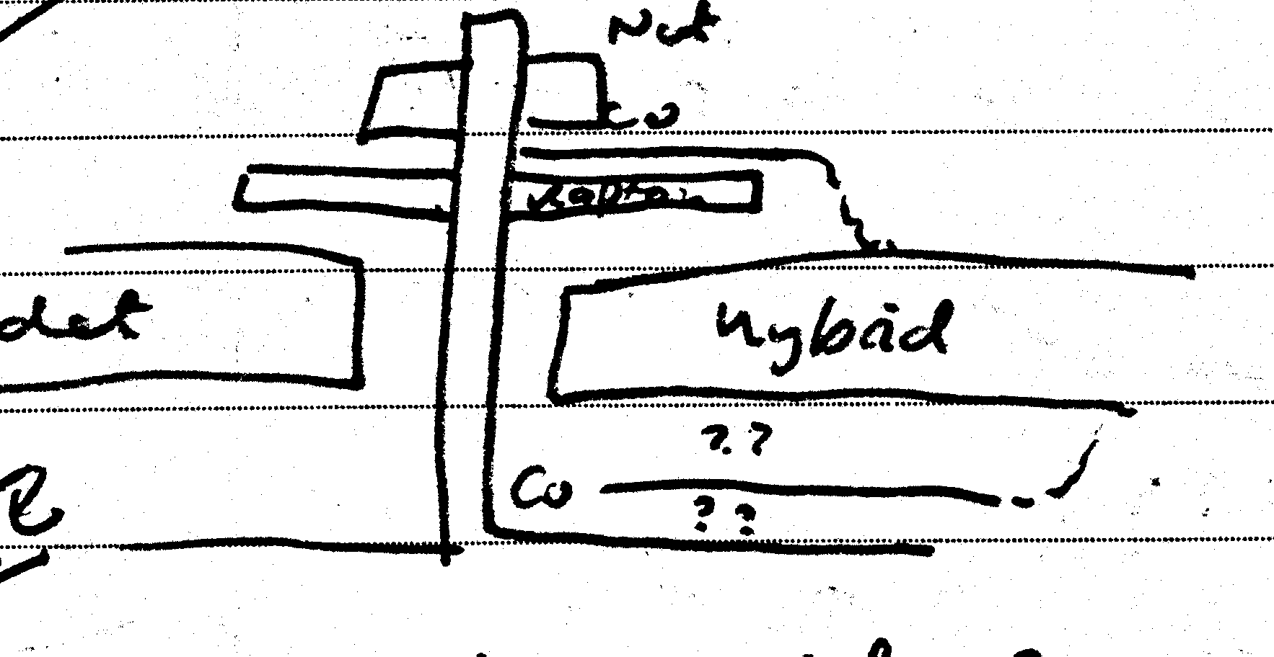

PPF0 – Electrical
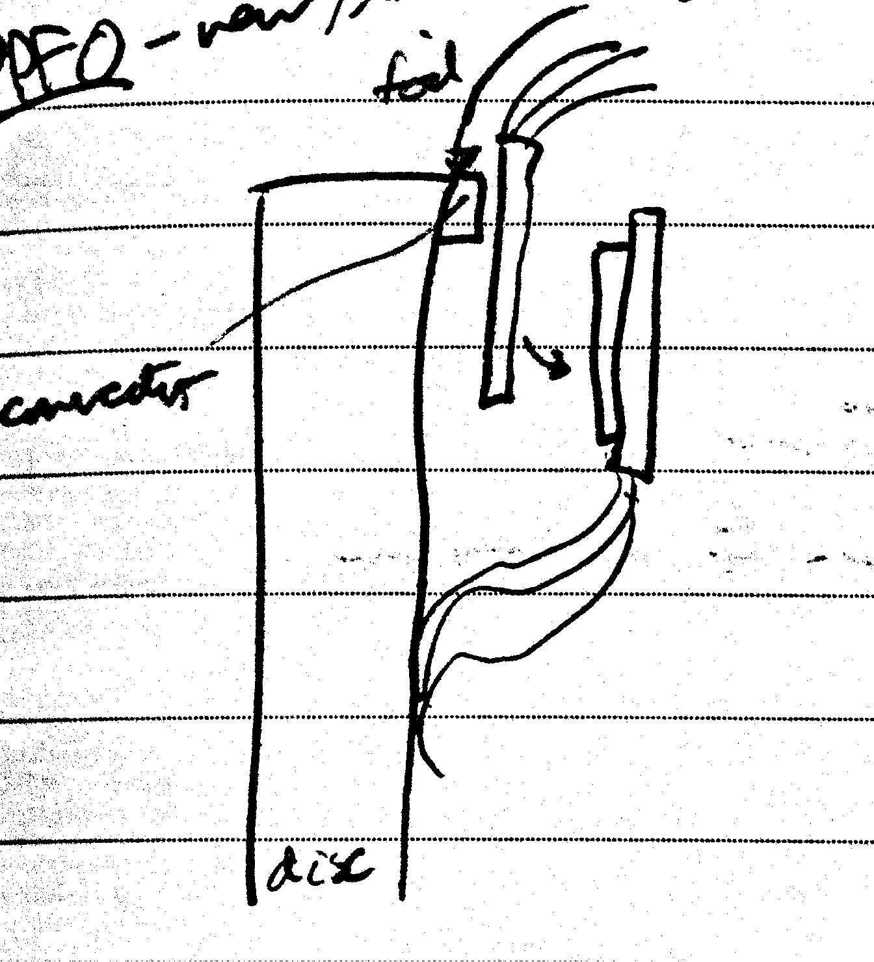

PPF0 – Cooling
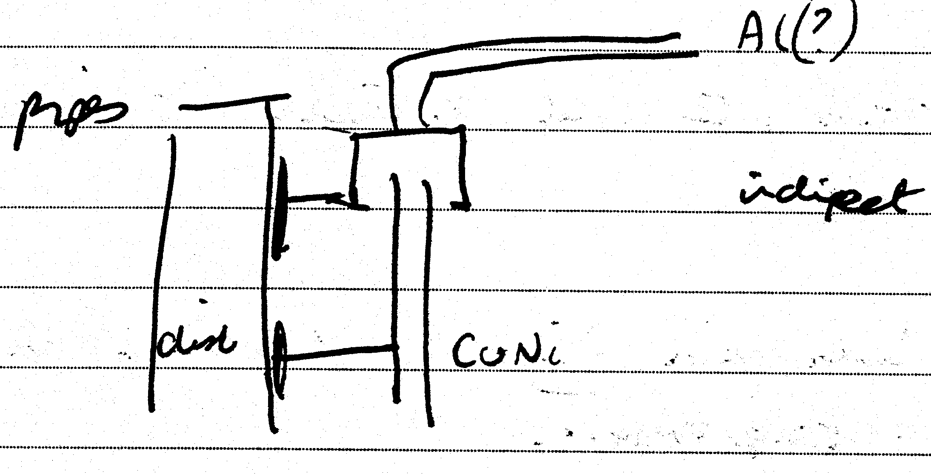

Connection of Front Wing to OTE
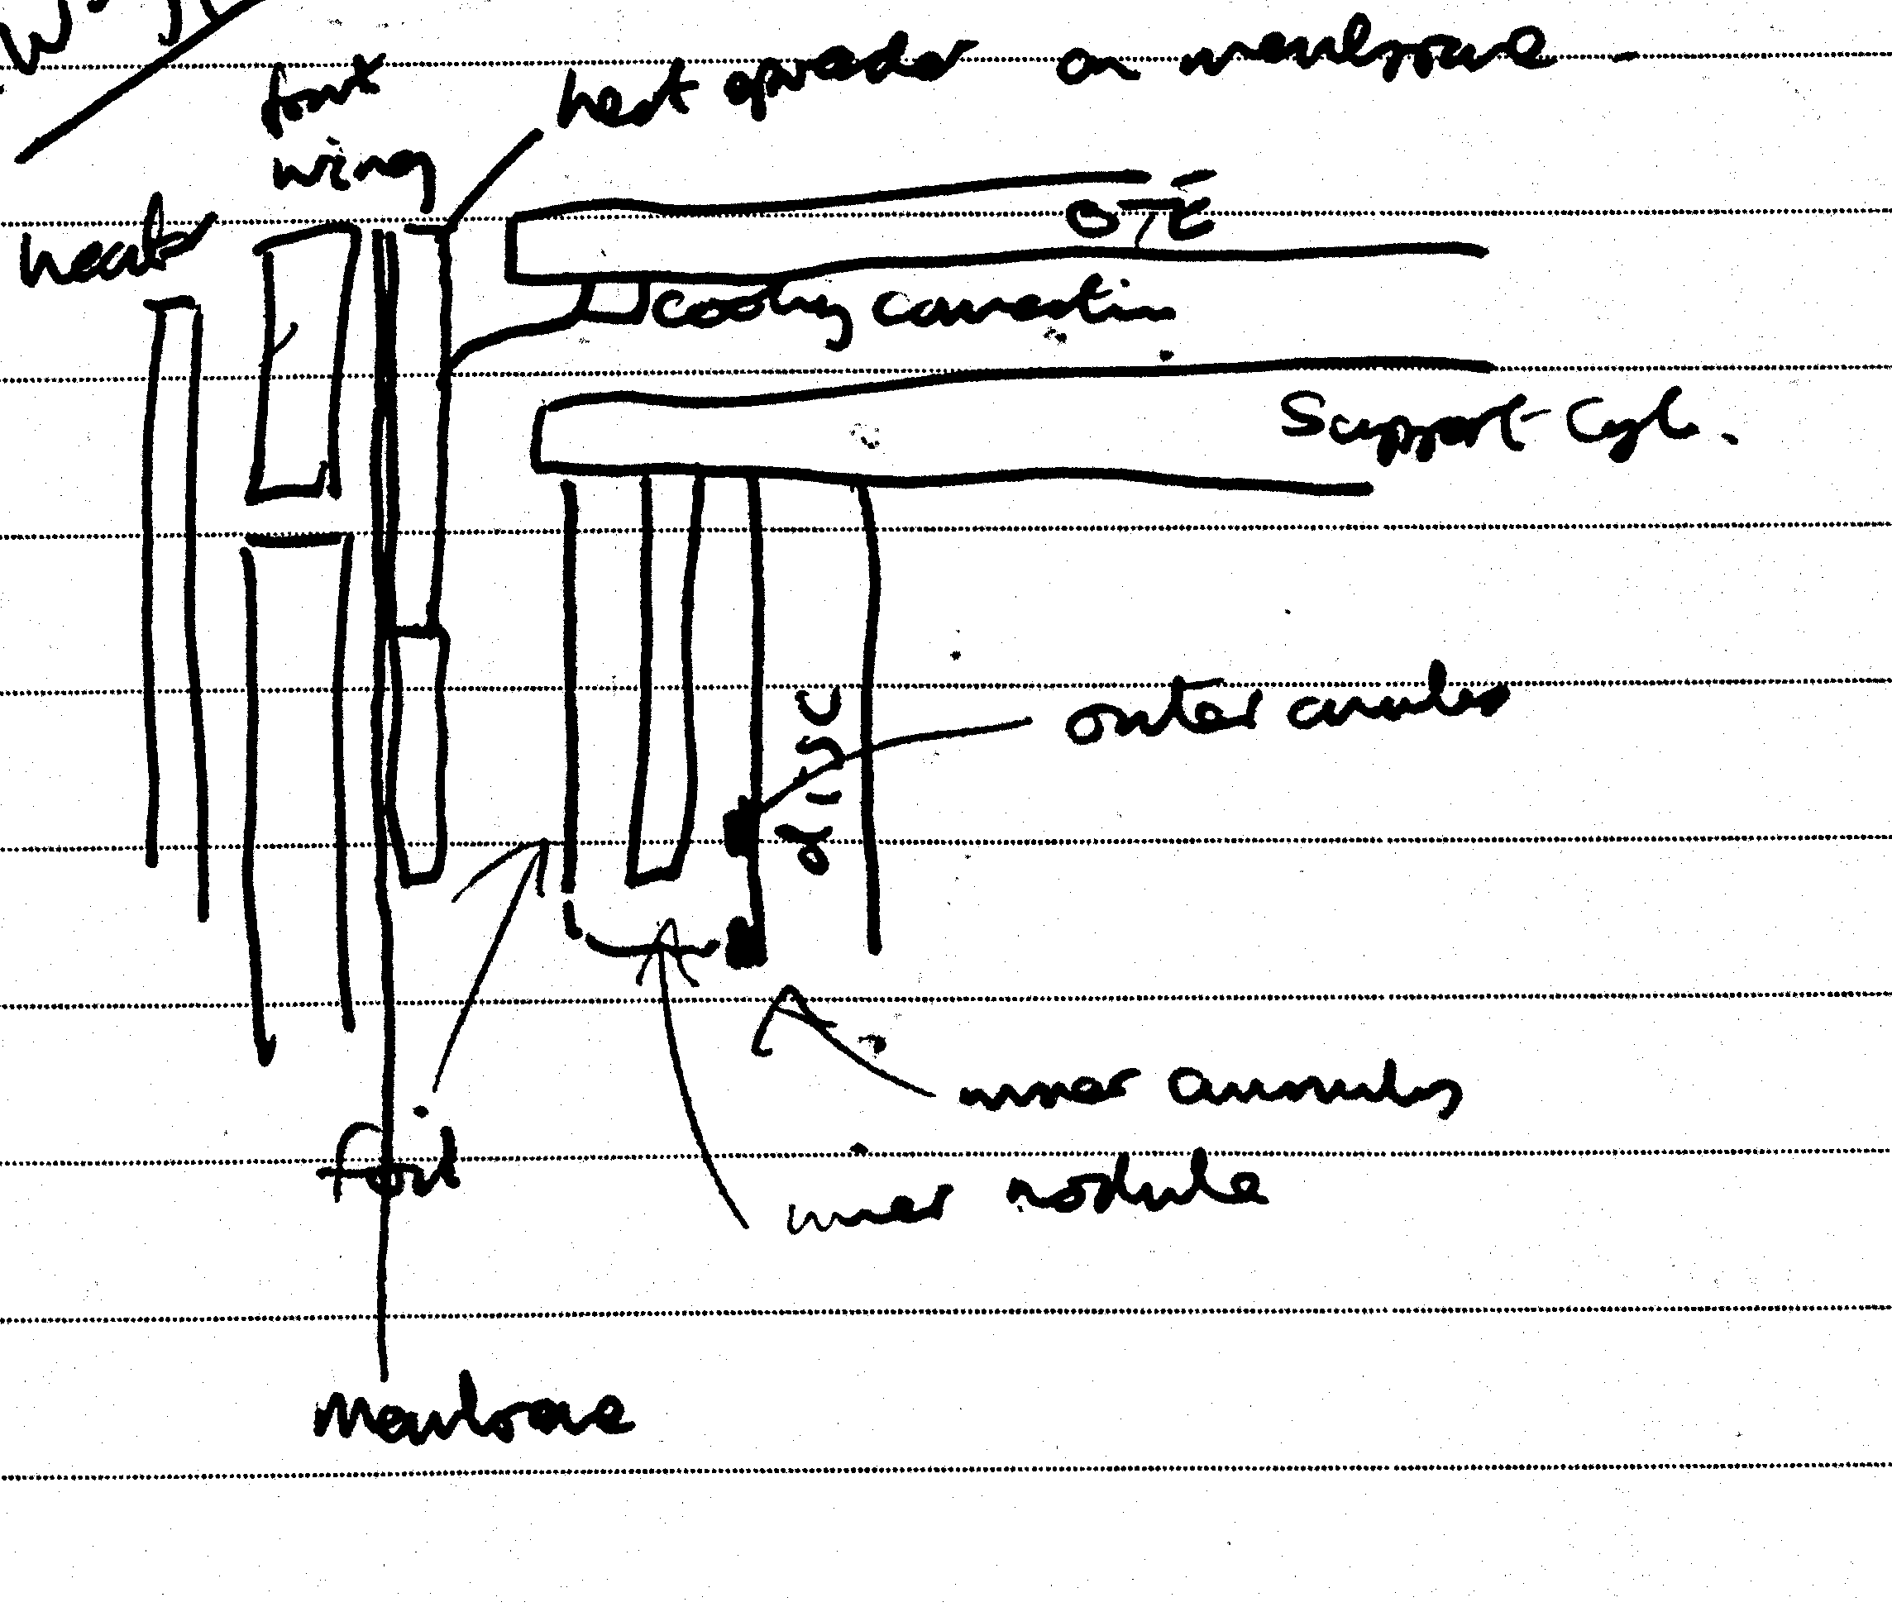

Connection of Front Wing to ITE
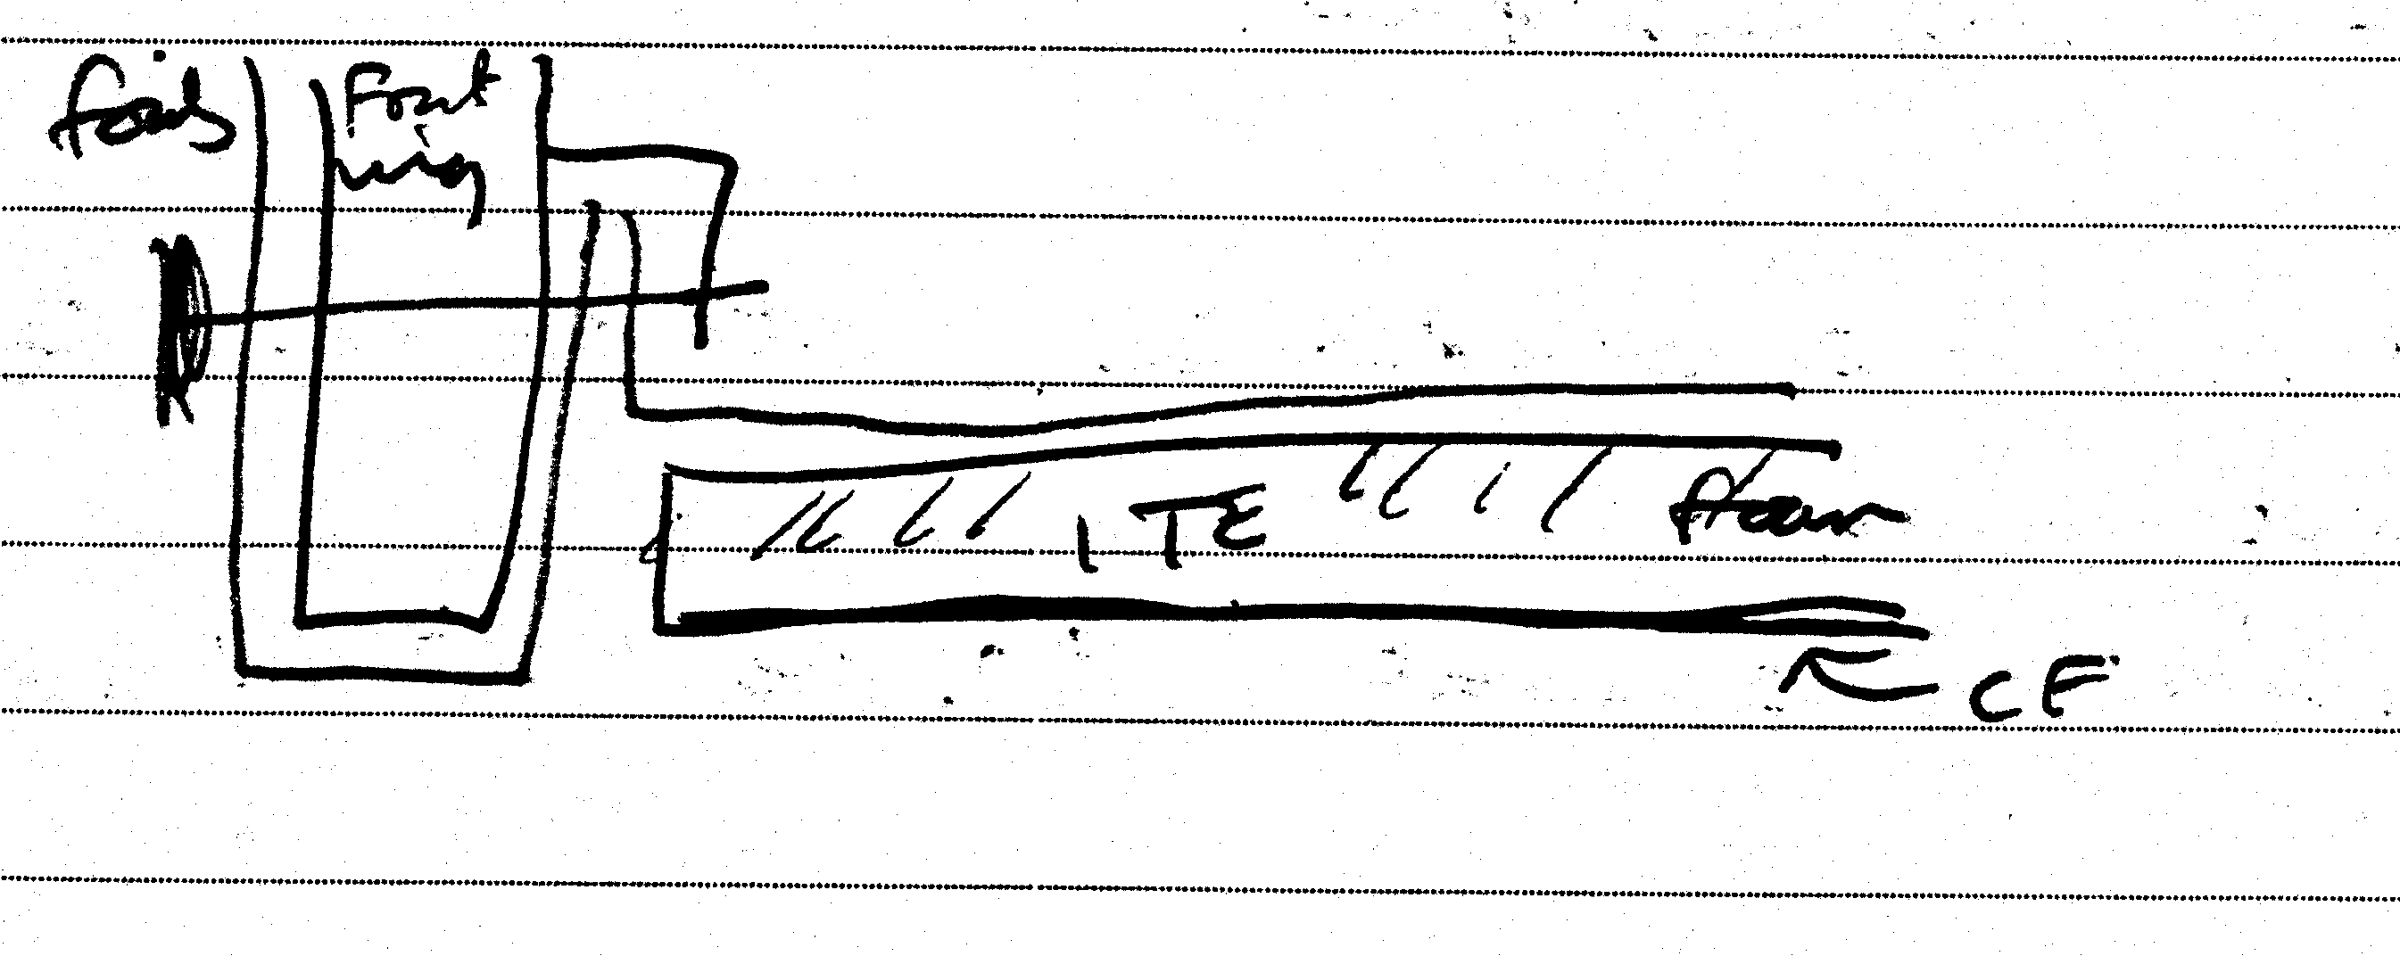

Tape Bundle on Support Cylinder
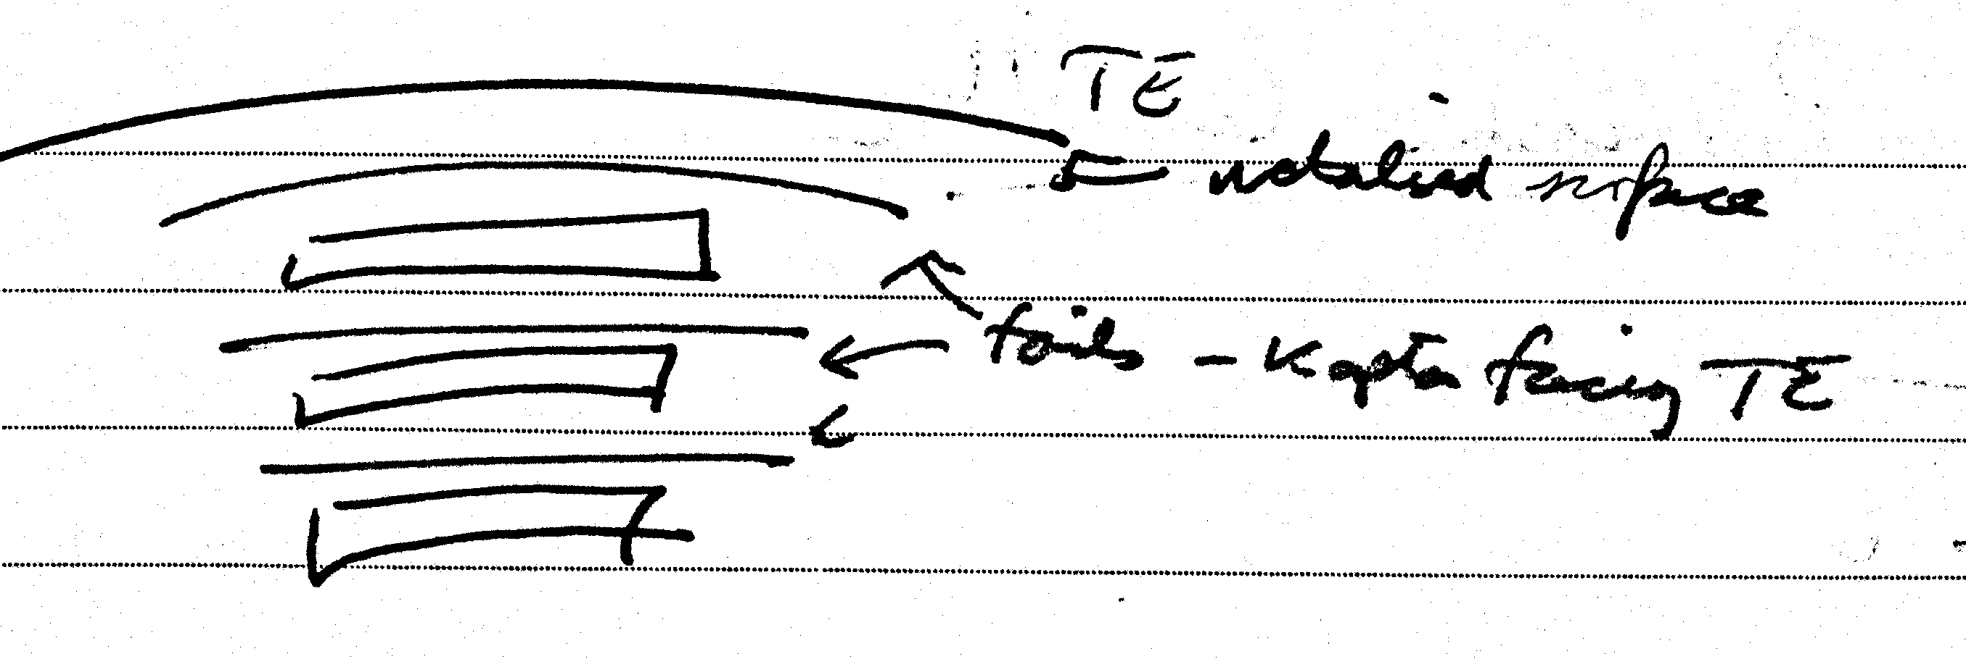

Tape Routing PPF0 to PPF1
