Report on work done during

PhD program at CERN

Boguslaw Gorski /PH

Work done for SCT and Pixel cooling system in ATLAS project:

1.1. Introduction 3
1.2. Components of the SCT & Pixel cooling system 6
1.3. The Data Acquisition System 8

Work done on PhD:

2.2. Calculations using a Finite Element software ANSYS® 11
2.3. Test stand. 12

1.1. Introduction

The II phase cooling system for the ATLAS ID should work for a ten-year operational lifetime in the high radiation field close to the LHC beams, the silicon substrates of the ATLAS SCT and pixel detectors must operate below -7°C with only short warm-up periods each year for maintenance. Around 60kW of heat will be removed through ~150 parallel cooling circuits.
All the SCT and Pixel detectors are placed around the collision point and beam pipe. It means that material must be resistant to the radiation and must produced minimum background of secondary particles. Fluid used in the cooling system must be non-corrosive, non-toxic, and non-flammable. Due to these requirements the evaporative cooling system has been chosen since it offers minimal extra material in the tracker volume compare to the mono-phase cooling system. A homogeneous fluorocarbon C₃ F₈ has been chosen as a refrigerant because it is: non-flammable, non-conductive, radiation resistant, and it evaporates with temperature -24ºC (require evaporating temp. to keep the silicon detectors below -7ºC) at 0.74 bars above the atmospheric pressure.
The idea of phase II cooling circuit is introduced in Fig.1. The cooling system is under development and a few tests remain to be performed. This is a fixed flow system. The mass flow is set at the beginning of the operation, and possibly readjusted from time to time during the lifetime of the detector as function of the increasing power dissipation of the electronics, by a pressure regulator (fig.1). The evaporating temperature is set and control by a back pressure regulator.
The cooling set-up to check the operational characteristic of the cooling system components has been installed at CERN. The scheme of the cooling test stand, shown in Fig.2, consists of: two compressors, condenser, pump, set-up to control the inlet pressure of the liquid and its vaporization pressure, mockup of the cooling channel and heat exchanger. Several designs of heat exchangers and heaters for the cooling system have been tested.
During my stay at CERN I’m involved in research activities of the team working on the ATLAS experiment phase II cooling system. I’m responsible for designing and manufacturing the test cooling circuits, sensors equipment and data acquisition system. The tests of the components for ATLAS ID and the fundamental research for my PhD are being performed on the same test stand in parallel.

Mass flow and evaporating pressure control:

Fig.1. Scheme of the cooling circuit, mass flow rate and pressure control

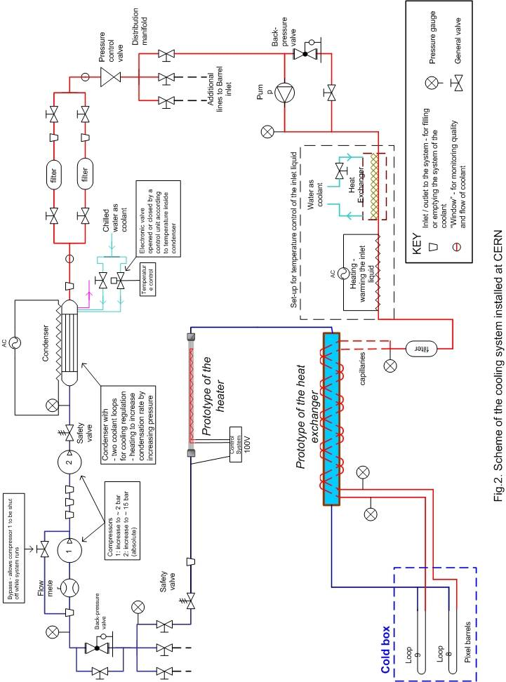

1.2. Components of the SCT & Pixel cooling system

Goals of the tests preformed at CERN were:
- to check the operational characteristic of the heat exchanger (HEX), and the heater (H),
- to determine design parameters for the HEX, and H, and to size the capillaries for SCT and Pixel cooling system (Fig.2).
- to test functionality of the temperatures and pressures control system.
The test stand was many times modified and lots of measurements were done in the last two years.
The first prototypes of heat exchangers and heaters were tested and results have been presented in the FDR in May 2003. All the prototypes that were tested are presented in Table 1. The tests were continued until September 2003. Results from these measurements were used to design the final prototype of the heaters for the SCT and Pixel detectors cooling loops. The next steps to determine the capillaries and heat exchangers were specified. To understand the complex process of pressure drop in the capillary a new test stand was build. The pressure drop along a capillary in two-phase flow is not featured correctly by any mathematical correlation. The test stand, (fig 3), to performance capillaries test was designed and prepared at CERN. Results of measurements were used to predict the length and diameter of the capillaries to choose correct parameters of the capillary used in the cooling circuits for different types of SCT and Pixel detectors.
The heater in the cooling circuit is used to superheat the return vapor above the due point in the cooling loops. The control system and several heater prototypes were tested. Results were presented at the ATLAS ID engineering meetings in the last months.
Table.1. Tested components of the cooling circuit.
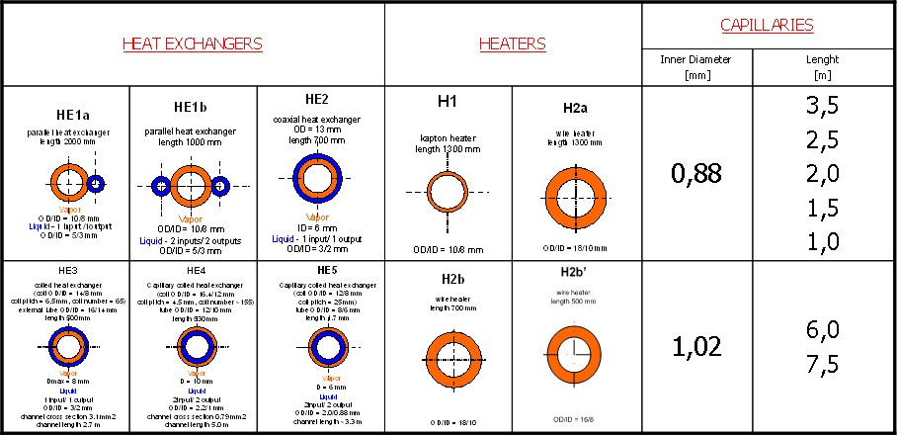

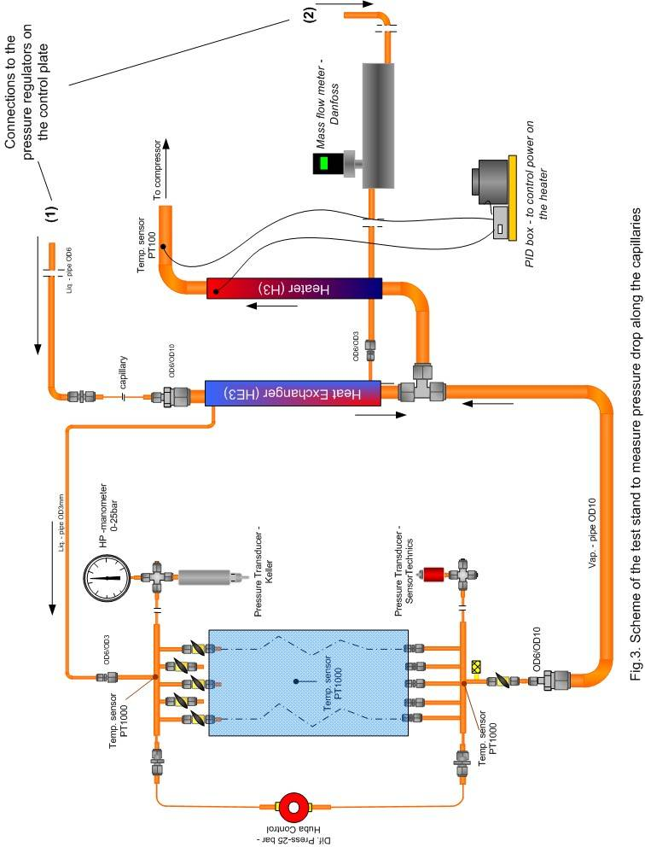

1.3. The Data Acquisition System

There are a lot of temperature and pressure sensors installed on the cooling circuit test stand. The data acquisition was built based on ELMB cards. There are 4 ELMB cards used to collect and transfer data from sensors to a computer. The data are monitored and recorded with PVSS software. The main part of the DAQ System was written by Sergey Basiladze. The monitoring part of his project is modified every time a new prototype component of the cooling system component is tested.
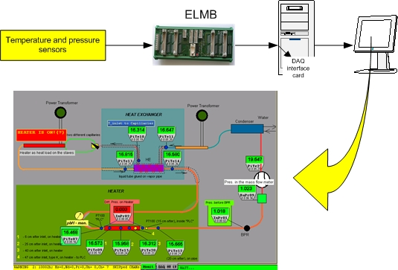
Fig. 7. The DAQ System on the cooling test stand
All data are collected, analyzed and after presented at the engineering’s meetings.
The major documents with results are introduced on the web pages:
No. | Subject | web page / no. of document
1. | Cooling system installed in the Bld.175 | http://bgorski2.home.cern.ch/bgorski2/CERN_badania/default_cool.htm
2. | First SCT cooling layers tests
3. | First Pixel cooling loops tests
4. | Kapton heater test
5. | Coaxial heater test
6. | ID two-phase cooling system - FDR
7. | The capillary tests
8. | DIMECA heater 500W – final prototype
9. | DIMECA heater 800W – final prototype
10. | Pixel heat exchanger tests | ATLI-IC-ER-0002
2.1. Bibliography review

Tens of papers, articles and others were gathered in the bibliography (appendix 1). The theme of all of them is connected with the thesis of my PhD tract – two-phase heat transfer with small diameter channels. The investigations and mathematical description of the boiling process in the small diameter channels have been started and is continuing because of fast developing of the compact heat exchangers. Good knowledge of that process makes possible to optimization designing of condensers and evaporators. Investigations were based on calculation of local heat transfer coefficient. The local heat transfer coefficient is a cooling efficiency criterion. To find the limits of local and global system for proper functionality and regulations of the cooling systems is very important also.
The stability of the boiling process along the small diameter channels is defined by the geometry, surface quality, numbers and layout of the channels, properties of the coolant, mass flow, heat load, vapor quality, pressures. There are a lot of factors that impact upon the stability of boiling inside a small diameter channel. There are many investigations done for very narrow range of channel diameters, pressures and mass flow rate. Some of them are done for round channels but with different coolant and working conditions compare to my PhD thesis. The heat load is distributed evenly with circumference and along the length of models [1-30]. In case of the ATLAS detectors the heat load is provided by a special connector from the electronics and the silicon detectors but never is coming to the cooling channel evenly with circumference. Also the heat load is not provided evenly along the length of a cooling channel but locally in the several places (fig.7, 8). The two-phase flow with cooling pipes for the ATLAS SCT & Pixel detectors is a special case of heat exchange. The idea of the cooling system for ATLAS SCT & Pixel detector is presented in Fig.1.
Some of the articles apply to the horizontal cooling systems with single- and multi- channels [23, 24, 25, and 26]. The boiling flow along vertical cooling channels is described in the references no.: 27, 52, 28, and 13. The inner diameters of tested channels contain values from 1.39 mm [28] to 10.7 mm [7] and length from 0.5m [28] to 3.5m [10]. The scope of all investigations on boiling with small diameter channels is presented in the table1.

Table1. The scope on boiling with small diameter channels.
No | No. of  reference | fluid | Evaporation pressure/temp. | Heat flux | Mass flux density | Channel geometry
 |  |  | Bar /ºC | kW/m² | kg/(m²s) | mm
1 | 17 | R113 | 1.3 ÷4.1/  55÷97 | 14÷380 | 125÷725 | Circular profile – 3.1
2 | 18 | R113 | 1.24÷1.6/  54÷62 | 8.8÷90.75 | 50÷300 | Circular profile – 2.92
3 | 22 | R113 | 1.38/  56 | 20÷2560 | 19÷95 ml/min | Circular profile – 2.54, 0.51
4 | 4 | R12 | 5.1÷8.2/  16÷34 | 3.6÷129 | 44÷832 | Circular profile– 2.46  Rectangular profile – 1.7x4.06
5 | 3 | R141b | 0.98/  31 | 9.7÷90 | 188÷1480 | Circular profile – 1.39, 3.69
6 | 19 | R134a | 3.48÷7.67/  5÷29 | 5÷20 | 50÷200 | Circular profile– 2.0
7 | 20 | R134a | 4.13/  10 | 0÷3.4 | 9.375÷750 | Square profile – 0.8x0.8
8 | 21 | R141b | 1.35÷2.2/  40÷56 | 18÷72 | 510 | Circular profile– 1.0
9 | 11 | R22 | 5.3, 6.2/  2 , 7 | 5-20 | 50÷700 | Circular profile – 6.5
10 | 44 | NH₃ | 0.72÷4.98/  -40 ÷ 4 | 17÷75 | 50÷150 | Circular profile– 10.0
11 | 14 | R22/R407C | 6/  5.9 | 6÷14 | 100÷300 | Circular profile – 9.52
12 | 6 | R134a | 3.6/  6 | 2.2÷56 | 163÷408 | Circular profile – 10.7

The boiling process is described by different mathematical correlations depend on the type of coolant, mass flow rate and the heat load. Mostly the Weismann’s, Fyodorov’s, Winterton’s criterions are used. The goal of these measurements is to find right factors to describe properly two-phase flow of C₃F₈ in small diameter horizontal pipe.

2.2. Calculations using the Finite Element software - ANSYS®

The temperature distribution in cross section of the cooling channels was objective of the first calculations done using the finite element software - ANSYS®6.1. The model used in these calculations is introduced in the Fig.4. Scope of estimations covered changes of different geometry of cooling channels (such as inner diameter and wall thickness), materials, heat load and heat transfer coefficient is presented in the table 2 (appendix I). Based on these results the geometry of the channel has been chosen to get a measurable wall temperature distribution.
The goal of my PhD thesis is to find the right factors for one of the criterion which can describe the C₃F₈ two–phase flow in small diameter horizontal pipe, define the local and global heat transfer coefficient and determine the best working conditions for the cooling system of the detectors.
Fig.4. Geometry of model analyzed in ANSYS ®

2.3. Test stand.
The cooling system used to test the heat exchangers and heaters is used also to make measurements on the PhD’s mockups. The test stand with important measuring points is introduced in Fig.6. The last prototype of the heat exchanger for SCT EC is being tested now (fig.7 appendix I). The measurements of the PhD project were started in parallel. To control the inlet conditions of the coolant to the mockup a simple software “badania_wstepne” (fig.5) is used. It is a short processing program based on the properties of C₃F₈ to calculate the inlet enthalpy and vapor quality at the inlet to heater (H1) after a capillary. There is a small heater installed before the model. According to pressure and temperature of liquid incoming into that heater it is possible to know and control by the heater the incoming conditions of the coolant to the mockup. The outlet boundary conditions are set by a back pressure regulator and heat load emitted on the mockup.
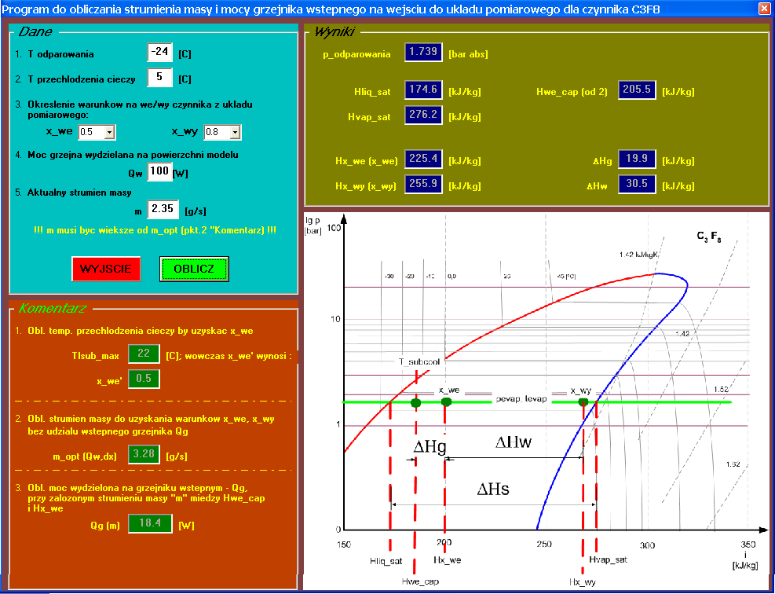
Fig.5. “Badania_wstepne” program
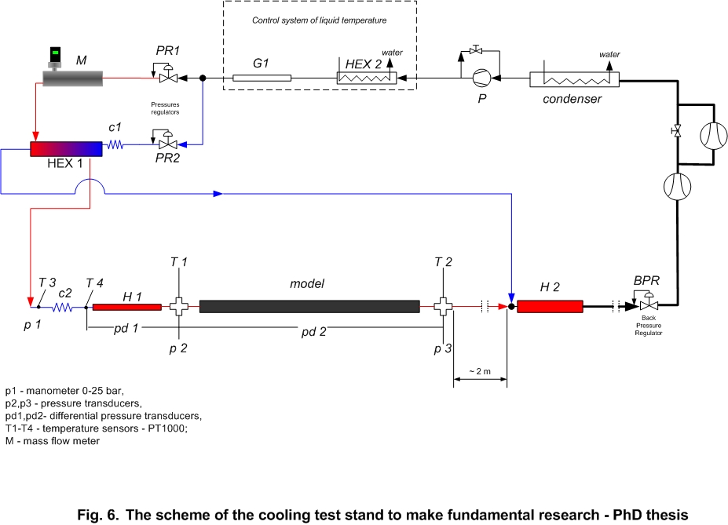
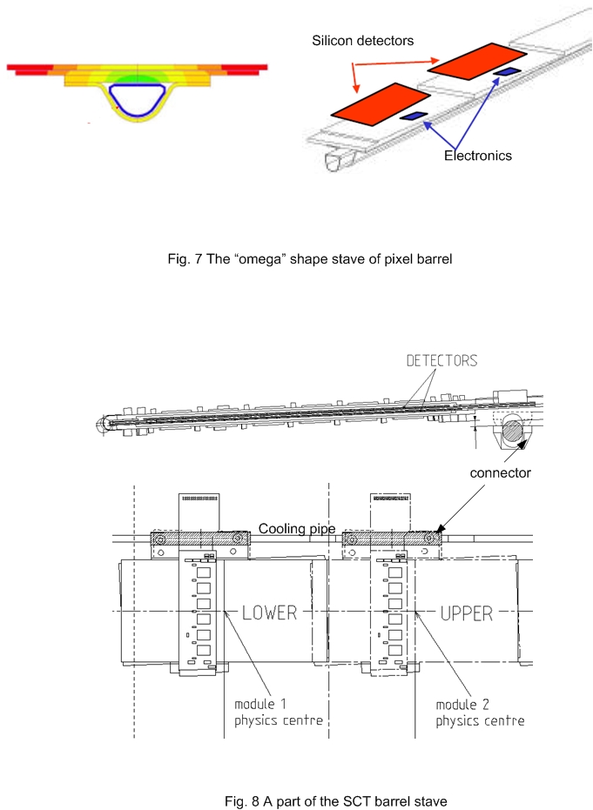

People and documents: http://st-support-cooling-electronics.web.cern.ch/st-support-cooling-electronics/CoolingSystemWeb/ATLASphII/AtlasPh2.htm

