Operation procedures for the cooling system in bldg. 175 laboratory:

The testing cooling system installed in Bldg. 175 consists of several main parts: two compressors, condenser, set-up for controlling the inlet temperature of the liquid in the heat exchanger, heat exchanger, capillaries, cold box with installed staves with heaters and the heater which should assure vapor at compressor inlet.
The file with the scheme of whole circuit is attached (CS_Cern28_08.vsd).

Switching-on the circuit:
Prior to switching on the circuit, the cold-box must be in operation and stabilized at about –12 C – this can take a few hours. See Cold-box operation, page 4.

- Check the level of the coolant in the condenser. It must be above the red line, else vapor could go inside the circuit from condenser.
- If there is atmospheric or lower pressure in the circuit, the whole system should be vacuumed with vacuum pump. See procedure for evacuating the circuit, page 4.
- Allow the temperature in the condenser to increase from normal room temperature to approximately 40 – 45 C by setting the Set temp. on the condenser control unit to ~ 44 C (Fig. 2 – press the second button from the left 2 times and then set temperature by arrows on the right – by pressing the arrow and the fast button together, setting will be quicker), closing the bypass valve (3) and plugging in the heater (10). Temperature is controlled by the blue valve (2), which controls the amount of the chilled water cooling the condenser (the valve at the wall of the laboratory should be a little opened (black tube) – do not change its setting).
- The cooling water, which goes to the set-up for temperature control (heat exchanger for liquid before the pump) should be opened at the maximum (white tube on the wall – should be opened always, even when system is shut down).
- Check that the black backpressure regulator (11) on the pump bypass is open.

- Wait until there is pressure higher than 9 bars in the condenser.
- Close the silver bypass valve (4) near the mass flow meter. (All coolant should go through backpressure valve.)
- Open the grey valves (5) before and after the filter on the right-hand line.
- All three valves switching the manometer, which serves to measure pressure drops along the “main” heat exchanger should be closed. (Note: these valves should be opened only for a short period during the measurement because there is a small leak in the manometer).
- Open the valve “condenser output” (7)
- Open big black valve “compressor inlet” (8)
- Switch on the RIGHT compressor (piston).
- Switch on the LEFT compressor (membrane).
- Switch on the heater (9) after the heat exchanger on the vapor side (adjuster should be set approximately at 200 ohms and the control PID unit set to approx. 26 C)
- Start the PVSS II. Program (proj_bob … SCT_cooling … Pipe Sens).
- Switch off the heater (10) on the condenser after the temperature on the staves become constant (app. –20C).
- The liquid pump can increase the pressure in the liquid part of the circuit by 3 to 7 bars. To switch on the pump, first make sure the black backpressure regulator (11) on the pump bypass is open. In this case, the pump increases the pressure by 3 bars. Switch on the pump by the switch on the wall near the water valves mentioned above. To raise the pressure further (up to by 7 bars), gradually close the black backpressure regulator.
- Allow some time for the circuit to stabilize, and check in PVSS the temperature profile along the staves. Once the temperature is stable, you can switch on the heaters at the staves (12).
- If it is necessary to increase the temperature of the liquid at the inlet to the heat exchanger (should be around 40 C – see PVSS), switch on the heater (13) at

temperature control set-up (Fig. 4) (adjuster should be set between 80 and 100 ohms and must be plugged in. When not in use, it must be unplugged from electricity, as setting it to 0 does not turn it off completely).

Shutdown of the circuit:

- Switch off the power at the staves (12).
- Open the black backpressure regulator on the liquid pump bypass (11).
- Switch off the pump.
- Switch off and disconnect from electricity the heater (13) at liquid inlet of the heat exchanger (smaller adjuster).
- Close the grey valve (5) after the filter and shortly afterwards the “condenser output” valve (7).
- Open the silver bypass valve (4).
- Set the temperature in the condenser to approx. 25 C and open fully the water bypass valve (3).
- Switch off the heater (9) after the heat exchanger (larger adjuster).
- Wait until the pressure in the circuit decreases and refrigerant returns to the condenser and condenses (see liquid level in condenser window).
Note: If you want to run the circuit again after a short while, leave the pressure in the circuit at approx. 2.5 bars – check left manometer on the compressor-condenser unit rack.
- Switch off the RIGHT and then the LEFT compressor, and close the black “compressor inlet” valve (8).
Note: This procedure, when both compressors are running during the shutdown, leads to a rapid drop in pressure in the staves, and consequently exposes the structure to a large thermal shock (temperatures may drop bellow –50 C).
A possible prevention of this occurrence can be done by shutting down the left compressor (membrane / compressor 1 on diagram) and immediately afterwards opening the bypass around it.

Cold box operation:

- Cooling unit of the cold-box is switched on with the red button (14).
- The set-temperature of the cold box control unit may be changed and saved by pressing both buttons at digital thermometer.
- The cold-box inner fan should be plugged in (15) (the white connector).
- The pressure difference between outer barometric pressure and inner pressure should be less than 4 at “inches water gauge” (16). If it is more, the cooling unit of the box and the inner fan must be switched off and the defrost heater (black connecter) (15) should be plugged in. After half an hour the defrost water should be removed by shaking the transparent tube going from the cooling system under the cold box. After this the cold-box system can be switched on again by unplugging the defrost heater and repeating the above steps.

Procedure for evacuating the system:
Evacuation of the circuit must be done before the opening of the circuit (disconnecting some parts) or before starting the system after a long period without operation.
Prior to this procedure, as much of the coolant as possible must be drawn into the condenser and the system must be shut down. If doing this within a short period of the last operation of the system, and/or if the pressure in the circuit is higher than atmospheric (i.e.: in either case, the system pressure must be higher than atmospheric to guarantee there was no contamination), the circuit compressors can be used to do this as follows:
- All valves should be in their system-shut-off position, namely the “condenser output” valve (7) should be closed, and the silver bypass valve (4) and the black backpressure valve on the pump bypass (11) should be open.

- Set the temperature of the condenser control unit to the room temperature or to approx. 25 C, whichever is lower, and open fully the water bypass valve (3) if not already opened.
- Open the black “compressor inlet” valve (8) and immediately afterwards, switch on first the right and then the left compressor.
- Let the system run for several minutes so that the pressure decreases well bellow atmospheric pressure throughout the system – in theory, 0.3 bar (-0.7 on the relative pressure gauges) should be attainable. This can take even half an hour.
- Close the black “compressor inlet” valve (8) and immediately afterwards, switch off first the right and then the left compressor.

- Make sure all valves are in their system-shut-off position, namely the “condenser output” valve (7) and the black “compressor inlet” valve (8) should be closed, and the black backpressure valve on the pump bypass (11) should be open.
- Connect the vacuum pump to electricity. Lift up the vacuum pump hose and set the yellow valve on the pump to the “open” position.
- Uncap the small filling valve (1) just before the “compressor inlet” valve (8), press the hose connection down onto it firmly, and screw the holding sleeve tightly. (This valve behaves like an automobile tire valve – it opens gradually as a connection is pressed onto it. To minimize the interface with the surrounding air, we recommend the above procedure – i.e. to press down the hose connection quickly and firmly, thereby minimizing the amount of air that could reach the circuit, and then with another hand, screwing tight the connection)
- Let the vacuum pump run for several minutes – at least 20 – allowing it to evacuate all possible air and moisture from the circuit. The pressure in the circuit should reach almost 0 bar.
- Disconnect the pump hose similarly as connecting it in step 3 – i.e. first press down on the hose connection firmly, with your other hand, unscrew the connecting sleeve quickly, and only then pull out the hose quickly. The pump should run throughout all of this.
- Recap the valve (1), set the vacuum pump valve to the “closed” position, and disconnect it from electricity.

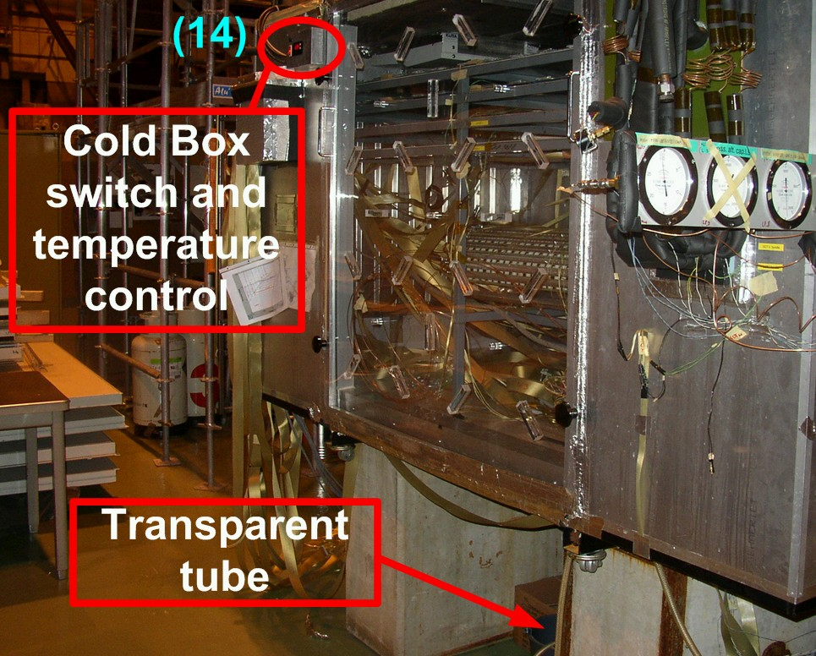
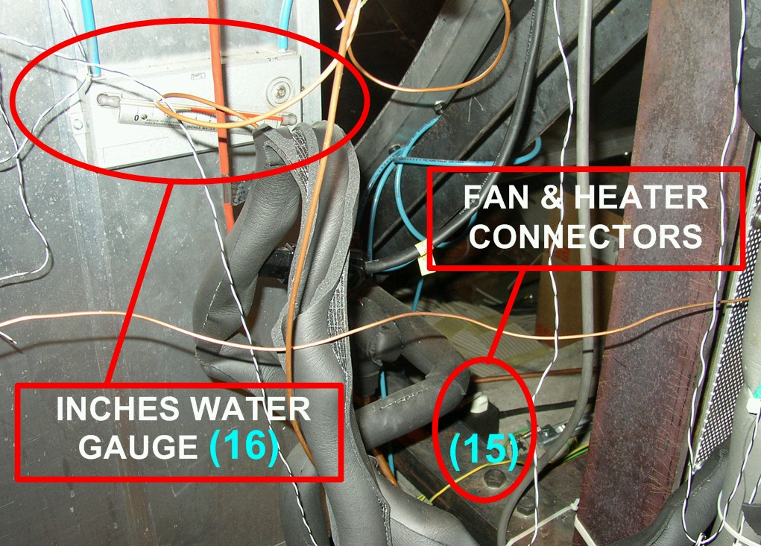

Fig. 1: Cold Box

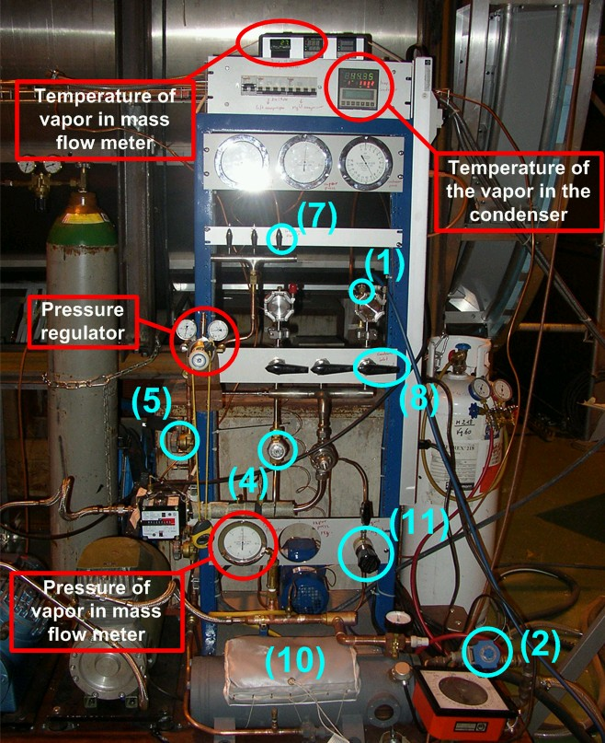

Fig. 2: Main controlling panel of the circuit

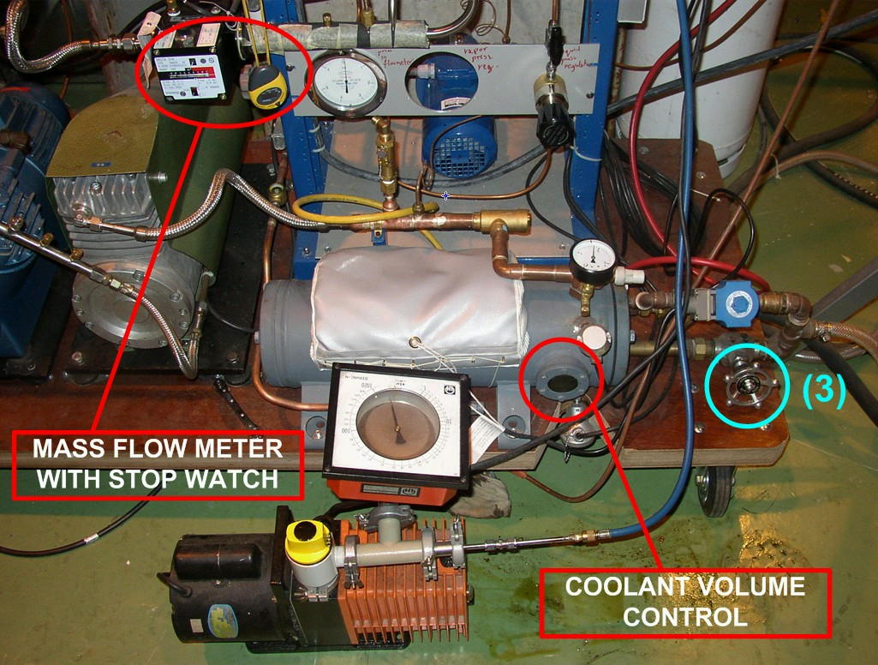

Fig. 3: Condenser and vacuum pump

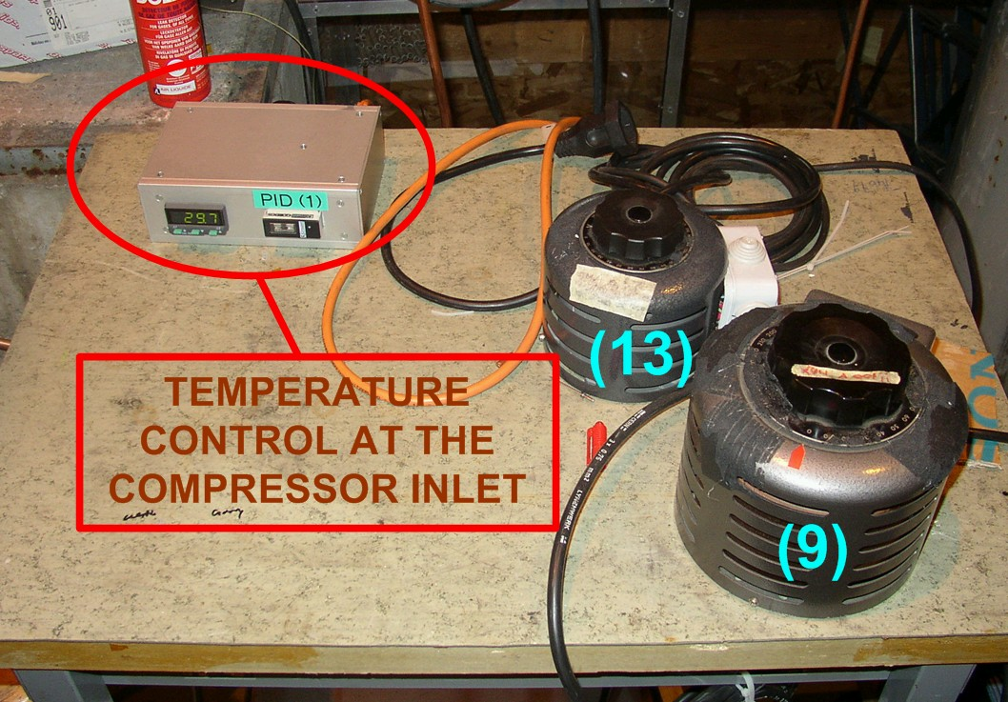

Fig. 4: Resistors for heaters regulation

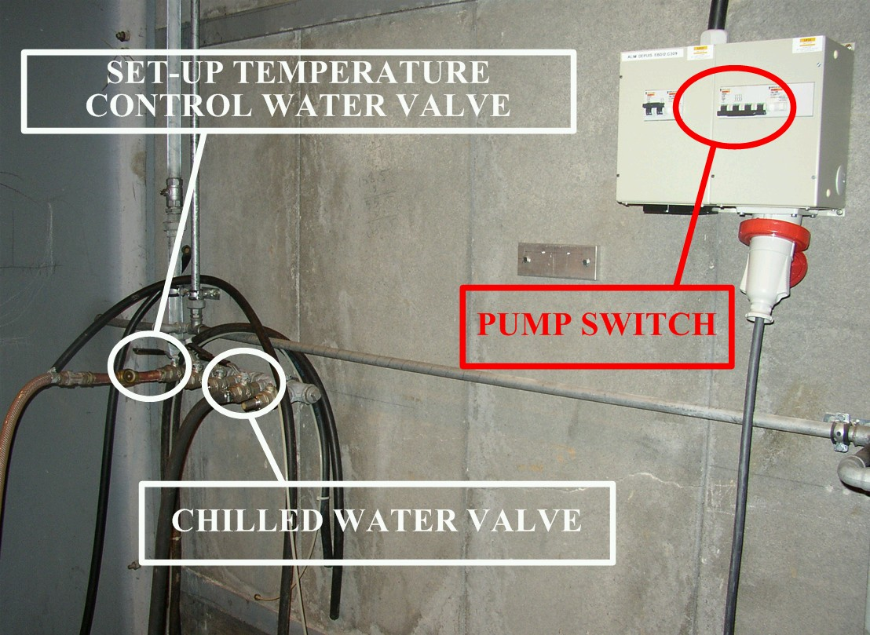

Fig. 5: Pump switch and valves on the wall of Bldg. 175

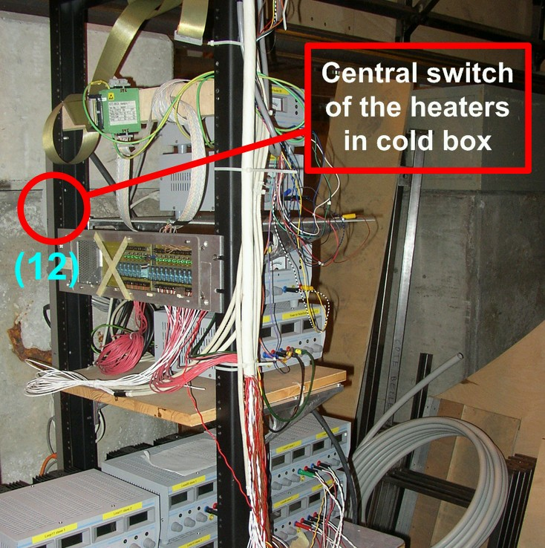

Fig. 6: Power suppliers for the heaters at the staves

