Endcap HEX measurements

This paper reports on the measurements performed on both the first prototype QM EC HEX, (QM-1) and the final CERN prototype EC HEX, (CERN). The CERN EC HEX was tested during July and August 2004, while the QM-1 was tested during February and March 2005. All measurements were made using the evaporative cooling system at CERN in building 175.
The Endcap HEX is a contra-flow HEX which consists of a straight outer pipe that contains a coiled inlet pipe. The inlet pipe coil is in intermit contact with the inside wall of the outer pipe and remains so via friction. The QM-1 and CERN HEXs differ slightly in detailed design. The CERN HEX inlet liquid pipe is a 3m long 2mm ID, (3mm OD), copper pipe coiled inside a 14mm ID, and 380mm long stainless steel vapour return tube. The free diameter inside the vapour return pipe is 8mm. The inlet liquid pipe leaves the outer pipe at 45º to the plane of the cross section of the outer pipe. The vapour tube reduces in ID to 4mm and remains in line with the HEX at both ends. The QM-1 HEX has a 2mm ID copper liquid inlet pipe but which is only 2764mm in length. The vapour return tube is a 14mm ID, and 361mm long 200micron thick straight copper nickel pipe. The liquid and vapour pipes leave both ends perpendicular to the cross section of the vapour pipe and run parallel with each other for 10 to 20cm; detailed drawings of the QM-1 EC HEX are available elsewhere.
The majority of the measurements with the CERN prototype were performed with the HEX in the horizontal plane. The effect of orientation was only studied at the end of the measurement period when the HEX was placed at ±45 degrees to the horizontal plane as will be the case in the final experiment. The QM-1 was only tested in the ±45deg orientations. The -45 deg geometry is shown in figure 1. This arrangement is such that the vapour inlet from the detector structures is lower than the liquid inlet to the HEX.
Figure 1: -45deg geometry of HEX.
Vapour in
45
x
z
-45 deg geometry
The Endcap HEX was tested in conjunction with pipe work that simulated the final on-cylinder pipe work for Disk 1, which is furthest from the HEX. Therefore this has the longest pipe run and as a result the largest pressure drops on the vapour return line. For the CERN prototype copper nickel capillaries of 0.65 and 0.75mm ID were used and operated with an inlet liquid pressure between 12.5 and 14bara. The QM-1 HEX was measured with production copper nickel capillaries, (ID 0.68 and 0.76mm), which were cut to length to deliver the required massflow for an inlet liquid pressure of 13bara. Both EC HEXs were tested with a single heater which represented the detector structure heat load. All three, (or two), capillaries were connected to the same heater and the massflow through the system was only know as a sum of that through the three capillaries.
Pressure drops over the inlet liquid line inside the HEX (including the filter for the QM-1 HEX), the on-cylinder vapour return line and the vapour return pipe of the HEX were performed. For the CERN prototype the pressure drops over the inlet liquid line before the HEX and the vapour line after the final heater were also measured to enable an estimate of the pressure drops over the complete system to be obtained.
Figure 2 illustrates the experimental set-up and table 1 details the pressures and temperatures measured in the experiments. Difference in the CERN and QM-1 measured quantities are noted were appropriate.

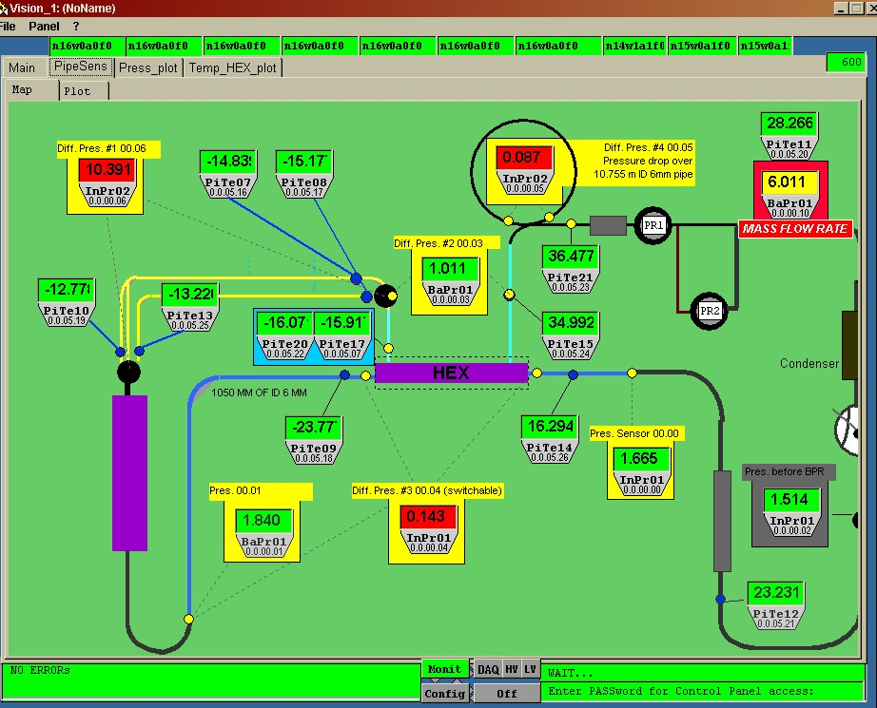
Figure 2: layout of the EC HEX

Table 1: measured quantities
Temperatures |  | Pressures
TlbHEX | Temp. of liquid before HEX inlet | PlbCap | Press. Of liquid before capillary
TlaHEX | Temp. of liquid after HEX | PlaCap | Press. of liquid after capillary
TlbCap0 | Temp. of liquid at the start of capillary 0 | ΔPCap | Press. Difference across capillary
TlbCap1 | Temp. of liquid at the start of capillary 1 | PlbHEX | Press. Of liquid before HEX
TlaCap0 | Temp. of liquid after capillary 0 | PvbHEX | Press. of vapour before HEX
TlaCap1 | Temp. of liquid after capillary 1 | PvaHEX | Press. of vapour after HEX
TvbHEX | Temp. of vapour before heat exchanger | ΔPvHEX | Press. Difference across HEX vapour side (QM-1 includes 90deg elbow)
TvaHEX | Temp. of vapour after heat exchanger | ΔPlHEX | Press. Difference across HEX liquid side (QM-1 includes filter)
TvaH | Temp. of vapour 20cm after the final heater | ΔPvCylinder | Press. Difference across on cylinder pipe work
TinFM | Temp. of vapour in volume flow meter | ΔPlInletPipe | Press. Difference across inlet liquid pipe before HEX (CERN only)
 |  | ΔPvAfterHeater | Press. Difference across vapour pipe after final heater (CERN only)
 |  | PvbBPR | Press. of vapour before BPR
 |  | PinFM | Press. of vapour in volume flow meter

CERN HEX results

The first set of measurements performed aimed to obtain a minimum stable operating massflow through the system with 100% of the nominal power load (346.5W). At this massflow the increase in massflow observed by reducing the temperature of the liquid before the HEX to 20ºC and turning the detector power off was noted. This gave the maximum and minimum massflows in the system. The pressure drops across the system were recorded for all operating conditions to confirm that they were below the limits imposed by the final apparatus. Any changes in the operating conditions of the EC HEX due to changing the physical orientation of the HEX were observed. Finally one capillary was closed and the detector power reduced to 241.5W, to simulate Disks with only 2 cooling loops, and the operating conditions of the system were studied.

Minimum massflow possible as a function of TlbHEX with 100% detector power

Figure 3 shows the minimum stable massflow with 100% detector power that the system could run at as a function of the liquid temperature before the HEX. Originally the nominal massflow of the system was defined as 5.3g/s but for an inlet liquid temperature before the CERN HEX of 35C a massflow of 5.7g/s was required to maintain stable operation of the system. As it was not possible to increase the efficiency of the EC HEX with the present design, (inlet liquid line coiled inside an outer vapour return tube), without changing the physical size the baseline massflow was changed to 5.7g/s. Table 2 shows the operating conditions of the CERN EC HEX with an inlet liquid temperature of 35ºC and 100% detector power

Table 2: Operating conditions of the CERN EC HEX with 100% power and TlbHEX = 35ºC and for 0% power and TlbHEX = 20ºC
Quantity | Value for 100% power and TlbHEX = 35ºC | Value for 0% power and TlbHEX = 20ºC
Massflow (g/s) | 5.7 | 5.74
Detector power (% of 346.5W) | 100.9 | 0
TlbHEX (ºC) | 34.8 | 20.5
PlbCap (bara) | 13.25 | 13.5
ΔPCap (bar) | 11.68 | 11.97
PlaCap (bara) | 1.72 | 1.62
TlbCap0 (ºC) | -10.3 | -21.9
TlbCap1 (ºC) | -11.6 | -23.5
TlaCap0 (ºC) | -9.6 | -20.5
TlaCap1 (ºC) | -10.1 | -21.1
Average TlbCap (ºC) | -11.0 | -22.7
Average TlaCap (ºC) | -9.9 | -20.8
TlaHEX (ºC) | -12.8 | -25.6
TvbHEX (ºC) | -25.9 | -27.4
TvaHEX (ºC) | 16.5 | -25.7
HEX efficiency | 0.8 | 1.0
ΔPvHEX (mbar) | 56 | 22
ΔPlHEX (bar) | 0.886 | 1.20
ΔPvCylinder (mbar) | 86 | 28
ΔPlInletPipe (mbar) | 85 | 89
ΔPvAfterHeater (mbar) | 105 | 112
Vapour Quality after capillary, Xi | 0.17 | 0.07
Vapour Quality before HEX, Xu | 0.76 | 0.07

The massflow with 100% detector power and TlbHEX =35ºC was 5.7g/s. Turning off the detector power and reducing the liquid temperature before the HEX to 20ºC resulted in an increased HEX efficiency and therefore a reduced liquid temperature after the capillary. This in turn increases the massflow through the system. The massflow increased to 5.74g/s, which is only a 0.7% increase. The operating condition of the HEX in this situation is also given in table 2.

Stability tests: Increasing power from 0% to 100% and long term tests.

The stability of the system was confirmed by suddenly turning the detector power on from 0% power. The system was started with TlbHEX = 35ºC and inlet and back pressures set so that with 100% power a massflow of 5.7g/s and an evaporation temperature -25ºC would be obtained. The detector power was increased to full power in less than 30seconds and the temperatures and pressures of the system were observed. Figure 4 illustrates the change in system temperatures for such a change in detector power. The system was stable after approximately 10 minutes to such a change in power.
The cooling loop was run at 100% with a massflow of 5.7g/s for over 2 hours to show that the system was stable.

Pressure drops over the system for a massflow of 5.7g/s

The pressure drops over the circuit are dived into two sections; the pressure drop over the high pressure liquid inlet line to the capillary input, and the pressure drop over the low pressure fluid side from the capillary to the back pressure regulator, (BPR). The pressure of the warm high pressure liquid must be at or above 13bara before the capillary to ensure that the liquid is above the saturation point. The outlet of the liquid pump in the cooling plant is 16bara which gives:
- A pressure drop budget in the inlet tubes from the PR to the capillary of 1bar
- A pressure drop across the PR and along the main tubes to the cooling plant of 1bar
- A liquid regulation range of plus 1bar
To obtain an estimate of the pressure drop from the capillary to the PR in the real system, the pressure drop across the coiled pipe work inside the HEX and the pressure drop across a 10.755m long 4mm ID pipe before the HEX were measured.
The pressure drop budget on the vapour side from the exit of the capillary to the BPR is 350mbar. This is obtained from the requirement of an evaporation temperature of -25ºC, (1.67bara), in the detector structures and a minimum pressure before the BPR of 1.3bara. The pressure drops across the on-cylinder pipe work (2-phase flow), the HEX vapour return pipe work, (2-phase flow), the short pipe between the HEX and the heater, (2-phase flow), and over a 6m long pipe of ID 8mm after the heater (1-phase flow) were measured as a function of massflow and detector power load to determine the pressure drop across the system.
Table 2 summarises the measured pressure drops across the system for 100% detector power. The pressure drops as a function of massflow and for different detector power loads are shown in figures 5 and 6 for the vapour sections of the system before the final heater. The maximum pressure drop over the HEX vapour side and for the on-cylinder pipe work is given at 100% detector power. The pressure drop over the liquid inlet pipe and vapour return pipe after the final heater is unaffected by the power on the detector structures and for the liquid side increases linearly with massflow.

Predicted pressure drops across the system.

From the measured pressure drops in the system a prediction of the required pipe work outside of the ID volume was made so that the total pressure drops in the system are within budget. These are given in table 3. The pressure drop on the high pressure liquid side is dominated by the pressure drop across the coiled liquid pipe inside the HEX. As a result the total pressure drop from the PR to the capillary is above the 1bar design value which implies a reduction in the available inlet liquid pressure regulation range.
The vapour side pressure drops were calculated estimating the pressure drop over the heater from the HEX. These are within the budget of 350mbar discussed above.

Table 3: Pressure drops in the EC SCT cooling system, calculated for a massflow of 5.7g/s.
From | To | Length (mm) | ID (mm) | Pressure drop (mbar)
Inlet
PP3 | PP2 | 25000 | 6 | 45.9
PP2 | PPF1 | 6000 | 4 | 55.8
PPF1 | Inlet of HEX | 800 | 3 | 23.5
HEX |  | 3000 | 2 | 1000
Total inlet side |  |  |  | 1125.2
Exhaust
PPF0 | Inlet of HEX | 2463 | 6&8 | 90
HEX |  | 380 | 8 | 60
Outlet of HEX | Inlet of Heater | 140 | 8 | 2.5
Heater |  | 390 | 8.7 | 43
Heater exhaust | PPF1 | 470 | 6 | 26.7
PPF1 | PP2 | 6000 | 10 | 44.2
PP2 | PP3 | 25000 | 14 | 48
Total return side |  |  |  | 314.5

Study of change in HEX orientation

The change in the performance of the CERN EC HEX was observed due to a change in the physical orientation of the HEX. In the final experiment the HEX will be closed packed into an area of the detector at +45 and -45 degrees to the horizontal. Therefore the HEX was tested in these two configurations. It should be noted that the capillaries in the system for these tests were different from those used for the 0deg orientation and therefore the drive pressure was different. The minimum massflow for stable operation was found for the ±45deg orientations and the results are shown in table 4. The efficiency and therefore the temperature of the liquid after the HEX changed depending on the HEX orientation. The -45degrees orientation had the higher efficiency, then 0degrees and finally +45degrees. For a given liquid pressure before a capillary the massflow through the capillary increases with reducing liquid temperature and therefore the massflow for the -45 degree orientation should be higher than the +45degree orientation, as is observed. The increase in massflow for a change in orientation from +45 to -45 degrees is only 0.08g/s or 1.5% which is due to the fact that the while the temperatures before the capillaries change they remain low.

Table 4: comparison of the operating conditions for different EC HEX orientations
Quantity | -45deg orientation | 0deg orientation | +45deg orientation
Massflow (g/s) | 5.5 | 5.7 | 5.42
Detector power (% of 346.5W) | 99.4 | 100.9 | 99.4
TlbHEX (ºC) | 34.3 | 34.8 | 35.4
PlbCap (bara) | 14.2 | 13.25 | 14.25
ΔPCap (bar) | 12.4 | 11.68 | 12.5
PlaCap (bara) | 1.74 | 1.72 | 1.73
TlbCap0 (ºC) | -13.4 | -10.3 | -5.5
TlbCap1 (ºC) | -13.7 | -11.6 | -5.7
TlaCap0 (ºC) | -12.8 | -9.6 | -5.0
TlaCap1 (ºC) | -13.2 | -10.1 | -5.0
Average TlbCap (ºC) | -13.6 | -11.0 | -5.6
Average TlaCap (ºC) | -13.0 | -9.9 | -5.0
TlaHEX (ºC) | -15.1 | -12.8 | -6.5
TvbHEX (ºC) | -24.9 | -25.9 | -25.2
TvaHEX (ºC) | 16.9 | 16.5 | 19.2
HEX efficiency | 0.83 | 0.80 | 0.69
ΔPvHEX (mbar) | 54 | 56 | 54
ΔPlHEX (bar) | 0.985 | 0.886 | 0.901
ΔPvCylinder (mbar) | 90 | 86 | 96
ΔPlInletPipe (mbar) | 90 | 85 | 84
ΔPvAfterHeater (mbar) | n/a | 105 | n/a
Vapour Quality after capillary, Xi | 0.13 | 0.17 | 0.22
Vapour Quality before HEX, Xu | 0.74 | 0.76 | 0.83

Effect of closing one capillary to simulate Disks with 2 cooling loops

Finally the HEX was studied when one capillary was closed and the full power reduced to 241.5W, to simulate Disks with only 2 cooling loops. The test was performed with the HEX in the +45deg orientation. The HEX was found not to be stable with a massflow reduced in proportion to the power load. That is running at 3.98g/s rather than 5.7g/s. The minimum massflow that allowed stable operation was 4.4g/s, which is 10% higher than the expected massflow. This massflow corresponds to that obtained from two larger ID capillaries instead of a large and small ID capillary. While this massflow will not cause any problems with pressure drops over the off-detector cooling circuit, as it is lower than 5.7g/s, it might have a detrimental effect on the pressure drop over the middle on-disk cooling loop which will now have 24% more massflow. The massflow through the outer cooling loop remains the same. The on-disk pressure drops have not been tested to date. Turning the power off to the detectors and reducing the TlbHEX to 20ºC resulted in only a 0.7% increase in massflow. It would be possible to run the system with a large and small ID capillary with an increased liquid inlet pressure to increase the massflow through each circuit by 10%. This experiment has to be performed and will be done so on the QM-1 HEX.

QM-1 HEX

Only the -45 and +45degree orientations were investigated for the QM-1 EC HEX. The HEX had an inlet liquid pipe length 8% less than the CERN EC HEX and therefore a slightly reduced efficiency. The performance of the HEX was studied for an inlet liquid temperature of 35ºC. The liquid inlet line had the prototype filter attached and the pressure drop over the HEX liquid line included the pressure drop over the filter. The pressure drop over the vapour side of the HEX included the 90degree bend in the exhaust pipe to the heater connection which was not included in the CERN prototype.
The +45degree orientation was studied first. The capillaries were trimmed to give the a massflow close to 5.7g/s, with an inlet liquid pressure before the capillaries of 13bara and a 100% detector power load. The HEX was not able to run stably with 100% detector power and a massflow of 5.7g/s with an inlet liquid temperature of 35ºC. Stable operation was achieved by reducing the power just slightly to 97.5%, and increasing the massflow slightly to 5.84g/s; the results are summarised in table 5. The 5.84g/s massflow is a 2.5% increase over the 5.7g/s baseline massflow. Changing the HEX to the -45deg orientation caused an increase in the liquid temperature after the capillary as observed for the CERN EC HEX. However, an increase in massflow was observed, which is not understood at present. A massflow reduction should occur as the liquid increases in temperature for the same inlet liquid pressure. The massflow increased to 5.99g/s which is a 2.5% increase over the +45deg orientation and a 5% increase over the 5.7g/s baseline massflow for the EC cooling system. Turing off the detector heat load and reducing the TlbHEX to 20ºC resulted in an increase in the massflow by further 3% to 6.16g/s, which is 8% above 5.7g/s. This was the largest massflow observed.
Table 5: summary of QM-1 HEX results
Quantity | +45deg orientation | -45deg orientation | -45deg orientation with 5.8g/s massflow
Massflow (g/s) | 5.84 | 5.99 | 5.8
Detector power (% of 346.5W) | 97.5 | 98.8 | 98
TlbHEX (ºC) | 34.6 | 34.71 | 34.98
PlbCap (bara) | 13.08 | 13.01 | 12.59
ΔPCap (bar) | 11.33 | 11.06 | 10.69
PlaCap (bara) | 1.73 | 1.74 | 1.7
TlbCap0 (ºC) | -8.1 | -4.5 | -4.4
TlbCap1 (ºC) | -9.3 | -4.7 | -4.5
TlaCap0 (ºC) | -7.8 | -3.9 | -3.7
TlaCap1 (ºC) | -8.2 | -4.1 | -4.3
Average TlbCap (ºC) | -8.7 | -4.6 | -4.5
Average TlaCap (ºC) | -8.0 | -4.0 | -4.0
TlaHEX (ºC) | -9.1 | -7.6 | -7.5
TvbHEX (ºC) | -24.6 | -14.6 | -15.1
TvaHEX (ºC) | 12.2 | 5.3 | 8.9
HEX efficiency | 0.75 | 0.72 | 0.72
ΔPvHEX (mbar) | 56 | 58 | 58
ΔPlHEX (bar) | 1.12 | 1.18 | 1.14
ΔPvCylinder (mbar) | 130 | 120 | 120
Vapour Quality after capillary, Xi | 0.18 | 0.12 | 0.13
Vapour Quality before HEX, Xu | 0.74 | 0.71 | 0.72

For the +45degree orientation it was possible to reduce the inlet liquid pressure, (to 12.6bara), to decrease the massflow to 5.8g/s while maintaining 100% detector power; results are shown in table 5. The reduced massflow had little effect on the liquid temperature after the HEX and therefore the efficiency of the HEX. However the vapour, (fluid), temperature after the HEX increased, as expected. The recorded pressure drops across the system were not significantly altered. If the inlet liquid temperature is kept at 35ºC, or below, then it will be possible to run the final system at a lower liquid inlet pressure than 13bara if required from evaporation temperature requirements.
The increase in massflow resulted in an increase in the pressure drops across the off-detector cooling system. The pressure drop across the HEX vapour line never gets above the 60mbar assumed for the pressure drop budget, (see table 3), but the on-cylinder pressure drop increased to 130mbar which is 40mbar above that assumed before. Assuming that the pressure drop across the heater is not significantly increased and those across the pipe work from PPF1 to the BPR are small the over all pressure drop from the capillary to the BPR will still be close to the 350mbar limit. The pressure drop over the HEX inlet liquid line has increased to 1200mbar from 1000mbar assumed in the table 3. This will further reduce the available pressure regulation range.

Figure 3: Minimum massflow as a function of liquid temperature before the CERN HEX for 100% detector power

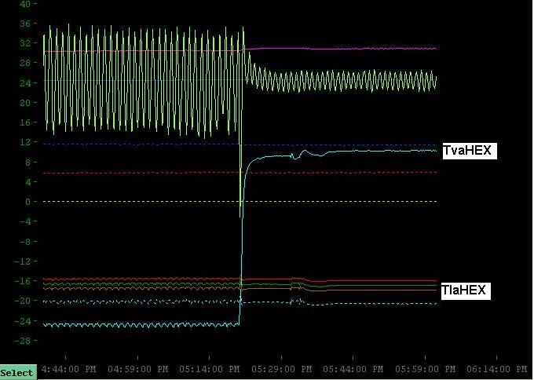 Figure 4: An illustration of the change in temperatures of the EC HEX with a sudden increase in detector load from 0% to 100% power.

Figure 5: Pressure drop across the vapour side of the CERN EC HEX as a function of massflow through the HEX for different detector power loads.
Figure 6: Pressure drop across the on-cylinder pipe work as a function of massflow through the HEX for different detector power loads.

