Write up on barrel HEX

This paper reports the measurements made on the first prototype of the QM barrel heat exchanger, HEX, from September 2004 to January 2005.
All measurements were made using the evaporative cooling system at CERN in building 175.
The barrel HEX is L shaped in design with two inlet liquid lines running inside the vapour return tube. The liquid lines are attached to capillaries after the HEX. The shape of the barrel HEX is shown in figure 1. In the experiments the HEX was placed and tested in two geometrical arrangements called -45 and +45 degrees. The -45 degrees geometry is shown in figure 1. This arrangement is such that the vapour inlet from the dummy detector structures is lower than the liquid inlet to the HEX.

Vapour in
45
HEX out of page
x
z
y
z
Vapour in
-45 deg geometry
Liquid in
Figure 1: -45deg geometry of HEX.

The barrel HEX was placed into the evaporative cooling test circuit, as shown in figure 2. The high pressure C3F8 cooling liquid from the cooling rig passed through a water cooled HEX before it entered the Danfoss massflow meter. This cooled the C3F8 to allow accurate measurements from the Danfoss meter. It has been observed that the Danfoss meter required a C3F8 liquid temperature below 16ºC to obtain accurate measurements. After the meter the liquid was warmed, via an inline heater, to the required temperature before entering the HEX under test. For the high massflows required for the barrel HEX tests the capacity of this heater was not sufficient to warm the incoming liquid to 35ºC if the water cooled HEX before the Danfoss meter was utilised. Therefore the water cooled HEX was turned off for the barrel HEX experiments which compromised the accuracy of the Danfoss meter. This meter was therefore by-passed and the massflow measurements were obtained from a volume flow meter situated in the vapour section of the cooling circuit just before the compressors. The massflow is determined from the measurement of a volume of gas that passed through the volume meter for a measured time, typically 10 minutes, recorded with a stopwatch. The vapour temperature was measured with a PT1000 in the vapour flow and the vapour pressure was measured with a manometer. The temperature and pressure are required to convert the volume measurement into a mass measurement.
The C3F8 inlet line split into two before the barrel HEX and the coolant passed through the two inlet pipes of the barrel HEX where it was cooled by the returning fluid in the vapour return tube. After the barrel HEX each liquid line was connected to a capillary.
Copper capillaries 2.7m long with an ID of 0.9m were used at the start of these experiments as the expected massflow from stand alone experiments predicted that this would be the correct length to deliver the required massflow. However, the operating temperature of the system was higher than expected and the capillaries were initially operated with a much higher drive pressure, (19bara instead of 13bara), to obtain the required massflows. The capillaries were eventually shortened to 2.4m and operated with a pressure of 17bara. For the measurements with the barrel cooling loop the capillaries were further shortened so that the operating inlet liquid pressure was 16bara.
The other end of the capillary entered the dummy detector load. For the first experiments both capillaries were joined together before entering the dummy detector load; which consisted of a heater wire of approximately 30cm in length inside a pipe with an internal diameter of order 2cm. This allowed heat to be added to the system without adding a significant pressure drop in the detector load. The outlet of the dummy detector was connected to the vapour inlet of the barrel HEX via large ID pipe work. For the final experiments, where the pressure drops along a final barrel cooling loop were investigated, each capillary entered an individual cooling loop which were joined at the far end to a single exhaust manifold before being connected to the vapour inlet of the barrel HEX. More details of the cooling loop experimental set-up are given in the appropriate section. After the barrel HEX the fluid passed through an ATLAS prototype heater under PID control to ensure only vapour at 20ºC returned to the cooling manifold before compression and condensation in the cooling rig. Before the compressors a volumetric flow meter was positioned to allow the calculation of the massflow through the system to be calculated from a volume flow, vapour temperature and pressure. Temperatures and pressures in the apparatus were recorded as indicated on figure 2 and listed in table 1.
The cooling system must remove, via evaporation, the heat produced by the detector structures. To reduce the massflow, and therefore the associated pressure drops in the systems pipe work, the HEX is utilised to cool the incoming liquid to increase the available enthalpy of the cooling fluid. The HEX must be sufficiently efficient to cool the liquid before the capillaries to a point that the required enthalpy for stable operation is available. The HEX efficiency, η_{hex}, is defined by:

$$η_{\text{hex}}=\frac{T_{0}−T_{1}}{T_{0}−T_{2}}$$
Equation 1

where; T₀ is the inlet liquid temperature to the HEX from the cooling rig side, T₁ is the outlet fluid temperature from the HEX to the capillaries before the detector structures and T₂ is the temperature of the fluid from the detector structures just before the HEX, which is close or equal to the evaporation temperature in the detector structures.
If the HEX is not efficient enough then the vapour fraction of the fluid, defined as the vapour quality, after the detector structure will increase. This tends to reduce the efficiency of the HEX, which raises the temperature of the liquid before the capillaries and therefore reducing the massflow through the capillaries. The reduced massflow results in a high vapour quality after the detector structures. A negative feed back loop is established which drives the system to zero cooling capacity and thermal run away, know as dry-out.
The vapour quality before the detector structure, Xi, is calculated from the measured quantities; the evaporation pressure, and the liquid temperature at the end of the capillary. The vapour quality after the detector structure, Xu, is calculated from the initial vapour quality, Xi, the coolant massflow, W (g/s), the power load, P (J/s), and the latent heat of the liquid at the evaporation pressure, h_{ev}, (kJ/kg) by:
$$X_{u}=\frac{P}{{\text{Wh}}_{\text{ev}}}+X_{i}$$
Equation 2
Table 1: measured quantities
Temperatures |  | Pressures
TlbHEX0 | Temp. of liquid before HEX inlet line 0 | PlbCap | Press. of liquid before capillary
TlbHEX1 | Temp. of liquid before HEX inlet line 1 | PlaCap | Press. of liquid after capillary
TlaHEX0 | Temp. of liquid after HEX inlet line 0 | ΔPCap | Press. Difference across capillary
TlaHEX1 | Temp. of liquid after HEX inlet line 1 | PlbHEX | Press. of liquid before HEX
TlbCap0 | Temp. of liquid at the start of capillary 0 | PvbHEX | Press. of vapour before HEX
TlbCap1 | Temp. of liquid at the start of capillary 1 | PvaHEX | Press. of vapour after HEX
TlaCap0 | Temp. of liquid after capillary 0 | ΔPvHEX | Press. Difference across HEX vapour side
TlaCap1 | Temp. of liquid after capillary 1 | ΔPlHEX | Press. Difference across HEX liquid side
TvbHEX | Temp. of vapour before heat exchanger | PvbBPR | Press. of vapour before BPR
TvaHEX | Temp. of vapour after heat exchanger | PinFM | Press. of vapour in volume flow meter
TvaH | Temp. of vapour 20cm after the final heater
TinFM | Temp. of vapour in volume flow meter

Figure 2 : cooling system with barrel HEX

-45deg geometry – with large dummy heater

The geometry was such that the vapour inlet end of the HEX was at the lowest point and the HEX rose at 45deg to the horizontal, (x), in the vertical plane. After the corner of the HEX the HEX was horizontal, as illustrated in figure 1. This corresponds to the geometry denoted as –45deg for the Endcap SCT HEX. In this arrangement the Endcap HEX operated at its minimum temperatures. That was TlaHEX= –15ºC compared with –13ºC for 0deg and –6.5ºC for +45deg measured for 100% power, TlbHEX = 35ºC and massflows from 5.5 to 5.6 g/s.
At the nominal massflow of 7.8 g/s with a liquid temperature before the HEX of 35ºC and full nominal detector power, (504W=100%), the operating characteristics found for the HEX are those given in table 2.
In summary the efficiency was 0.44 and the temperature of the liquid after the HEX was 9ºC. The operating temperatures were higher than those obtained for the Endcap HEX. The vapour quality before the detector structures was 0.36 and after was 0.99. Such a high vapour quality implies that the barrel HEX relies on the specific heat capacity of the cold vapour to a larger extent than the Endcap HEX which required lower vapour qualities for stable operation.
The pressure drop along each of the two liquid inlet lines is 160mbar and across the vapour return is 170mbar at full power and nominal massflow. The evaporation temperature at 1.8 to 1.9bara was higher than the desired 1.67bara due to limitations in the test apparatus, which prevented an evaporation temperature of 1.7bara being obtained. The pressure drop along the vapour return is high but manageable. The original design required a 50mbar pressure drop over the vapour return tube of the HEX, but as the space is very limited there is little that can be done to reduce the pressure drop across the HEX with this HEX design. The pipe work from the heater to PP3 must be maximised to obtain a total vapour side pressure drop within the 350mbara budget.

Table 2 : the operating characteristics of the HEX in the -45deg geometry
Characteristic values: | Power on staves | 100.9% | 0.0%
 | Inlet temp into HEX | 35.513 | 35.4965
 | Massflow | 7.80 | 8.46
Pressures | Pressure before capillary | 19.1 | 19.2
 | differential pressure across capillary | 17.162 | 17.195
 | Pressure after capillaries | 1.841 | 1.893
 | differential pressure across HEX liquid | 0.126 | 0.142
Cap temperatures | Temp. of liquid before capillary 0, TlbCAP0 | 10.913 | -7.16
 | Temp. of liquid before capillary 1, TlbCAP1 | 13.586 | -2.051
 | average TlbCAP | 12.2495 | -4.6055
 | Temp. of liquid after capillary 0, TlaCAP0 | 11.125 | -4.974
 | Temp. of liquid after capillary 1, TlaCAP1 | 7.479 | -7.119
HEX efficiency/temps | Temp. of liquid before HEX, line 0, TlbHEX0 | 35.54 | 35.535
 | Temp. of liquid before HEX, line 1, TlbHEX1 | 35.486 | 35.458
 | average TlbHEX | 35.513 | 35.4965
 | average TlaHEX | 9.156 | -7.789
 | Temp. of vapour before HEX, TvbHEX | -24.07 | -23.36
 | Temp. of vapour after HEX, TvaHEX | 13.695 | -24.12
 | HEX efficiency | 0.44 | 0.73
Other Pressures |  | 0.14 | 0.111
  differential pressure across HEX vapour
 | Pressure drop over liquid inlet tube | 0.165 | 0.166
 | Liquid pressure before HEX | 19.2 | 19.3
 | Press. vapour after HEX | 1.593 | 1.718
 | pressure before BPR | 1.266 | 1.376
Detector heating | Volts | 183 | 0
 | Current | 2.78 | 0
 | Power on detector structure [W] | 508.74 | 0
nominal power = 504W | % of full power | 1.0094048 | 0

The massflow increased from 7.8 to 8.46 g/s when the detector structure power was reduced from 100% to 0% of the nominal, for a constant liquid temperature before the HEX. This is an 8.5% increase. The increase in massflow that occurs for a reduction in the inlet liquid temperature to 20ºC was not measured for this experimental set-up. However, the massflow increase was measured when the real barrel cooling loop was used as the detector dummy load, discussed below. The increase in massflow measured for a change in operational conditions of 100% detector power with an inlet liquid temperature to the HEX of 35ºC changing to 0% detector power with an HEX inlet liquid temperature of 20ºC was 14.5%.

Comparison of the HEX performance for different liquid temperatures before the HEX

Tests were performed at nominal massflow for inlet liquid temperatures measured before the HEX of 20, 30 and 35ºC. The efficiency of the HEX as a function of inlet temperature is shown for 100% detector power in figure 3. As the inlet temperature rose the temperature of the liquid after the HEX increased from –12ºC to 2.6ºC to 8.8ºC, which corresponds to a fall in HEX efficiency from 0.78 to 0.51 to 0.45. Even though the efficiency of the HEX fell, with increasing inlet liquid temperature, the system was still able to operate successfully.
The HEX was operated for the above 3 liquid inlet temperatures for different detector powers. The efficiency and liquid temperature after the HEX as a function of detector power is summarised in figure 4. As can be seen the HEX efficiency is close to 0.75 for all three inlet liquid temperatures for a detector power below 75% of the nominal maximum (that is at 378W). At higher detector powers the efficiency falls to approximately 0.5 for 90% of full power for an inlet liquid temperature of 35ºC, compared with an efficiency of 0.69 for an inlet liquid temperature of 30ºC. Further increasing the power to 100% reduces the efficiency slightly to 0.45 for TlbHEX equals 35ºC and to 0.5 for an inlet temperature of 30ºC. For an inlet liquid temperature of 20ºC the efficiency only falls slightly from 0.78 to 0.72 with an increase in detector power from 0 to 100%. Therefore while the efficiency is low at the nominal operating conditions, the situation improves quickly with a small reduction in either inlet liquid temperature or detector power. It should be noted that at the start of operation of the ATLAS experiment the detector power will be lower than the nominal as there will be no power coming from the silicon detectors. This will result in a high HEX efficiency and lower operating conditions and therefore a higher massflow for the same liquid pressures.

Stability tests: Increasing power from 0% to 100% and long term tests.

The system was stable under a sudden change in detector structure power from 0% to 100%. While the detector structures were un-powered the system was operated with the drive pressure equal to that required to give the nominal massflow for an inlet liquid temperature of 35C with 100% detector power. The detector power was turned upto100% power over a time of less than 30 seconds. Figure 5 shows the temperatures of the system before and after such a change in power. The transient in the temperatures of the system is short lived with at most the temperatures becoming constant after 10 minutes.
The system was left running for over 2 hours after a change in detector power and the system remained stable, as illustrated in figure 6.

+45deg geometry – with large dummy heater

The HEX was rotated about the vapour inlet point so that the HEX vapour inlet pointed upwards and the HEX fell at 45deg to the horizontal in the vertical plane. After the corner of the HEX the HEX was horizontal. This corresponds to the geometry denoted as +45deg for the Endcap SCT.
The HEX behaved in a very similar fashion as in the -45deg geometry. The operating conditions at 100% detector power with TlbHEX of 35ºC for both -45deg and +45deg geometries are summarised in table 3 below. Again the evaporating pressure was slightly high due to the limitations of the test system.

Table 3 : comparison of the HEX operating conditions for the two geometries
 | +45deg geometry | -45deg geometry
Power (%) | 100 | 100
TlbHEX (ºC) | 35 | 35
Massflow (g/s) | 7.8 | 7.8
TlaHEX (ºC) | 9.5 | 9.2
Efficiency (%) | 43 | 44
ΔP vapour (mbar) | 145 | 140
ΔP liquid (mbar) | 120 | 160
Pressure after Cap | 1.81 | 1.84

For the nominal inlet liquid temperature of 35ºC, the efficiency and therefore temperatures of the system changed only slightly up to 75% of the total detector power as was observed for the -45deg geometry. Figure 7 illustrates this for an inlet liquid temperature of 35ºC.

Difference in massflow for 100% and 0% detector power and TlbHEX = 35C and 20C

The change in the massflow and the pressure drops going from 100% power and TlbHEX = 35ºC to 0% power and TlbHEX = 20ºC was studied for this HEX geometry and is summarised in table 4. A maximum increase in massflow of 13% was observed.

Table 4: change in massflow as power and TlbHEX changes
Power (%) | TlbHEX (ºC) | Massflow (g/s) | % change in massflow | ΔP vapour (mbar) | ΔP liquid (mbar) | TlaHEX (ºC) | Efficiency (%)
100 | 35 | 7.8 | N/A | 145 | 120 | 9.5 | 43
0 | 35 | 8.2 | 5 | 120 | 130 | -1.25 | 60
0 | 23 | 8.8 | 13 | 75 | 170 | -19.5 | 90
The operating condition of the system after a power reduction from 100% to 0% was not the same as turning the system on with 0% power. The efficiency was smaller and the temperature of the liquid after the HEX higher in the former case and consequentially the massflow was less. The difference in the two situations are summarised in table 5. This effect was observed during normal running as shown in figure 8. Reducing the inlet liquid temperature to 20ºC increased the HEX efficiency to 90%. Further increasing the inlet liquid temperature resulted in system efficiency and temperatures as obtained at start up, as shown in figure 9. This effect was not observed for the -45deg geometry. The maximum massflow obtained was 8.8g/s. Therefore the maximum massflow increase above that obtained at full detector power with a liquid temperature before the HEX of 35ºC is still 13%.

Table 5 : difference in TlaHEX depending on history of system.
Change | Power (%) | TlbHEX (ºC) | Mf (g/s) | % change in mf | ΔP vap (mbar) | ΔP liq (mbar) | TlaHEX (ºC) | Eff (%)
TlbHEX:35C  Power 100% to 0% | 0 | 35 | 8.2 | N/A | 120 | 130 | -1.25 | 60
Power 0%  TlbHEX:22C to 35C | 0 | 35 | 8.8 | 7 | 110 | 150 | -18 | 90

Stability tests: Increasing power from 0% to 100% and long term tests.

The system was stable for power cycles and long runs for this geometrical configuration. Increasing the detector structure power suddenly from 0% to 100%, while adjusting the inlet liquid heater to maintain 35ºC liquid temperature before the HEX, resulted in stable operating temperatures; as shown in figure 10. The transient in the operating temperatures of the HEX was less than 10 minutes long. The system was run for over an hour at 100% power and remained stable.

Cooling loop tests with HEX geometry of -45deg

The large heater that represented the dummy detector load was replaced with a final full barrel cooling loop to simulate the pressure drops inside the real experiment and to confirm that the system was able to cool the first and last modules on the cooling loop. The full cooling loop consists of two single cooling loops of two straight staves with module mounting points joined at one end by a semi-circular pipe section. Each stave can accommodated 12 barrel modules, one loop therefore takes 24 modules and the full cooling loop, (of two sub-loops), 48 modules. Two capillaries are required with one entering each cooling loop. The two cooling loops were connected together via an exhaust manifold at the exhaust end. The module closest to the capillary was called module 1, while the one closest to the exhaust was called module 24. The experiments were performed with the exhaust manifold from barrel six to obtain the largest pressure drops in the circuit. The manifold was connected to the vapour inlet of the barrel HEX via pipe work of ID 7mm and 500mm in length, an approximation of that of barrel 3, which simulated the worse case for pressure drops along this pipe work.
The heat load was applied to the cooling loop via ceramic heaters mounted onto the loop in the same fashion as the final modules. Due to limited availability of heaters only 36 heaters were used. These were placed and powered in groups of three along the cooling loops starting at module 1. Heaters were not placed on module mounting points 4, 5, 9, 16, 20 and 21. The power was applied to the system so that each half loop had 25% of the total power applied and as far as possible every heater supplied the same power. Close to the maximum power the 4 groups of modules at the centre of each cooling loop stave had slightly more power than the others due to power supply limitations.
The capillaries from the barrel HEX were connected via a small section of pipe work with an adaptor for pressure measurements, to the inlet of the cooling loop. On the exhaust pipe after the cooling loop, 5cm from the connector to the cooling loop manifold, an adaptor for pressure measurements was made. Therefore pressure measurements could be measured just after the capillary at the start of the cooling loop and just after the exhaust manifold at the exit of the cooling loop. A differential pressure measurement was also made across one cooling loop and the manifold.
Temperature sensors were placed on each loop before and after module 1, after module 12, and before and after module 24. Temperature sensors were also mounted on some ceramic heaters to confirm that the system cooled the heaters. However, from the recorded temperature of a heater it is not trivial to deduce the expected temperature of the silicon of a real module.
Figure 11 and table 6 details the pressure and temperature measurements in the experiment for the whole system, while figure 12 illustrates the cooling loop and the position of the heaters and temperature sensors on the cooling loop.
To date all tests were performed with the cooling loop in the horizontal plane and the barrel HEX in the -45deg geometric arrangement.

Figure 11: circuit used to test barrel HEX and cooling loop

Table 6 : measured quantites for the barrel cooling loop experiment
Temperatures |  | Pressures
TlbHEX0 | Temp. of liquid before HEX inlet line 0 | PlbCap | Press. of liquid before capillary
TlbHEX1 | Temp. of liquid before HEX inlet line 1 | PlaCap | Press. of liquid after capillary
TlaHEX0 | Temp. of liquid after HEX inlet line 0 | ΔPCap | Press. difference across capillary
TlaHEX1 | Temp. of liquid after HEX inlet line 1 | ΔPLoop | Press. difference across cooling loop from capillary to exit of manifold
TlbCap0 | Temp. of liquid at the start of capillary 0 | PvaLoop | Press. of vapour after the cooling loop manifold
TlbCap1 | Temp. of liquid at the start of capillary 1 | PlbHEX | Press. of liquid before HEX
TlaCap0 | Temp. of liquid after capillary 0 | PvbHEX | Press. of vapour before HEX
TlaCap1 | Temp. of liquid after capillary 1 | PvaHEX | Press. of vapour after HEX
TlbMob1 | Temp. of fluid before module 1 on cooling loop | ΔPvHEX | Press. difference across HEX vapour side
TlaMob24 | Temp. of fluid after module 24 on cooling loop | ΔPlHEX | Press. difference across HEX liquid side
TvbHEX | Temp. of vapour before heat exchanger | PvbBPR | Press. of vapour before BPR
TvaHEX | Temp. of vapour after heat exchanger | PinFM | Press. of vapour in volume flow meter
TvaH | Temp. of vapour 20cm after the final heater
TinFM | Temp. of vapour in volume flow meter
Figure 12: detail of barrel cooling loop arrangement
Comparison of barrel HEX functionality connected to the cooling loop compared to the large dummy load.

The same behaviour was observed for the HEX connected to the cooling loop as observed for the HEX connected to the dummy load. Figure 13 compares the efficiency of the HEX and the liquid temperature directly after the HEX as a function of inlet liquid temperature to the HEX for both the HEX connected to the cooling loop and the dummy load. The values obtained were the same, within the errors of the experiment.
The inlet vapour quality into the cooling loop and the calculated outlet vapour quality after the cooling loop are given in table 7 for inlet liquid temperatures to the HEX of 20ºC and 35ºC for 100% detector power and a massflow of 7.8g/s.

Table 7 : comparison of vapour quality for TlbHEX of 20 and 35C with 100% detector power and a massflow of 7.8g/s
TlbHEX, (ºC) | Inlet vapour quality, Xi | Outlet vapour quality, Xu
20 | 0.15 | 0.78
35 | 0.38 | 0.99

A reduction in the inlet liquid temperature resulted in a reduced inlet fluid vapour quality after the HEX, due to the increased HEX efficiency. However, the change in vapour quality along the cooling loop is approximately the same at 0.6, as expected for the same detector power and coolant massflow.

Are the first and last modules cooled?

The temperature of the first and last module and the temperature of the cooling pipe before and after these modules were measured on both cooling loops. At full detector power these modules were cooled correctly. A difference in temperature between the coolant and module temperature of approximately 10ºC was observed for all the modules. The temperature of the cooling pipe, and therefore the cooling fluid, at the start of the cooling loop near the capillary was consistent with the saturation temperature of the vapour at the pressure measured at this point. The pressure in the cooling pipe at the exhaust of the cooling loop was not measured, only the pressure after the exhaust manifold was measured. Therefore the temperature of the fluid at the end of the cooling loop before the exhaust can not be compared directly with the saturation pressure here. However, the temperature was low and independent of the detector power and the outlet vapour quality. Therefore the final module is assumed to be cooled by evaporative cooling as required.
The difference in the coolant temperature along the cooling loop was observed to be significant. The temperature of the coolant at the start and end of the cooling loops are given in table 8 for 100% detector power, a massflow of 7.8g/s, and an evaporative pressure of 1.8bara, (the minimum possible) at the end of the manifold. The deduced saturation pressure and the measured fluid pressure after the capillary are given in the table for comparison. Also included in table 8 is the fluid temperature and pressure measured a few cm after the manifold along the exhaust pipe to the barrel HEX.

Table 8 : cooling loop pressure and temperatures
 | Coolant temperature, C | Calculated Saturation pressure, bara | Measured pressure, bara
Start of loop 1 | -13.2 | 2.6 | 2.7
End of loop 1 | -19.1 | 2.1
Start of loop 2 | -13.2 | 2.6 | 2.7
End of loop 2 | -19.2 | 2.1
In exhaust pipe a few cm after manifold | -22.8 | 1.8 | 1.8

As can be seen the measured pressures and the pressures deduced from the fluid temperature, obtained assuming that the fluid is in saturation, agree very well. This implies that the coolant pressure at the end of the cooling loop can be deduced from the cooling pipe temperature. Therefore the pressure drop along the cooling circuit can be separated into a pressure drop across the loop and one across the manifold.
Figure 14 shows the pressure drop across the cooling loop and the manifold as a function of detector power for a liquid inlet temperature to the HEX of 35ºC and a fixed liquid inlet pressure that gave a massflow of 7.8g/s for 100% power.
In figure 14, the total pressure drop over the upper cooling loop and manifold was measured directly by a differential pressure transducer. These values are in agreement with the pressure drop over the lower cooling loop calculated from the difference of two absolute pressure measurements. The maximum total pressure drop over the cooling loop and manifold, measured directly by a differential pressure transducer, was 820mbar observed at full detector power.
From the temperature of the cooling loop at the manifold the pressure drops over the manifold and over the cooling loop without the manifold were calculated and plotted. At 100% detector power 35% of the pressure drop, (290mbar), was across the exhaust manifold while a pressure drop of 530mbar was calculated to be present over the cooling loop staves.
A sharp increase in pressure drop over the cooling loop was observed at 400W, 80% power, which coincides with an increase in outlet vapour quality and a reduction in HEX efficiency. Re-plotting the data as a function of outlet vapour quality, see figure 15, reveals a smooth increase in pressure drop as a function of outlet vapour quality.

Total pressure drops in the cooling system

The total pressure drop on the vapour side for the whole system can be estimated. The pressure drop on the vapour side over the HEX and through the pipe work to the cooling loop manifold was measured for 100% power, TlbHEX = 35ºC and a massflow of 7.8 g/s to be 260mbar. Pervious measurements of the pressure drop over only the HEX, see above, gave a pressure drop of 170mbar. Therefore the pressure drop over the pipe work for barrel 3 from the HEX to the cooling loop manifold is 90mbar.
The total pressure drop from just before the connector of the cooling loop manifold to the BPR is predicted to be 390mbar from these measurements, which is only slightly above the 350mbar spec.
The pressure drop over the cooling loop, including the manifold, was measured at 820mbar. Therefore the total pressure drop from the BPR to the first module is 1210mbara. To reach an evaporation temperature of -25ºC at the first module, which corresponds to a saturation pressure of 1.67bara, the pressure at the BPR must be 460mbara, which is not possible for the apparatus.
Therefore the evaporation temperature will be higher than -25ºC at the first module of the cooling loop. For the design pressure at the BPR of 1.3bara, with the pressure drop of 820mbar along the cooling loop, the pressure at the first module will be 2.51bara which corresponds to an evaporation temperature at the first module of -14.5ºC.

The pressure drop along the cooling loop is reduced, but is still high, if the inlet liquid temperature to the HEX is reduced to 20ºC. Reducing the inlet liquid temperature increases the HEX efficiency and reduces the vapour quality of the fluid into the cooling loop. For the same massflow, the pressure drop along the cooling loop is reduced to 594mbar, which corresponds to a temperature difference along the cooling loop of only 3ºC instead of 6ºC. The measured evaporation temperature at the first module was -16.6ºC. In the real experiment with a pressure at the BPR of 1.3bara and a total pressure drop of 390mbara to the manifold and 594mbar along the cooling loop the estimated evaporation temperature at module 1 will be -17ºC.
It should be noted that for operation with TlbHEX of 20ºC that reducing the massflow through the system is not advisable as this increases the vapour quality before the cooling loop. An increase in vapour quality increases the pressure drop along the cooling loop as observed, thus negating the advantage of reducing the inlet liquid temperature before the HEX. The measured pressure drops and coolant temperatures in the cooling loop, for inlet liquid temperatures of 35ºC and 20ºC to the HEX, are compared in table 9. It should be noted that the pressure measured just before the exhaust manifold was approximately 1.8bara for both situations.

Table 9 : comparison of pressure drops in cooling loop for TlbHEX of 20 and 35C, 100% detector power and a massflow of 7.8g/s
TlbHEX | 35ºC | 20ºC
VQ inlet | 0.38 | 0.15
VQ outlet | 0.99 | 0.78
ΔP TOTAL (mbar) | 819 | 594
ΔP loop | 538 | 365
ΔP manifold | 281 | 229
T start of loop (ºC) | -13.4 | -16.6
T end of loop (ºC) | -19.3 | -19.2
ΔT (ºC) | 5.9 | 2.6
Figure 3: change in operating conditions as a function of TlbHEX (-45deg geometry).

Figure 4: change in operating conditions as a function of detector power (-45deg geometry).

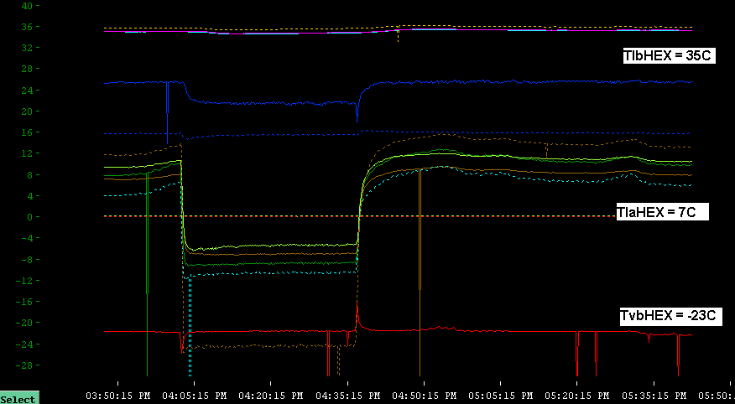
Figure 5: -45deg geometry; Power change for 0 to 100% power.

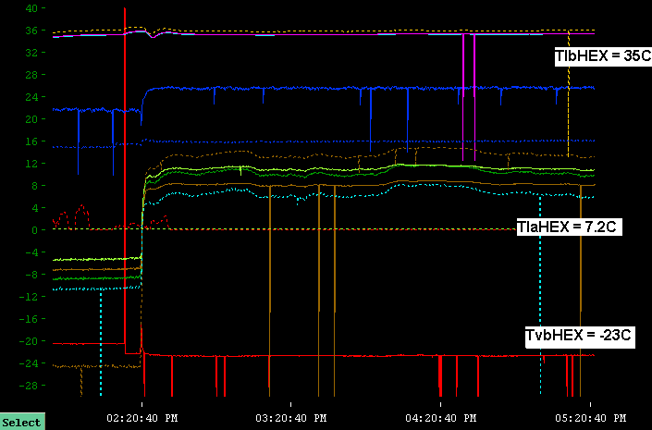
Figure 6: -45deg geometry; Power change from 0 to 100% power and 2hour long run.

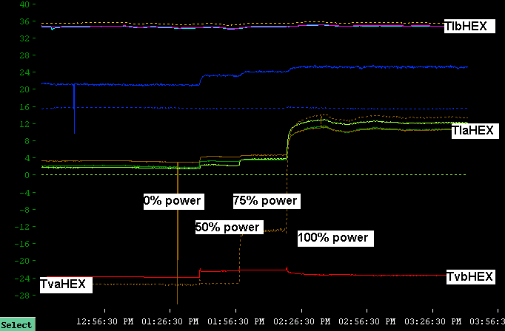
Figure 7: +45deg geometry; change in HEX temperatures as a function of detector power for TlbHEX = 35C. Note the increase in the vapour temperature after the HEX for above 50% power.
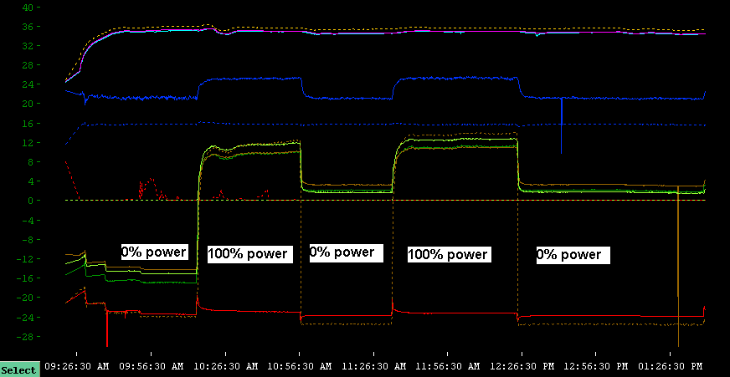
Figure 8: +45deg geometry; two power cycles 0% to 100% to 0%, illustrating stable operation and different 0% power temperature conditions.

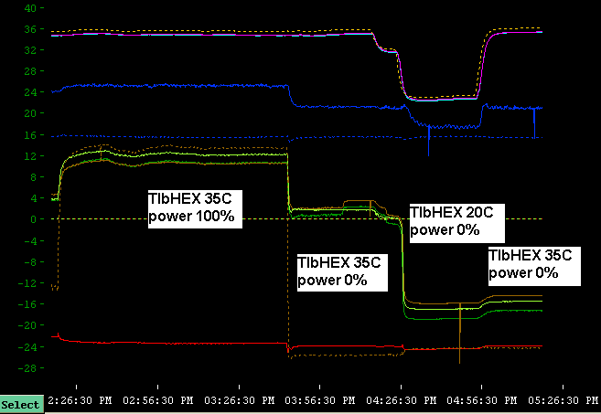
Figure 9: +45deg geometry; Change in operating conditions of HEX as TlbHEX and power changes.
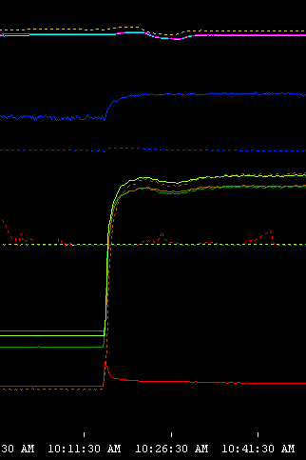
Figure 10: +45deg geometry; change in temperatures for a sudden change in detector power from 0% 100% nominal power.

Figure 13: the efficiency of the HEX and the liquid temperature directly after the HEX as a function of inlet liquid temperature to the HEX for both the HEX connected to the cooling loop and connected to the dummy load

Figure 14: pressure drop across the cooling loop as a function of detector power for TlbHEX = 35C and a massflow of 7.8g/s

Figure 15: pressure drop across the cooling loop as a function of outlet vapour quality for TlbHEX = 35C and a massflow of 7.8g/s

