 | ATLAS Inner Detector Evaporative Cooling System
ATLAS Project Document No: | Institute Document No. | Created: 8/05/2003 | Page: 1 of 31
ATL-IC-ES-0006 |  | Modified: 27/11/2003 | Rev. No.: 3.0

Inner Detector Evaporative Cooling System
Requirements and general design issues

Abstract
This document describes the design requirements for the ID evaporative cooling system focussing on the design of the internal part up to the cooling rack on the ATLAS UX platforms.
The design parameter of heaters, heat exchangers, capillaries as well as the various operating and test conditions are discussed in detail.
Prepared by:  M.Olcese - CERN  M.Stodulski – CERN & H.Niewodniczanski Institute of Nuclear Physics, Krakow | Checked by:  See approval list on EDMS | Approved by:  EDMS approval process
Distribution List

History of Changes
Rev. No. | Date | Pages | Description of changes
1.1  1.2  1.3  2.0  3.0 | 01/09/2003  24/09/2003  16/10/2003  20/11/2003  27/11/2003 | all | General update. Added specific requirements and design criteria for the heat exchangers, heaters and capillaries. Operating conditions, required flows and main system parameters are described  Incorporated comments from first check. Added flow chart with design method  Modified operating scenarios. Reviewed heater calculations, reviewed heat loads of SCT  Introduced comments from approval cycle  and added temperature control granularity

Table of Contents

1 Overview 4
2 Functionality and control of the system 4
2.1 The external part of the evaporative cooling system 5
2.2 The internal part of the evaporative cooling system 6
2.3 Control and monitoring of the evaporative cooling system 8
3 The internal cooling system design 10
3.1 Requirements and basic design parameters 10
3.1.1 Temperature specifications 10
3.1.2 Circuit parameters, layout and power load 11
3.2 Granularity of the pressure control 13
3.3 Design criteria and assumptions 14
3.4 Pressure specifications 17
3.5 Efficiency of the heat exchanger and flow calculation. 18
3.6 Heater design parameters and power capacity 20
3.7 Capillary design parameters 22
3.8 Flow chart of design process 24
3.9 Analysis of different operating and test conditions 24
3.9.1 Normal operating conditions at full power 25
3.9.2 Operating conditions with nominal power load but at higher evaporation temperature 25
3.9.3 Operating conditions with no power 25
3.9.4 Start-up and shutdown 25
3.9.5 Warm tests 26
3.9.6 Tests with no sub-cooling 26
3.10 Physical implementation and design of main components 26
3.10.1 Heater design 26
3.10.2 Heat exchanger design 27
3.11 System integration and layout 28
4 References 31

Overview

An evaporative fluorocarbon system has been chosen to cool the Pixel and SCT volume inside the thermal enclosure (modules and on-detector services) and also the SCT active thermal enclosures. In total the system has to remove around 60 kW of heat. The selected refrigerant C₃F₈ is non-flammable, non-conductive and radiation resistant. It has a good heat transfer coefficient and a small vapour specific volume allowing minimal tube sizes. The Inner Detector evaporative cooling system can be divided into internal and external parts, Fig.1. The internal part includes all components internal to the ATLAS detector: recuperative heat exchangers, capillaries, Pixel and SCT detector structures, thermal barriers, heaters on the return vapor lines and services connecting all those items to distribution racks on UX platforms. The power supplies for the heaters are also considered as part of the internal system. The external part includes a cooling plant, pneumatic and distribution racks and services connecting them. Control cubicles based on a PLC system control the cooling plant, the pneumatic/distribution racks and the heaters on the return tubes, Fig.1. A Supervisory Control and Data Acquisition (SCADA) allows for start up/ shut down and operating the cooling system as well as monitoring temperatures and pressures in the internal part of the cooling system.
The components of the evaporative cooling system are located in different areas. The cooling plant, the pneumatic rack and the control cubicles as well as the monitoring/control unit of the internal part are situated in the accessible cavern USA15. The distribution racks and the internal part of the system except heater power supplies are located in the experimental hall UX15 on the ATLAS detector on the ATLAS detector platforms and they are exposed to a magnetic field. The power supplies of the heaters are located half in US15 and half in USA15. Typical length of pipes connecting the detector structures with the distribution racks is around 35 m while those connecting the racks with the cooling plant are around 120 m long.
The Inner Detector community is responsible for the internal part of the evaporative cooling system while ST/CV is responsible for the external part including control of the heaters on the return vapor lines.

Functionality and control of the system
The evaporative system basic functionality is similar to that of a standard industrial fridge system. The fluid is delivered in liquid phase at room temperature from the condenser to the capillaries located immediately before the detector structures. The fluid expands through the capillaries and then remains in saturation conditions (boiling) in the detector structure. The residual liquid at the exhaust of the detector structures is evaporated by means of an heater which also raises the temperature of the vapor above the cavern dew point and then reaches the compressor in superheated vapor state.
A recuperative heat exchanger between the inlet liquid (warm) and the return fluid (cold) allows to increase the efficiency of the cycle, decreasing the vapor quality at the inlet of the detector structures and hence the required flow.
The temperature in the cooling structures is maintained by setting the pressure of the return vapor by means of backpressure regulators (BPR) located at the end of the return tubes. The flow is set by changing the pressure of the inlet liquid by means of pressure regulator (PR) located at the beginning of the inlet tubes. Both the PRs and BPRs are located in distribution racks on the external ATLAS platforms.

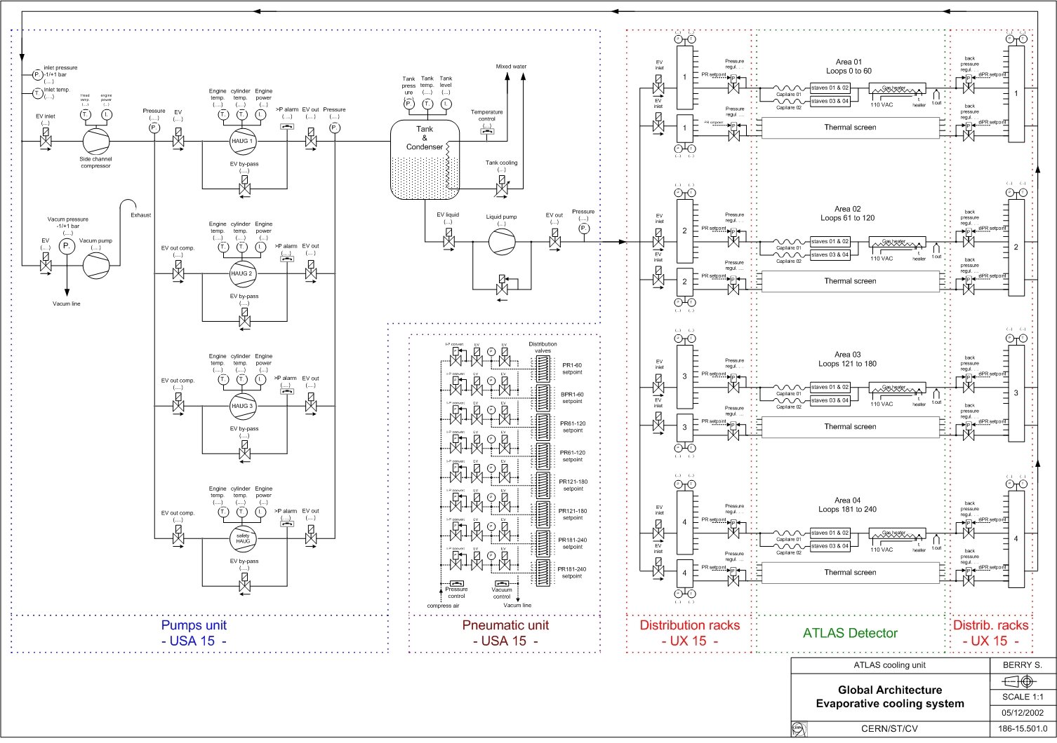
Fig.1 Internal and external parts of the Inner Detector evaporative cooling system and their PLC control

The external part of the evaporative cooling system

The current layout of the cooling plant in the cavern hall USA15 is shown in Fig.2. Details on its functionality and control can be found in [1] and [2].
There are up to 4 compressors working in parallel, one condenser and one liquid pump at the outlet of the condenser.
One main inlet liquid line and one main vapor return line connect the cooling plant in USA15 to the distribution racks (4 inlet and 4 return) located in the experimental cavern (UX15) on ATLAS services platforms 1 and 7 at both sites US15 and USA15, see fig.3.

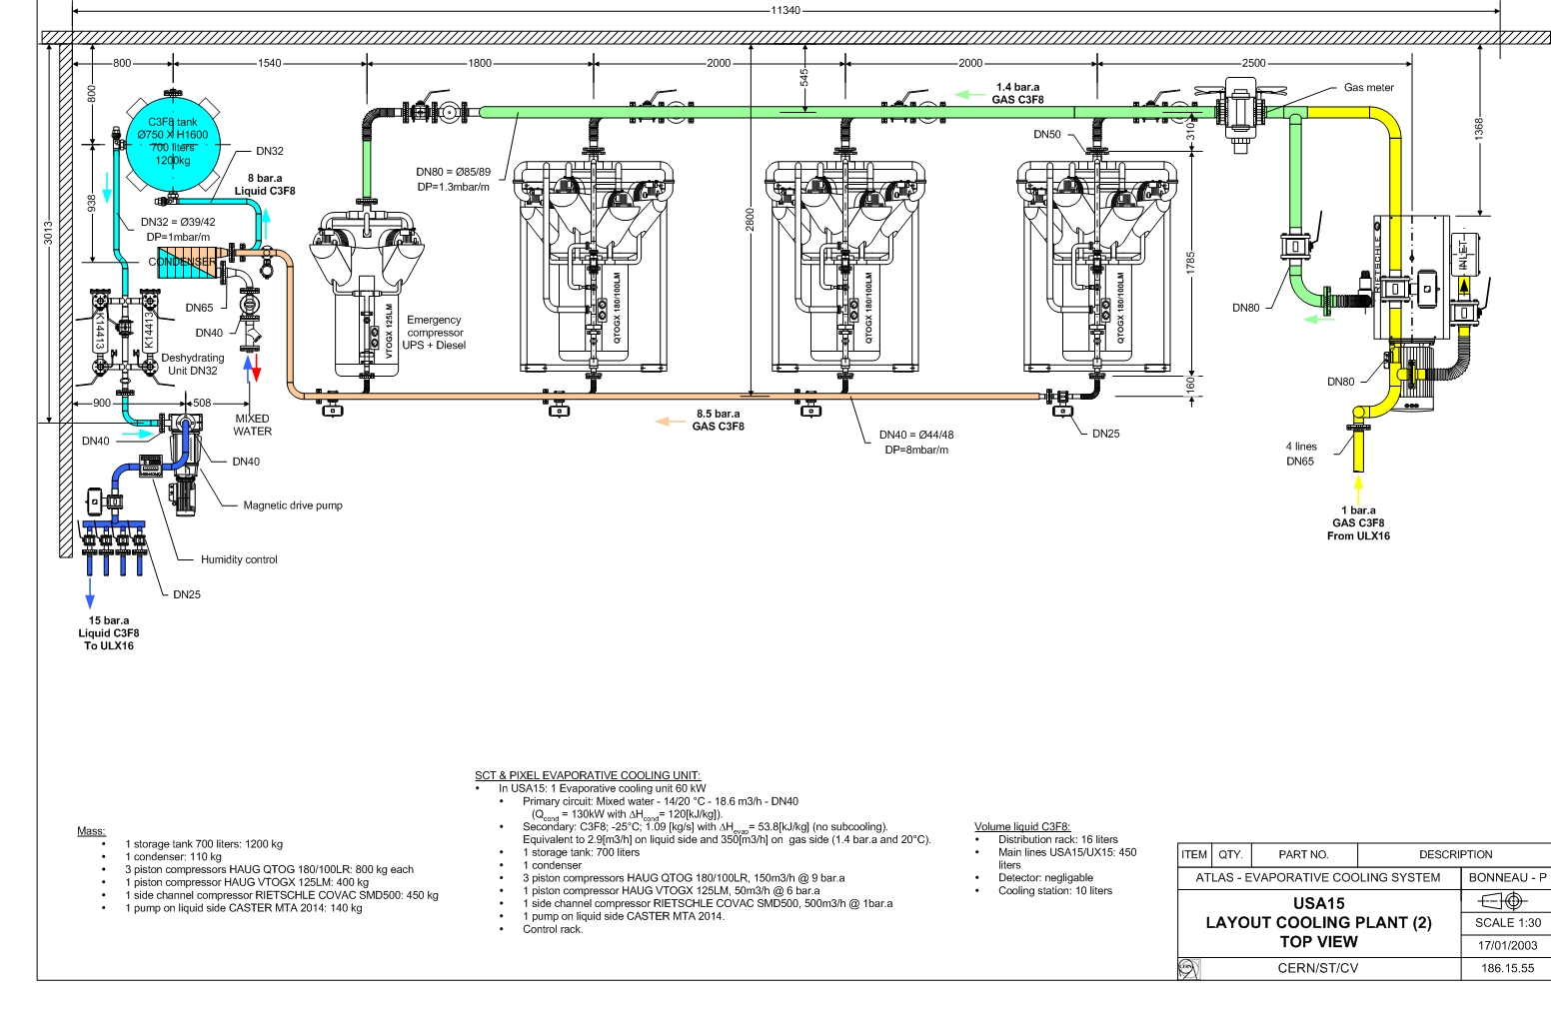
Fig.2 Current layout of the cooling plant in USA15

Each rack is divided in 2 parts: input (PRs) and return (BPRs) side, Fig.4. In each rack there is one sub-manifold for each of the different sub-detectors (Pixel, SCT barrel, 2 SCT end-caps) and three sub-manifolds for the SCT thermal barrier.
In the input rack on the main input line before the sub-manifolds of the sub-detectors there is an emergency pneumatic shut-off valve. The thermal barrier’s manifolds are connected before this valve as these circuits are supposed to be in operation even in case of general power cut-off. In the return rack each sub-manifold can be isolated with a manual shut-off valve.
After each connection/disconnection of the sub-detectors it will be necessary to vacuum pump the corresponding cooling circuits. Under vacuum we can consider that the BPR is a leak tight valve (vacuum sucks on the membrane in the closing direction) but, on the contrary, the PR is not a reliable leak tight valve. Thus each PR is followed by a manual closing valve and a Schrader valve to individually connect the vacuum pump.

The internal part of the evaporative cooling system
The detector structures of the Pixel, SCT Barrel, SCT End Caps and SCT thermal enclosers are grouped in 244 independent cooling circuits. Each cooling circuit consists of one recuperative heat exchanger, 1, 2 or 3 capillaries, detector structure, one heater on a return vapor line and piping connecting all the components to the distribution racks via one pressure and one back pressure regulator.

Fig.3 External part of the evaporative cooling system

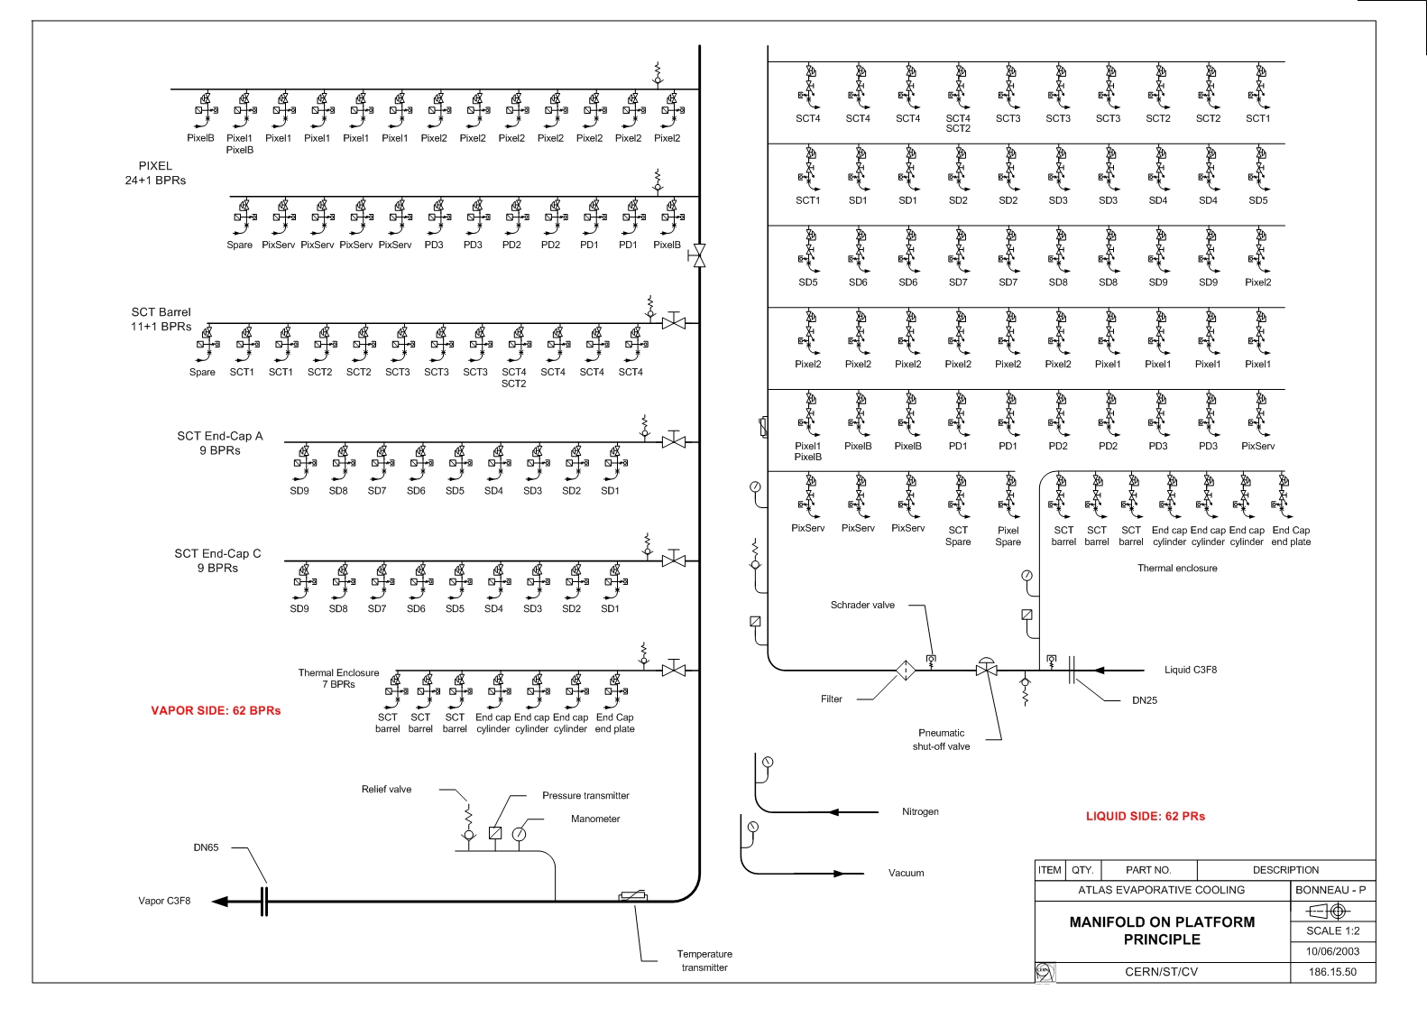

Fig.4 Current layout of the distribution rack – BPRs at left, PRs at right side

Each circuit is operated in fixed-flow mode
. The mass flow depends on the power dissipation of a specific detector structure, on the efficiency of the heat exchanger and on the vapor quality (VQ) at the exhaust of the cooling structures. The required mass flow is then typical of each circuit and it is tuned for each circuit by changing the geometry (length and ID) of the capillary. The tuning of the capillary is done experimentally before the production and the capillary length can not be changer after the installation. However, although each circuit is operated in fixed-flow mode the flow can be adjusted within a small range, if needed, by changing the pressure regulator settings.
The evaporation pressure (temperature) in the detector structures can be changed by changing the setting of the backpressure regulator.
In order to avoid condensation on external surfaces of the return tubes the remaining liquid after the detector structures has to be boiled off and the temperature of the return vapor has to be raised above the cavern dew point (12 °C). This is achieved by means of the power provided by an heater installed on the return tube as close as possible to the detector structures. In case of fully powered detector structures the heaters use only a fraction of their maximum power. When the detector structures are off, equivalent power will be supplied to the heaters to evaporate and to warm up the same amount of coolant. Thus, total power supplied to each cooling circuit is always the same regardless the power load of the detector structures. The PLC system controls the heaters in switching mode using as feedback the temperature sensors placed on the external surface of the vapor tubes after the heaters.
The recuperative heat exchanger allows to:
- Get rid of the subcooling of the inlet lines, required at the time of the varied flow system design. This allows to get rid of the active insulation along the inlet tubes
- Minimize the required flow rate and hence the heater power and to minimize the insulation requirements on the return tubes.
Each cooling circuit supplies several silicon modules or one sector of the thermal enclosures. For the module cooling circuits there is a local primary interlock system, which cuts off the power supplied to each module in case its temperature exceeds a given maximum acceptable limit. This system uses as feedback temperature readout on each module.
The temperature on the exhaust pipes immidiately after the last module is also measured. This information is used to determine the circuit operating conditions and it gives the indication whether there is still liquid in the coolant. In case of the SCT, the temperature monitoring on the exhaust tube is also used as a second level of interlock (global), which cuts off the power to all the modules of the relevant cooling circuit in case of coolant shortage. For the Pixels the temperature readout is used only for monitoring.

Control and monitoring of the evaporative cooling system

The evaporative cooling system control is based on CERN recommended Programmable Logical Controllers. The control system is based on a standard components and well-proven model architecture composed of the following elements, Fig.5:
- The ST/CV Programmable Logical Controllers (PLCs)
- The ST/CV Supervisory Control and Data Acquisition (SCADA)
- The ST/CV Archiving Computer
- The Experiment Supervisory Control and Data Acquisition (SCADA)
- The Technical Data Server (TDS)

The process control layer is handled entirely in the PLCs, which can work even if the supervisor is not working. The PLCs, located next to the cooling plant, are independent of the supervisor being used. The Inner Detector SCADA based on PVSS software controls the operation of the cooling system. The supervisory PC is located in the Experimental Control Room (ECR). The Inner Detector SCADA is used to start up and to shut down the evaporative cooling system as well as to switch on/off each independent circuit. It is also used to change the set points of the pressure regulators and to monitor temperatures and pressures in the cooling circuits.
The ST/CV SCADA software (WIZCON) is used only to maintain and to debug the cooling system. The entire information from PLCs is stored on the ST/CV Archiving Computer. Only selected information, warnings and alarms are supplied to the TDS located in the Technical Control Room (TCR). The assumed role of the TCR regarding cooling and ventilation systems is to receive alarms and to call appropriate services. No action from the Technical Data Server is expected.
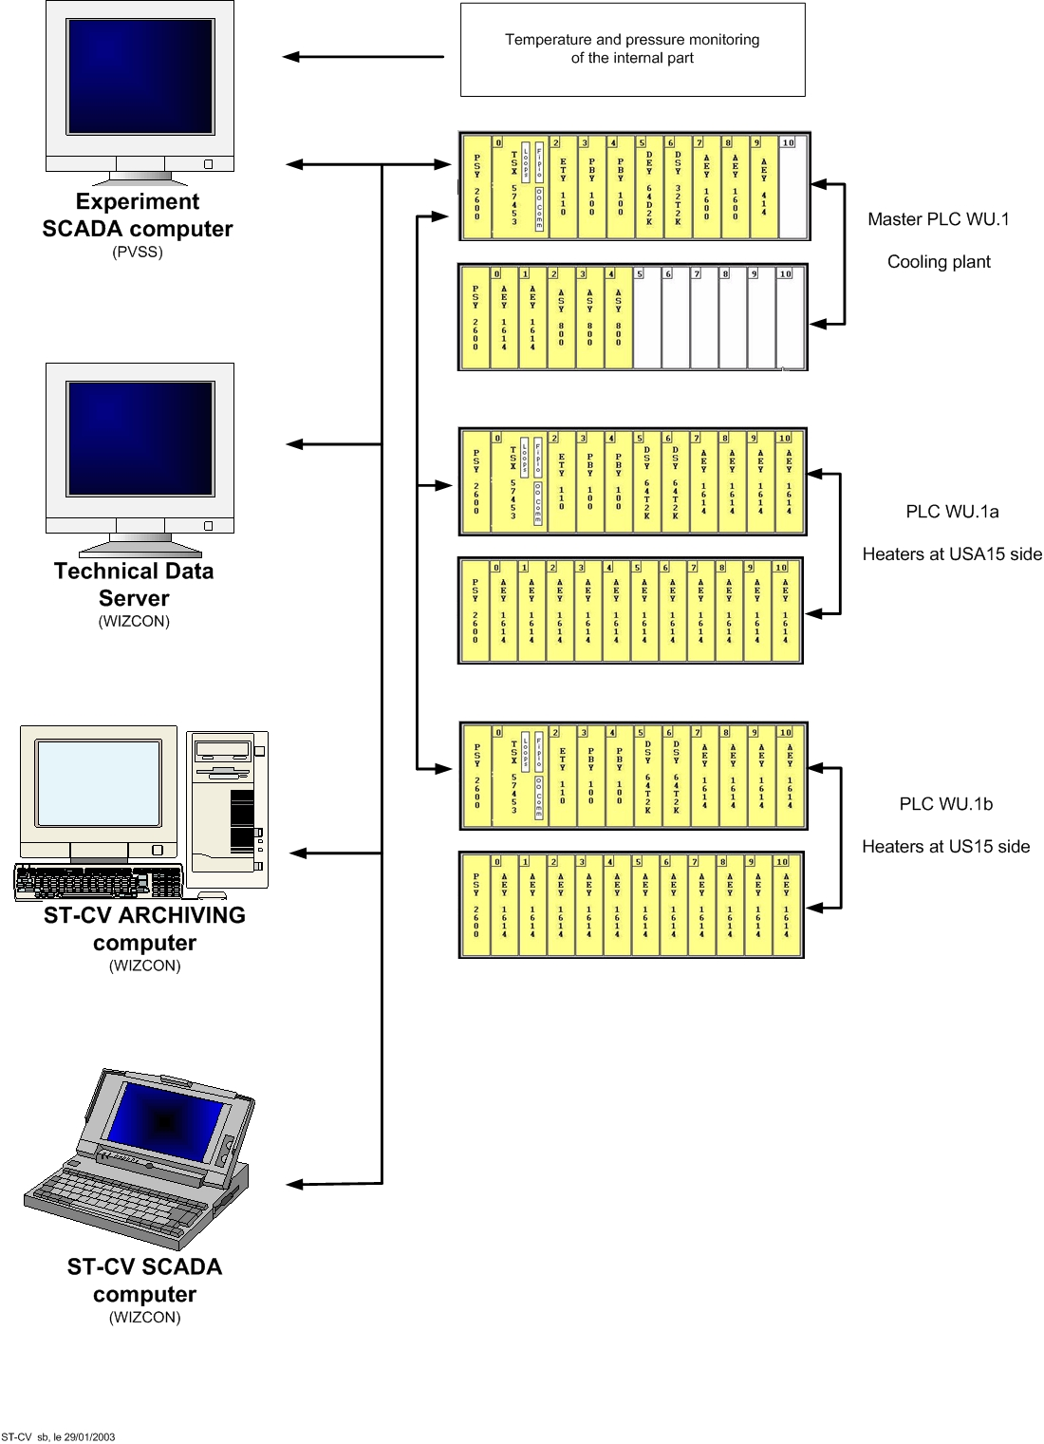
There will be three PLCs in the USA15 controlling the evaporative cooling system. One PLC (WU.1)
Fig.5 Control/monitoring architecture of the evaporative cooling system

controls the cooling unit and the electro-pneumatic valves. Two PLCs (WU.1a and WU.1b) control the heaters on the return vapor lines. The electro-pneumatic valves grouped in a separate rack in the USA15 cavern control the pressure regulators on the liquid and vapor lines. The WU.1 unit is the master one exchanging information with the experiment SCADA system and also supplying information to all ST/CV computers. The units WU.1a, b collect information on both the vapor and heater temperature directly from each individual cooling circuit. Then, they send out the control signal to the heater power supplies. Each of those units can serve 128 circuits with a sampling frequency of 2 Hz, which is appropriate for a stable control of the heater, given the substantially greater time constant of the heater.

The internal cooling system design

Requirements and basic design parameters

Temperature specifications
The scope of the evaporative cooling system is to cool the Pixel and SCT detectors maintaining the max temperature of the silicon modules at – 7 °C. This requirement applies to the fully irradiated detector and allows for minimizing the effect of the radiation damage and the detector to survive at least up to 10 years of operation.
During the initial operation, when the detectors are only partially irradiated, this requirement is somehow looser and the acceptable temperature may be significantly higher than - 7 °C.
The sturtup of the detector, with the silicon modules non irradiated, could even be done maintaining the max temperature at +15 °C.
Therefore the evaporative system is required to have enough built-in flexibility to cope with such a wide range of operating temperatures.
Another requirement concerns the stability of the temperature control during running, which has to better than +/-2 °C.
It is also required to minimize as much as possible the thermal shocks and number of thermal cycles of the detector. Therefore the cooling system has to be able to overcome the transient conditions with the minimum temperature runaway and has to be reliable enough to minimize the number of accidental shut downs.
This scope is achieved by means of:
- Direct cooling of the detector modules: either with direct contact of cooling tubes to modules (SCT) or by means of local support structures with integrated cooling tubes (pixels).
- Indirect cooling of on-detector services and other heat sources (incoming heat through the thermal/gas enclosures walls) by means of extra cooling power of the module cooling circuits
- Direct cooling of the Pixel opto-board
- Cooling of other specific items: SCT thermal enclosure facing the TRT volume and pixel type I services on panels (same cooling circuit of the opto-board).
The temperature requirement of the Pixel services on the panels is determined by that of the opto-board.
The SCT thermal barrier inner (cooled) surface has to be maintained at a temperature close to that of the modules.
Therefore there are three families of cooling circuits:
- Module cooling circuits: for both SCT and Pixels
- SCT thermal enclosures cooling circuits
- Pixel service panels cooling circuits
The temperature requirements of the detector electronics and of the SCT thermal barrier can then be translated into evaporation temperature requirements for the related cooling circuits. This correlation is driven by the specific design of the detectors, which has been validated by extensive test programs.
The assessement of the design has lead to the following design evaporation temperature requirements for the on-detector cooling circuits during operation at full power:
- Module cooling circuits of SCT and Pixel and Pixel service panels: -25 °C.
- SCT thermal enclosures: -15 °C.
The module cooling circuits are critical for the detector operation with the expected lifetime, so, the evaporative system is requested to be able to cope with unexpected problems during operation, which might lead to an increase of the thermal impedance detector-cooling circuit. It is therefore required that the temperature in the detector structures could go as low as –35 °C.
However, it is important to say that at –35 °C the corresponding saturation pressure is 1.1 bar(a) so only slightly above the atmospheric pressure. In these conditions part of the return tubes will be below the atmospheric pressure and potentially exposed to the fluid contamination in case of leaks. That’s why this low temperature working condition should be considered as an unlikely scenario.
The temperature requirement for the thermal enclosure circuits comes from the requirement of keeping the temperature of the thermal enclosure surface facing the modules on the average at the same temperature of the modules.

Circuit parameters, layout and power load
According to the detector layout, to modularity reasons and to other design constraints the internal ID evaporative cooling system has been organized in several circuits as shown in table 1.
Each circuit is a stand alone unit with independent control, which allows for a completely independent operation from any other circuit. Figure 6 shows a typical schematic of one module cooling circuit with all the basic components and control equipment.
Thermal enclosure and Pixel panels circuits differ from that of figure 6 only concerning the location of the temperature sensors on the heating structures.
Fig 6: Schematic of one of the internal circuit

The main components of each circuit are: input, output tubes, capillaries, heater and a recuperative heat exchanger.
The capillaries are integrated in the heat exchanger for all the SCT circuits, while for the pixel the current baseline is an heat exchanger between the input and output tubes with the capillary starting immediately after it.
On the inlet pipes as close as possible to the capillary (right before it for SCT and before the heat exchanger for the Pixel) there is a filter stopping solid particles from blocking the capillary. The filter is located on the warm part of the circuits in order to avoid the risk of blockage due to ice formation due to residual moisture in the circuit.
For layout and distribution reasons there are three different types of the circuits with different numbers of capillaries (sub-circuits), Fig.7, in details:
  - one capillary (Pixel detector, 2 discs of SCT End Caps, SCT barrel thermal enclosure, SCT EC rear end thermal enclosure),
  - two capillaries (SCT Barrel modules, 6 discs of SCT End Caps, SCT EC outer thermal enclosure),
  - three capillaries (10 discs of SCT End Caps).
For the SCT circuits the capillaries of each sub-circuit are connected in parallel to the input tube before the heat exchanger and then the return tubes from each detector structures are manifolded into one common return tube before the heat exchanger. Therefore the heat exchanger is always made of one return tube with one or more (up to 3) inlet capillaries coiled inside.
For the SCT thermal enclosure circuits there are redundant input lines and corresponding redundant capillaries on each circuit. This allows for increasing the reliability of these critical components in case of blockage of one of the input lines. Switching from one input line to the second one is done manually after the PR which is always one per circuit. The two capillaries are connected into one circuit just before the input to the pipe run inside the thermal enclosure.
The Pixel heat exchanger is made up of one return tube and one supply tube connected in parallel. The capillary of the Pixel system is connected in series after the supply tube.
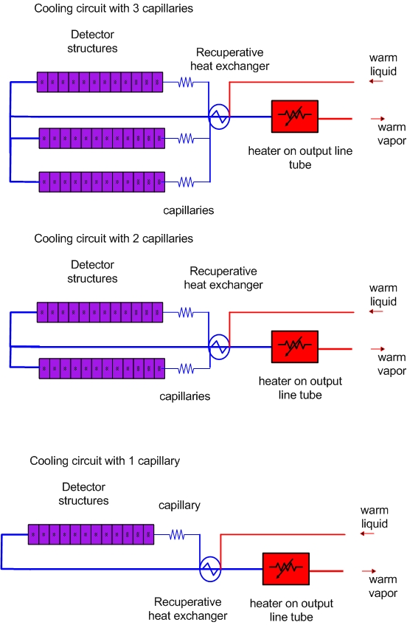

Fig.7 Three types of internal cooling circuits

The power loads of the cooling circuits have been calculated taking into accout the worst case internal heat dissipations (from modules and services) and the max external incoming heat flux from the thermal/gas barriers [3].
The cooling capacity of the SCT thermal barriers in particular has been set equal to the incoming heating power from the heaters on the external surface when they are all in operation. This is a conservative assumption with respect to the design criteria established in [4], which allow for additional margin of operation for such a critical item.
Detailed information on the internal circuit parameters and corresponding power loads is given in Table 1.

Table 1: basic parameters and cooling capacity of the internal evaporative circuits
 | Numbers of capillaries per circuit | Number of circuits | Nominal power load | Subtotal nominal power load | Baseline heat exchanger design
 | Numbers of capillaries per circuit | Number of circuits | [W] | [kW] | Baseline heat exchanger design
SCT Barrel | 2 | 44 | 504 | 22.2 | Capillary coiled inside return tube
SCT EC (3 sectors disk) | 3 | 40 | 346.5 | 13.8 | Capillary coiled inside return tube
SCT EC (2 sectors disk) | 2 | 24 | 241.5 | 5.8 | Capillary coiled inside return tube
SCT EC (1 sectors disk) | 1 | 8 | 136.5 | 1.1 | Capillary coiled inside return tube
Pixel Barrel | 1 | 56 | 220 | 12.4 | Parallel supply and exhaust tubes, capillary after supply
Pixel Discs | 1 | 24 | 110 | 2.7 | Parallel supply and exhaust tubes, capillary after supply
Pixel service panels | 1 | 16 | 250 | 4.0 | Parallel supply and exhaust tubes, capillary after supply
SCT EC outer thermal enclosure | 2 (*) | 12 | 525 | 6.3 | Capillary coiled inside return tube
SCT EC rear end thermal enclosure | 1 (*) | 4 | 220 | 0.9 | Capillary coiled inside return tube
SCT barrel thermal enclosure | 2 (*) | 12 | 216 | 2.6 | Capillary coiled inside return tube
TOTAL |  | 240 |  | 71.8
(*) These circuits have redundant capillaries

Granularity of the pressure control
Both the PR and the BPR are pneumatically controlled.
I/p (current-to-pressure) converters installed in the pneumatic control rack in USA15 are driven by the PLC and they are in charge of the pressure settings of the pressure regulator on the UX 15 platforms.
Although there is one pneumatic line connecting each pressure regulator to the pneumatic rack, the change of pressure set points, via the I/p converters, will be done initially at the level of groups of pressure regulators. Within the same group the pressure setting is then the same and the individual pressure regulators are simply switched ON and OFF according to the system operation strategy decided by the operator in the control room.
This approach is meant to reduce the cost and to keep the system as simple as possible and easy to operate.
The group selection for the flow control has been done taking into account that it is a fixed flow system and that adjustments of the flow is expected to be done at the level of detector.
The selection of groups for temperature control has been done with the aim of minimizing the temperature non-uniformities inside the detectors primarily due to temperature stratification.
However, the system is designed in such a way to be easily upgradeable, in case higher temperature or flow granularity would be required in the future.
Table 2 gives the details of the temperature and flow control granularity, which is currently requested.

Table 2: granularity of temperature/flow control
 | No. of flow set points | No. of temperature set points | Group description
Pixel detector | 1 | 4 | Top- bottom of services panel assemblies (2x)
Pixel detector | 1 | 1 | Disks side A
Pixel detector | 1 | 1 | Disks side C
Pixel detector | 1 | 1 | Top layer 1&2
Pixel detector | 1 | 1 | Bottom layer 1&2
Pixel detector | 1 | 1 | Top B-layer
Pixel detector | 1 | 1 | Bottom B-layer
SCT barrel | 1 | 2 | Top-bottom of layer 3
SCT barrel | 1 | 2 | Top-bottom of layer 4
SCT barrel | 1 | 2 | Top-bottom of layer 5
SCT barrel | 1 | 2 | Top-bottom of layer 6
SCT End Cap A | 1 | 4 | Top bottom of two groups of disks (2x2)
SCT End Cap C | 1 | 4 | Top bottom of two groups of disks (2x2)
SCT barrel thermal enclosure | 1 | 2 | Top-bottom
SCT End Cap A thermal enclosure | 1 | 3 | Top-bottom-end plate
SCT End Cap C thermal enclosure | 1 | 3 | Top-bottom-end plate
TOTAL | 7 | 34

Design criteria and assumptions

The most important design parameter of the cooling circuits, which affects the size of all the components, is the flow rate.
The goal is to minimize the required flow since the size of the components/tubes and the capacity of heater and of the main system is directly proportional to the flow itself.
The required flow is a function of the nominal power, the evaporation temperature, the inlet vapor quality and the outlet vapor quality of the heating structures and is given by the following equation:
W=P_{n}/(h_{ev}*(X_{u}-X_{i})) (1)
Where:
- W: flow rate (g/s)
- P_{n}: nominal power load (W)
- h_{ev}: latent heat (function of pressure) (kJ/kgK)
- X_{i}, X_{u}: heating structures inlet and outlet vapor quality
The power and the latent heat (function of the evaporation temperature in the structures) are fixed parameters. The latent heat at -25 °C is 102 kJ/kgK and 98 kJ/kgK at -15 °C
Therefore to minimize the flow one can only play with the inlet and outlet vapor quality of the heating structures.
The inlet vapor quality is function of the liquid pre-cooling (see figure 8), which is determined by the efficiency of the heat exchanger (η_{he}). The higher is the heat exchanger efficiency the lower is the inlet vapor quality and hence the flow required.
Changing the pre-cooling efficiency from 0% to 100% implies about a factor of 2 on the required flow, that’s why the pre-cooling is so important in spite of the complication of the system.
The efficiency of the heat exchanger is affected by the structures outlet vapor quality (inlet to heat exchanger) and by the temperature of the liquid at the inlet of the heat exchanger.
The outlet vapor quality from the structures has to be as high as possible to minimize the flow, but also should not be too close to one (100% of vapor) for the following reasons:
- Some margin (same residual liquid in the outlet fluid) is needed during the operation. Having even a small portion of the module cooling circuit with superheated vapor would lead to unacceptable temperatures on the related modules due to the significantly smaller heat transfer coefficient of the pure vapor flow.
- Some residual liquid in the return flow is extremely effective to increase the heat exchanger efficiency in particular in the last portion of capillary where most of the expansion occurs.
Extensive tests have shown that an outlet vapor quality of about 0.9 gives enough operating margin and allows a good efficiency of the heat exchanger.
Fig. 8: Phase diagram and thermodynamic cycle with effect of subcooling

The temperature of the liquid at the inlet of the heat exchanger is an extremely important parameter, which unfortunately is not fully under our control.
Most of the inlet tubes from the distribution racks (where the inlet liquid coolant can be assumed at the cavern temperature, i.e. +20…+25 °C) to the detector are trapped inside very narrow gaps that are extremely congested and in some areas are routed together with power cables.
Therefore there might be some uncontrolled heat pickup from the cables in the gaps and from the other surrounding detectors, which is a function of the unknown temperature in the gaps and of the thermal contact efficiency of the liquid tubes with the other structures. The gap temperature is not a controlled parameter, according to ATLAS ground rules all the systems should be thermally neutral, however from the practical point of view this is simply not realistic and some heat imbalances with associated temperature non-uniformities are inevitable.
In order to minimize the heat pickup along the inlet tube routing, all the inlet bundles are insulated (thick insulation from the racks to tile barrel fingers and thin (up to 5 mm) insulation from the tile fingers to the detectors. Back up warm monophase cooling circuits, to be operated in case of need, are also foreseen along the inlet bundles (one per bundle), from the racks to the tile fingers. However this is not possible, due to space limitations, from the tile fingers to the detectors, which is also the most critical area with maximal services congestion.
The choice of the inlet liquid design temperature (maximum expected) is therefore very critical since it does heavily affect both the flow and the pressure of the liquid side of the system.
Due to the uncertainties in the determination of the possible warm up along the inlet liquid lines it is assumed conservatively that the liquid temperature before the heat exchanger will be within the range 20…40 °C, as function of the heat pickup along the routing from the distribution racks.
The max inlet liquid design temperature of 40 °C requires a pressure in the inlet tubes above 12.8 bar(a) in order to be always above the saturation. Any vapor produced before the expansion of the liquid in the capillary would unacceptably affect the system operation.
In case we would have to run the system without heat exchanger and with an inlet liquid temperature of 40 °C we would require twice the flow needed at 20 °C, which is clearly not acceptable.
Therefore the heat exchanger is not only a component, which allows to increase the efficiency of the system (recuperating the residual cooling capacity of the cold exhaust fluid), but it is also essential to counterbalance the negative impact of possible higher temperatures in the inlet tubes.
A summary of all the major design parameters of the internal circuits is given in table 3.

TABLE 3: main design parameters of internal evaporative circuits
PARAMETER | DESIGN SPECIFICATION
Cooling capacity of modules circuits | Determined by the worst case dissipation
Cooling capacity of thermal enclosure circuits | Corresponds to maximum power capacity of heaters on the outer surface
Evaporation temperature of module circuits during normal operation | - 15 °C … - 25 °C
Min evaporation temperature of module cooling circuits | - 35 °C
Normal evaporation temperature of thermal enclosure circuits | - 7 °C … - 15 °C
Maximum evaporation temperature during initial operation or during tests | + 15 °C
Nominal outlet vapour quality at the exhaust of detector structures | 0.9
Design temperature range of inlet liquid temperature | +20…+40 °C
Temperature stability in the detector structures | +/- 2 °C

Pressure specifications
Each circuit can be divided into:
- an high pressure warm liquid part (from the PR to the capillary)
- a low pressure evaporative part (from the capillary to the heater)
- a low pressure superheated vapor part (from the heater to the BPR)
The circuit design driving parameters are:
- The minimum pressure in the inlet tubes (fixed by the max temperature)
- The evaporation temperature in the detector structures
The evaporation pressure is set by the required evaporation temperature. The circuits are designed for an evaporation pressure corresponding to the minimum temperature during normal operation:
- Module cooling circuits of SCT and Pixel and Pixel service panels: 1.67 bar(a), corresponding to an evaporation temperature of -25 °C
- SCT thermal enclosures: 2.47 bar(a) corresponding to an evaporation temperature of -15 °C
Lowering the evaporation temperature down to the required –35 °C will be achieved by means of decreasing the pressure at the inlet of the compressor. This can be done introducing a booster pump at the inlet of the compressor.
The minimum pressure in the liquid part of the circuit is driven by the requirement of being above the saturation point. At 40 °C the saturation pressure is 12.8 bar(a), 13 bar(a) is then set as the minimum pressure in the inlet circuit at the inlet of capillary.
Assuming:
- A pressure drop budget in the inlet tubes from PR to the capillary: 1 bar
- A pressure drop across the PR and along the main inlet tube from USA15 to the cooling rack: 1 bar
- Regulation range of input pressure regulator to change the flow: 1 bar
the maximum pressure at the outlet of the liquid pump of the cooling plant is then 16 bar(a).
The pressure drop budger of 1 bar along the inlet tubes has been set out of a reasonable compromise between the tube sizes and the maximum pressure of the circuit.
The pressure drop budget of the return tubes from the on-detector structures to the BPR is determined by the evaporation pressure in the structures and the pressure which can be maintained at the BPR inlet. The latter depends on the BPR flow coefficient, the inlet pressure to the compressor and the pressure drops along the main vapor return line from the racks to USA15. Accounting for the design parameters of the compressor, BPR and connecting circuit the min design pressure at the inlet of the BPR is 1.3 bar(a), thus leading to a pressure drop budget for the internal return tubes of:
  - 350 mbar for module cooling circuit
  - 1000 mbar for the thermal enclosure circuits
The pressure drop budget has been used to calculate the size of the inlet and return tubes.
The calculation of the pressure drops in the tubes has been performed by Derek Cragg (RAL consultant) with the following assumptions:
- +25% of nominal flow.
- Two-phase flow treated with an homogeneous equivalent model.
The calculated minimum tube sizes and corresponding pressure drops can be found on EDMS: https://edms.cern.ch/document/374020/1
Table 4 summarizes the design pressures in normal operation at full power in the most relevant locations of the internal circuits.

Table 4: design pressure during normal operation at full power in the evaporative circuit (bar(a))
 | Outlet of liquid pump | Outlet of PR (1) | Inlet capillary (1) | Outlet capillary | Detector structures | Inlet of BPR | Inlet to the compressor (3)
Pixel, SCT EC module circuits | 16 | 14 | 13 | 1.67 | 1.67 | 1.3 | 1
SCT barrel module circuits | 16 | 14 | 13 | 2.3 (2) | 1.67 | 1.3 | 1
SCT thermal enclosure | 16 | 14 | 13 | 2.47 | 2.47 | 1.3 | 1
- Could increase by 1 bar (regulation range) to increase the flow if needed.
- For installation reasons, in between the capillary and the inlet of SCT cooling circuits there is around 0.5m of flexible 2mm ID tube with a max pressure drop of about 600 mbar.
- The pressure along the return tubes up to the compressor could be decreased by means of a booster pump, which would allow reaching the required minimum temperature in the detector structures of -35 °C. Assuming the pressure shifts by the same amount all along the return tube, to lower the temperature by 10 °C in the detector structures the booster pump would have to reach guarantee a pressure at the inlet of 0.4 bar(a).

Efficiency of the heat exchanger and flow calculation.
As we said before, the most important parameter of the evaporative system is the mass flow.
The mass flow is heavily affected by the efficiency of the heat exchanger which, with reference to the notation of figure 8 can be defined as follows:
Fig. 8: Heat exchanger schematics

η_{he} = (T₀ – T₁) / (T₀ – T₂)

T₂ is the evaporation temperature in the structures.
T₀ is the inlet liquid temperature, conservatively assumed +40 °C

Extensive tests on prototypes have shown that for the barrel SCT (worst case) at full power with a 40 cm long heat exchanger (fitting in the available space) with the capillary coiled inside it is possible to reach efficiencies above 60%, which correspond, for the module circuits, to a temperature of the inlet fluid after the heat exchanger of about 0 °C.
For the thermal barrier circuits these conditions correspond to a fluid temperature after the heat exchanger of about +5 °C.
For the pixel detector the tests on the parallel heat exchanger have shown that an efficiency of 50% can be reached, which correspond to a temperature of the inlet liquid after the heat exchanger of +8 °C
The design specifications for the heat exchanger are then listed in table 5.
Table 5: design specifications of the heat exchanger
 | Pixel heat exchanger | SCT Modules heat exchanger | SCT Thermal enclosure heat exchanger
Max inlet liquid temperature (T₀) | +40 °C
Nominal output temperature from structures (evaporation T), (T₂) | -25 °C | -25 °C | -15 °C
Max temperature of inlet fluid after heat exchanger | T₁= +8 °C | T₁= 0 °C | T₁= +5 °C
Corresponding heat transfer minimum efficiency | 50 % | 61.5 % | 63.5 %
Max pressure drops | 50 mbar
Max outlet temperature of the return fluid (T₃) | +25 °C
Design pressure | 16 bar(a)

Assuming this set of design specifications for the heat exchanger and an outlet vapor quality from the structures of 0.9, the required mass flow has been calculated for all the circuits and together with other useful parameters is given in table 6.
Table 6: heat exchanger operating conditions and calculated mass flow of the circuits
circuit | Power load | T₀ | Nominal Mass flow  (per circuit) | Heat exchanger efficiency at full power | Inlet quality to structures | Outlet quality from structures (P=100%) | T₁ | T₂ | T₃  (T₀=40 °C) | T₃  (T₀=20 °C)
 | W | °C | g/s |  |  |  | °C | °C | °C | °C
SCT Barrel | 504 | 40 | 7.8 | 61.5 | 0.27 | 0.9 | 0 | -25 | 21 | -8
SCT EC  (3 sectors disk) | 346.5 | 40 | 5.3 | 61.5 | 0.27 | 0.9 | 0 | -25 | 21 | -8
SCT EC  (2 sectors disk) | 241.5 | 40 | 3.7 | 61.5 | 0.27 | 0.9 | 0 | -25 | 21 | -8
SCT EC  (1 sectors disk) | 136.5 | 40 | 2.1 | 61.5 | 0.27 | 0.9 | 0 | -25 | 21 | -8
Pixel Barrel | 220 | 40 | 3.9 | 50 | 0.35 | 0.9 | 8 | -25 | 10 | -20
Pixel Discs | 110 | 40 | 2.0 | 50 | 0.35 | 0.9 | 8 | -25 | 10 | -20
Pixel service panels | 250 | 40 | 4.5 | 50 | 0.35 | 0.9 | 8 | -25 | 10 | -20
SCT EC outer thermal enclosure | 525 | 40 | 8.0 | 63.5 | 0.23 | 0.9 | 5 | -15 | 24 | -6
SCT rear end thermal enclosure | 220 | 40 | 3.3 | 63.5 | 0.23 | 0.9 | 5 | -15 | 24 | -6
SCT barrel thermal enclosure | 216 | 40 | 3.3 | 63.5 | 0.23 | 0.9 | 5 | -15 | 24 | -6

The return fluid temperature at the outlet of the heat exchanger does not change with higher efficency of the heat exchanger if, as is the case, the flow does not change.
It is also assumed that the flow does not change from 0 to 100% of power, in reality the experiments have shown a max increase of about 10% (due to the decrease of the average temperature in the capillary. However higher flows lead to an increase of the efficiency so the assumption of constant flow is conservative.
For the reasons explained in section 3.6 flows 20% higher than the nominal have to be assumed for the calculation of the capacity of the main plant. This assumption is coherent with that assumed for the calculation of the required maximum heater power (see later).

Heater design parameters and power capacity
Once the flow is known, then the power capacity of the heater needed to evaporate the residual liquid after the heat exchanger and to rise the vapor temperature up to +20 °C can be calculated.
The required heater power is maximum when there is no power load on the detector structures.
For the calculation it is also assumed, conservatively, that the inlet liquid temperature is +20 °C.
Table 7 lists the major design specifications for the heater.
Table 7: heater specifications
Inlet liquid temperature to heat exchanger | +20 °C
Outlet superheated vapor temperature | +20 °C
Acceptable temperature range of the vapor outlet temperature | +20 °C ….+30 °C
Max temperature of the heating element | +120 °C
Max pressure drops | 50 mbar
Design flow | +10% of nominal
Design pressure | 16 bar(a)
Design margin on the power | +15%
The max power of the heater is not affected by the efficiency of the heat exchanger, but it is a function only of the flow and of the temperature of the liquid at the inlet of the heat exchanger.
Table 8 gives the maximum, minimum power and design power of the heaters for the various circuits.
The heaters have been grouped into 2 classes and a number of subclasses:
- the first class contains heaters with power up to 650 W
- the second class contains heaters with power above 650 W
The two groups correspond to different size of the heater.

Table 8: heater design parameters
circuit | Power load | T₀ | Nominal Mass flow  (per circuit) | Min heater power (1) | Max heater power (2) | Heater design power (3) | Design margin | Heater class
 | W | °C | g/s | W | W | W | %
SCT Barrel | 504 | 20 | 7.8 | 184 | 840 | 960 | 15 | H2/2
SCT EC  (3 sectors disk) | 346.5 | 20 | 5.3 | 121 | 570 | 650 | 15 | H1/5
SCT EC  (2 sectors disk) | 241.5 | 20 | 3.7 | 85 | 400 | 480 | 20 | H1/3
SCT EC  (1 sectors disk) | 136.5 | 20 | 2.1 | 47 | 226 | 260 | 15 | H1/1
Pixel Barrel | 220 | 20 | 3.9 | 127 | 420 | 480 | 14 | H1/3
Pixel Discs | 110 | 20 | 2.0 | 68 | 216 | 260 | 20 | H1/1
Pixel service panels | 250 | 20 | 4.5 | 150 | 485 | 560 | 15 | H1/4
SCT EC outer thermal enclosure | 525 | 20 | 8.0 | 165 | 840 | 840 | 0 (4) | H2/1
SCT rear end thermal enclosure | 220 | 20 | 3.3 | 65 | 350 | 350 | 0 (4) | H1/2
SCT barrel thermal enclosure | 216 | 20 | 3.3 | 69 | 350 | 350 | 0 (4) | H1/2
- corresponding to nominal power load on the structures and nominal flow.
- corresponding to no power load on the structures and to 20% of mass flow increase (see section 3.7).
- Max heater power + design margin
- Assuming no design margin for the heaters of the thermal enclosures accounts for the fact that the thermal enclosure cooling circuits will be operating at the same time of the corresponding heaters: therefore there will be always a non negligibe heat load and the heater on the return tube will never work at full power.

Capillary design parameters
The correct choice of the capillary delivering the correct mass flow is critical for the operation of the evaporative circuits.
The mass flow through a capillary is determined by the pressure drops, the length and the inner diameter.
The design pressure drops of the capillaries can be extracted from table 3:
- Pixel and SCT EC modules circuits: 11.3 bar
- Barrel SCT modules circuits: 10.7 bar
- SCT thermal enclosures: 10.6 bar
The length of the capillary is driven by the circuit layout and, especially for EC SCT and pixel module circuits, which have the capillary inside the thermal enclosure, it has to be as short as possible.
The pressure drops are fixed, the length and ID can be changed within certain boundaries to give the required flow.
There is no reliable analytical model which can be used to determine the flow as function of the capillary parameters with sufficient accuracy. The right choice of the capillary can be achieved only in combination with an empirical approach.
Fig. 9: Capillary flow vs. pressure characteristic as function of length

Several tests have been done on different length and ID of capillaries and the following conclusions have been drawn:
- The mass flow is only slightly affected (<5%) by the inlet liquid temperature (in the range +20…+40 °C)
- The mass flow is slightly affected by changing the power load on the structures from 100% to 0%.
- The mass flow is negligibly affected by the change of the performances of the heat exchanger (from 60% upwards)
- There is about a factor of 2 between the change of pressure across the capillary and the corresponding change of the flow (10% increase of the pressure across leads to 5% flow increase)
Figure 9 shows an example of an experimental characteristic curve (flow vs Δp across) for a 0.88 mm ID capillary for different lengths.
The acceptable range of variation of the nominal flow for the correct operation of the circuit is rather limited.
Assuming the following possible variations of the nominal flow:
- 0..+5% from manufacturing
- +5% due to flow regulation
- +10% anticipated in the worst case from 1, 2 and 3
it gives a total flow range of variation of 0…20%, which is accounted for the calculation of the maximum heater power.
On the manufacturing side, taking into account that the flow changes with the diameter to about the 5th power, strict quality control procedures (individual testing) will have to be set up in order to tune the length of the capillary to achieve the right flow, thus compensating the manufacturing tolerances on ID.
Table 9 gives the main design parameters of the capillaires for the various circuits and also gives a tentative value for the ID, which will have to be finally determined through specific tests.

Table 9: capillary design parameters
circuit | Power load (per capillary) | Mass flow  (per capillary) | Approximate minimum required length | Estimated ID, corresponding to the minimum length (1)
 | W | g/s | mm | mm
SCT Barrel | 252 | 3.9 | 4000 | 1
SCT EC (first disks)  (inner and mid sectors) | 105 | 1.6 | 3000 | 0.7
SCT EC (last disks)  (inner and mid sectors) | 105 | 1.6 | 2000 | 0.65
SCT EC (first disks)  (outer sectors) | 136.5 | 2.1 | 3000 | 0.75
SCT EC (last disks)  (outer sectors) | 136.5 | 2.1 | 2000 | 0.7
Pixel Barrel | 220 | 3.9 | 600 | 0.7
Pixel Discs | 110 | 2.0 | 500 | 0.5
Pixel service panels | 250 | 4.5 | 600 | 0.75
SCT EC outer thermal enclosure | 262.5 | 4.0 | 4000 | 1
SCT rear end thermal enclosure | 220 | 3.3 | 3000 | 1
SCT barrel thermal enclosure | 108 | 1.7 | 3500 | 0.75

(1) the ID estimate is based on the available experimental data. As stated before, different combinations of lengths and ID can be adopted to achieve the same flow with the fixed pressure drop.

Flow chart of design process
The design process to determine the parameters of the circuits and related the assumptions is shown in the following chart.

Analysis of different operating and test conditions
There are 6 possible working conditions the system is requested to cope with:
- Normal operating conditions at nominal power: reference conditions, which the system is designed for
- Operation with nominal power load but at higher evaporation temperature
- Operating conditions with no power
- Start up and shutdown
- Warm tests
- Test with no subcooling

Normal operating conditions at full power

The evaporative temperature can be adjusted by tuning the BPR (with the limitations previously illustrated).
As function of the thermal impedances of the detector structures the expected ranges of variations of the set point of the evaporation temperature are:
- -15 °C … -25 °C for the modules cooling circuits
- -7 °C … -15 °C for the thermal enclosure cooling circuits

The system will also be able to decrease the temperature below –25 °C, possibly down to –35 °C, however, reaching such a low temperature is not guaranteed.

Operating conditions with nominal power load but at higher evaporation temperature
During the initial running it might be worth to operate the detector warm (at a temperature up to +15 °C) since the radiation damage is getting important only with the ageing. This option is interesting since it would allow postponing the problems related to the thermal control and possible condensation and focusing on other typical problems of the initial start-up.
Operating at higher temperature means having a higher evaporation pressure in the detectors structures.
A higher evaporation temperature implies a decrease of the cooling capacity; see detailed discussion in the warm tests section.
However, while during the warm tests the inlet liquid temperature can be maintained around 20 °C, thus allowing only a slight decrease of the cooling capacity, when the detector will be in operation the inlet temperature will not be fully under control. Therefore the fraction of cooling capacity lost due to higher temperature operation cannot be precisely predicted and will significantly depend on how well we could prevent the inlet liquid warm up.
In other words, the warm operation of the detector is possible, but the max temperature that can be achieved depends on the temperature of the inlet liquid and on the initial power load of the detector (see discussion in the warm tests section).

Operating conditions with no power
This is the mode of operation when the detector is installed, kept cold and ready for running, but there is no power load from the modules.
The module cooling circuits could be in operation in order to allow keeping the required low temperature on the module (this is in particular the case for the Pixel detector not having an actively cooled thermal enclosure). However, since in these conditions there is no heat load from the modules, the temperature in the cooling circuits is not required to be too low.
The expected range of variations of the set point of the evaporation temperature in these conditions is -7 °C … -15 °C for all the circuits.
By tuning the BPR the evaporation pressure and temperature can be increased to the desired value. The mass flow is reduced (lower pressure difference across the capillary) and the required heating power from the heater is lower.
This is a perfectly stable working condition and the system can cope with it without any problem.

Start-up and shutdown
The system start-up procedure (setting one or more circuits ON) does not require any particular care since the risk of thermal shocks is non-existing due to the high thermal inertia of the long feed lines.
In case of sudden shut off of one or more circuits the flow will decrease, but not so fast due to accumulated liquid in the inlet tubes. By the way, the associated pressure decrease will be in the worst case (assuming the BPR set point is unchanged) of the order of 350 mbar for the module cooling circuits, corresponding to a maximum temperature decrease of 5 °C, thus fully acceptable.

Warm tests
During integration on the surface and installation in pit it might be necessary to test the evaporative circuits at a temperature above the cavern dew point in order to avoid condensation on the cold tubes.
The required evaporative temperature to avoid condensation at the cavern dew point conditions is 15 °C.
The increase evaporation pressure (about 6.6 bar(a) @ 15 °C ) leads to:
- decrease of flow (by about 23%)
- decrease of the latent heat
- decrease of the vapor inlet quality to the detector structures.
The three effect are partially counterbalancing, but the cooling capacity is getting smaller.
Assuming that during testing (both on surface and in pit during installation) the input liquid temperature can be mantained at 20 °C, the reduced cooling capacity is able to cope with a power load 5% less than the nominal one.
Moreover, in these conditions the efficiency of the heat exchanger plays a limited role, in fact in case the heat exchanger would be missing, the cooling capacity would show a further, but slight reduction, leading to a max acceptable power load of about 10% less than the nominal one.
Given the fact that the design power loads have been calculated with good safety margins (certainly >10%), a 10% decrease of the max power load during the warm test should still allow to run a full system test at full power. Furthermore, the power consumption of the silicon detectors at the start is expected to be lower then after 10 years of operation
If there is the flexibility of using a different capillaries than the final one, as it could be the case for the SCT barrel, then the lack of capacity could be overcome by using a capillary delivering an higher flow.
Also the possibility of using a different capillary than the final one would allow reducing the inlet liquid pressure (down to 7.5 bar(a) if the inlet temperature is limited to 20 °C.
Another possibility would be of course to test only a fraction of the modules at a time.

Tests with no sub-cooling
At some of the integration stages when the heat exchanger is not yet available and when the subcooling is not possible it might be worth to be able to test the system without subcooling.
According to the discussion about the warm tests, test are possible with a power up to 90% of the nominal and with no subcooling only in case the evaporation temperature is close to 15 °C.
Tests at lower temperature with no subcooling are possible only with a fraction of the nominal power, where the fraction is determined by the required evaporation temperature.
Also in this case, if it is possible to use a different capillary, the lack of cooling capacity could be compensated by a larger flow. However increasing the flow above the nominal might lead to unacceptably higher pressure drops and different thermal conditions. Therefore a careful study case by case would be required.

Physical implementation and design of main components

Heater design
The heater design we have converged on consists of an heating element which is coiled in spiral and introduced coaxially inside the return tube (see Fig. 10). This type of heater is very efficient since the heating element is in direct contact with the fluid. This is proven by the fact that for the circuit with the highest power an heated length of the return tube of about 500 mm is enough to boil out the liquid when there is no power on the modules and to reach a temperature above the dew point with a max temperature on the heating element of about 80 °C. The heater, being internal to the tube, also minimizes the outer tube temperature, which, in the worst case, does not exceed 40 °C, thus also minimizing the required thickness of the insulation on the tube itself, which can be as small as 3-4 mm.

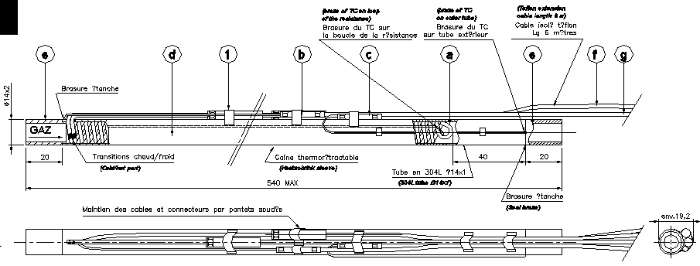
Fig. 10: Manufacturing drawing of current heater design

Heat exchanger design

The design of heat exchanger, which has been finally adopted for the SCT cooling circuits, consists of the capillary coiled inside the return tube over a given length (see fig. 11, showing a schematic of the EC SCT module circuit heat exchanger), which is function of the power of the circuit and of the integration constraints. Current required length is estimated to about 500 mm.
The capillary length can be increased as much as needed by the heat exchanger requirement, tuning the ID accordingly in order to achieve the proper working characteristic (pressure drop vs. flow).
This heat exchanger design allows for having the inlet fluid to the capillary always warm, thus avoiding the risk of possible blockages due to ice crystal formation in the fluid in case of non proper cleaning. This risk is usually unlikely on a small-scale system, but in the case of the ID evaporative system, wide, complex and with very limited access it might become a serious problem if underestimated.

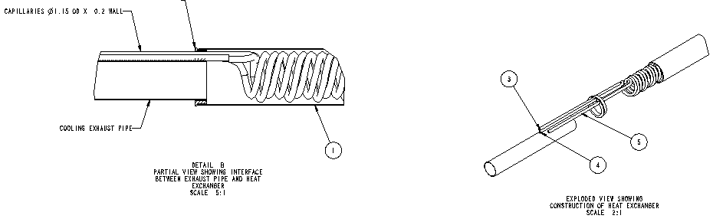

Fig.9 Design of the SCT type of heat exchanger

The pixel detector has adopted as a baseline a parallel tube heat exchanger with the supply and exhausts tubes running next to each other over a length of about 1.6 m and joined together with thermal epoxy.
This different design with respect to the SCT design is driven by the different material for the tubes (Al for pixel and Cu/Ni for the SCT) and by the different layout constraints.

System integration and layout

Liquid tubes of the evaporative cooling system are routed from four distribution racks on platforms 1 and 7 at sides US15 and USA15, Fig.3, to the detector structures and thermal barriers via Z = 0, along the Tile Barrel, through gaps between the Tile Fingers, LAr Electronic Boxes along the cryostat flange and along the cryostat bore (Fig. 10). Vapor return tubes follow the same routing that allows the implementation of the recuperative heat exchanger. Supply/return lines are grouped into bundles. Specific number of tubes in a bundle depends on the sub-detectors requirements and it varies from 5 (Pixel) to 9 (SCT EC).
All the tubes from the thermal enclosure feed through on the detector to the cooling racks will have to be insulated, individual insulation is also required around the heaters and the heat exchangers:
- From the detector up to PP2 at least 5 mm passive insulation is required (this is physically the maximum allowed by the available space).
- From PP2 to the cooling racks the input tubes need to be insulated to minimize the heat pickup from the other detectors (10 mm passive insulation is recommended). The return tubes do not require thermal insulation, but will have to be electrically insulated with respect to any other surrounding structure, for grounding purposes.
Cables for power supply and control of the heaters follow the same tube routing inside the ATLAS experiment volume.
The thermal enclosure tubes are bundled independently from the bundles of the module cooling tubes. This allows for keeping the thermal enclosure connected and working during access for maintenance until the last moment before the removal of the detector, thus minimizing the warm-up time of the silicon modules.

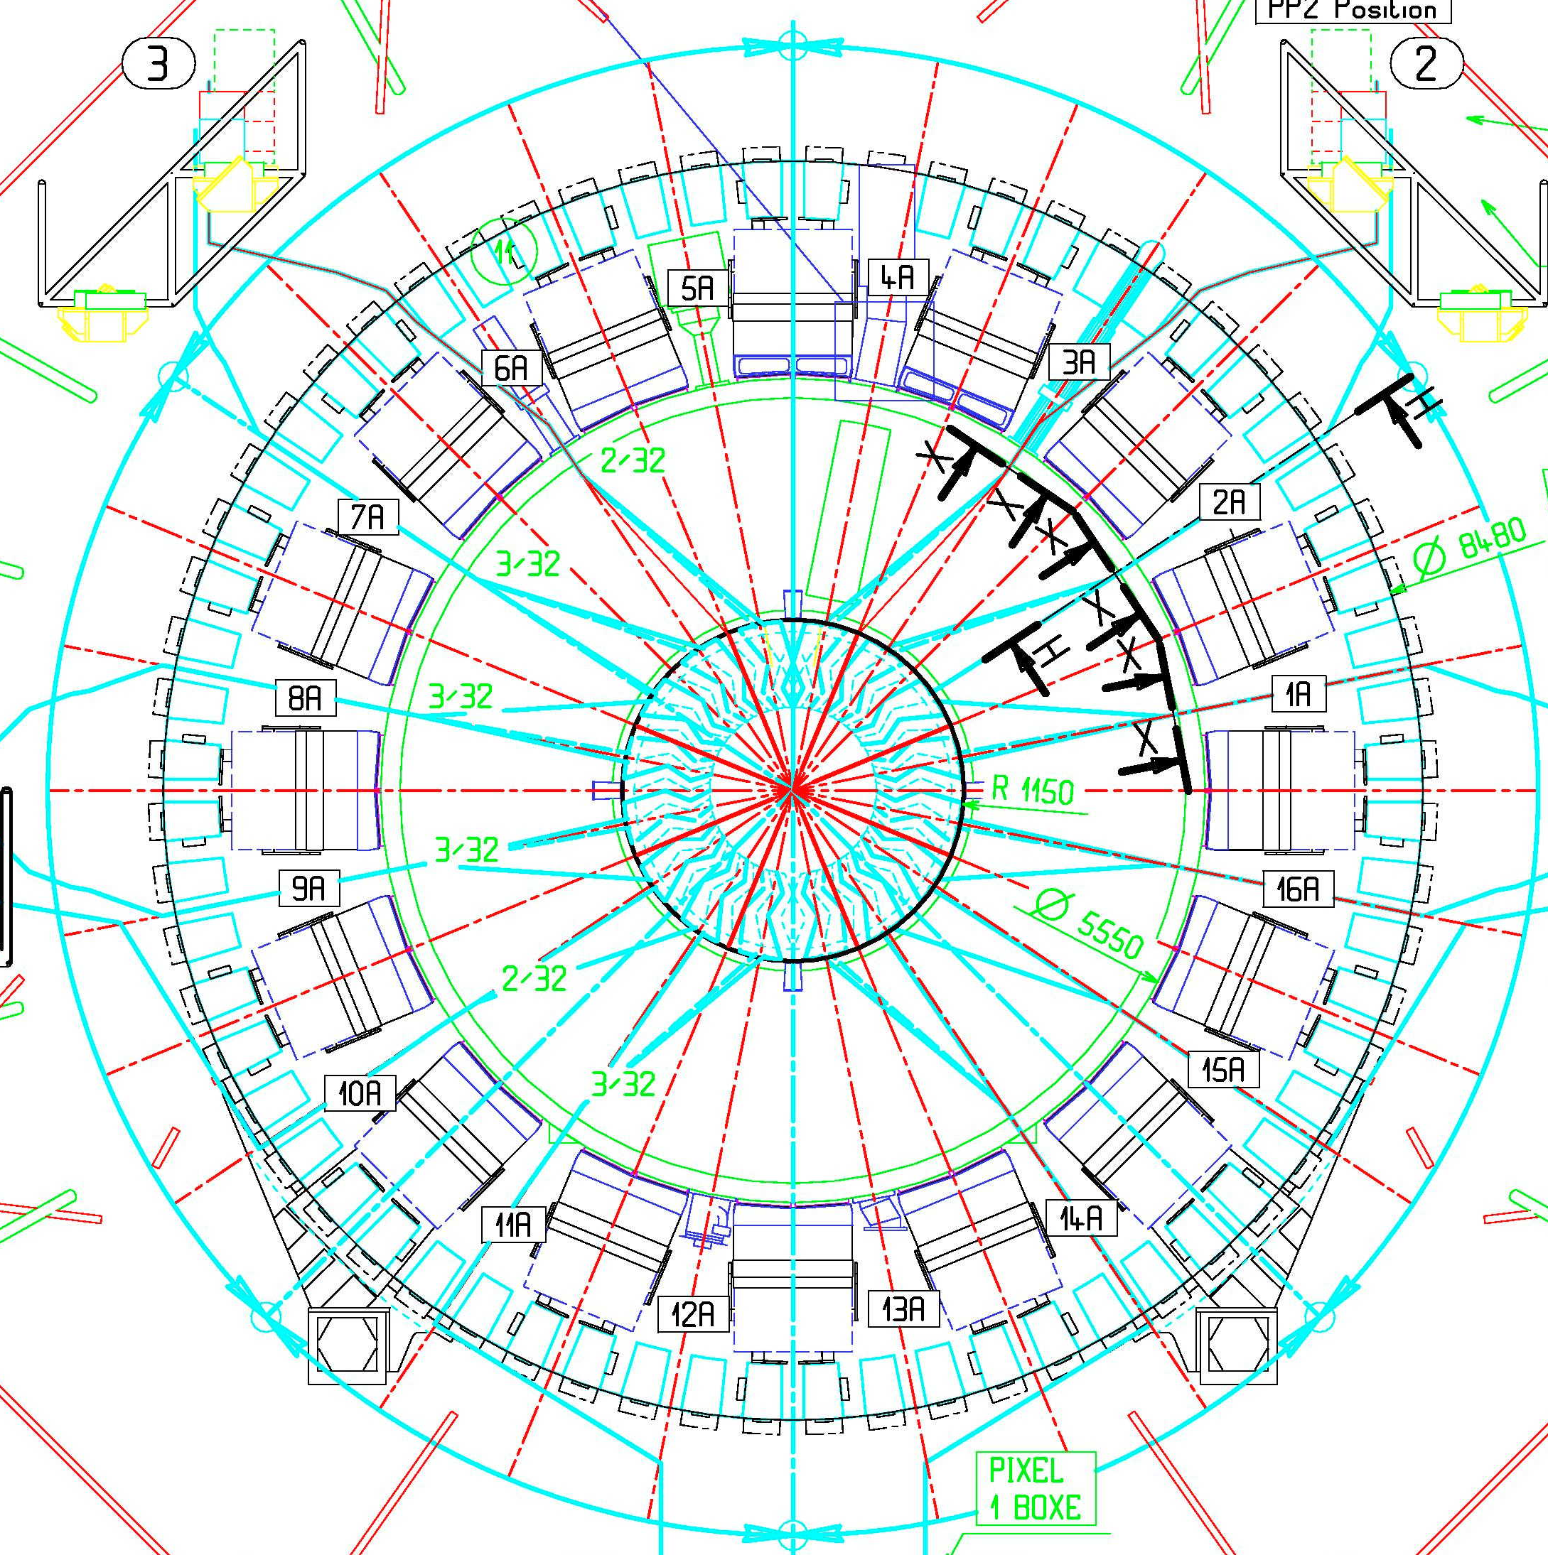

Fig.10 Gaps between LAr Electronic Boxes

Fig. 11: Pipe routing and position of the heater and heat exchanger in the ID volume

Position of the recuperative heat exchangers and the heaters for each sub-detector as well as routing of supply/return tubes up to the distribution racks is presented schematically in Fig.11.

References

  - ATC-TL-EP-0001: Evaporative Cooling System for ATLAS Inner Detector Silicon Trackers (Pixel and SCT): external part
  - ATL-IC-ES-0010: Evaporative Cooling Racks on ATLAS Services Platforms
  - ATL-IC-EN-0009: Environmental and Thermal Management of ATLAS Inner Detector
  - ATL-IS-ER-0045: SCT Thermal Enclosures

