Module and System Performance of the ATLAS Endcap SemiConductor Tracker

R.Batesª on behalf of the ATLAS SCT collaboration

ªThe University of Glasgow

The ATLAS Semiconductor Tracker, (SCT), is one of the three tracking detectors that will make up the ATLAS inner detector. The tracker consists of an assembly of 4088 silicon microstrip detector modules covering an area of over 60m², distributed over 4 barrel cylinders and 18 Endcap disks, 9 at each end of the barrel region. The detector modules consist of back-to-back silicon sensors that provide space points for track reconstruction. The sensors are readout via front-end ASICs, with binary data, from selected events, taken off module via optical links. A large number of prototypes have been built. These are tested individually in many institutes with electrical test-pulses. The modules however, must operate in a large-scale system with many hundreds of modules in close proximity to each other. To validate the electrical performance of such a system a "system test" has been established at CERN. This paper gives a brief overview of the ATLAS Endcap SCT. The performance of individual modules is discussed while and the electrical performance of assemblies of module studied at the system test is explored in detail. The off detector electronics and software used throughout these studies is also described.

The SCT modules are read-out using a binary scheme and therefore the most important characteristic of the device is the noise occupancy at a given discriminator threshold. Modules are characterized individually on the beach with electrical test-pulses and read-out electrically. The module is acceptable if the number of bad channels is low and the noise occupancy is below 1x10⁻⁵ at 1fC input charge. The characterization of single modules will be discussed in detail and the latest module results show. How the noise is affected in a multi-module system is also of crucial importance. To ascertain such a system test has been constructed.
The Forward (End-Cap) System Test is based around a carbon fiber sector, equivalent to one quarter of a disk. This is mounted on an aluminum support frame within a copper enclosure representative of the thermal shield. A total of 13 outer modules and 10 inner modules may be mounted on the front of the sector and 10 middle modules on the back. A close up showing four outer modules mounted on the sector is shown in figure 1. A total of 33 designs of “wiggly” low mass tape are required to service a full quadrant. For the system test, 9 designs have been produced which were fitted to the disk as best as was possible. Opto-harnesses comprising optical fibers and plug-in PCBs are used to provide clock and control signals for groups of 5 or 6 modules.
The grounding and shielding scheme used in the forward system test is again based upon that described in references [1] and [2]. All cooling blocks are electrically tied to the surface of the disk, and to the shield, through a system of foils applied to the disk’s surface. The two grounding schemes differ significantly from each other in how the modules are referenced to each other. One scheme tries to obtain as tight as possible DC connection between each and every module, while the other realizes on shunt shields between the module and the disk structure.
The two grounding and shielding proposals have been vigorously tested to enable the best possible rejection of external noise sources to be achieved. Measurements of the performance of the modules when run together have been performed to understand their behavior with and without intentionally injecting noise into the module power cables. Initial studies have shown good performance in the absence of noise injection. The noise measured for each of a group of four outer modules is shown in figure 2. The values have been normalized to the ATLAS operating temperature of 2OC. The noise occupancy of a group of four outer modules mounted on the sector is shown in figure 3. The occupancy of each chip is well below the limit of 5x10-4 imposed by the specifications.
External noise rejection depends significantly upon the grounding scheme adopted. The final results of the chosen scheme will be presented.
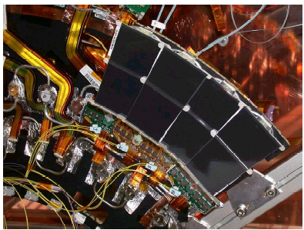
Figure 1 A close-up of four outer modules on the sector
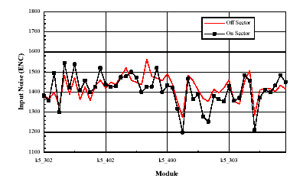

Figure 2 Noise of 4 modules measured on and off the sector
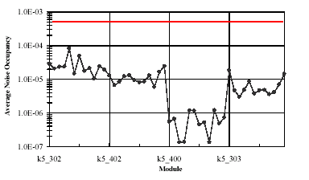
Figure 3 Noise Occupancy of four modules measured on the sector

References:

1: N. Spence, “ATLAS SCT/Pixel Grounding and Shielding note”, ATL-IC-EN-0004
2:N.A. Smith et al., ”Grounding and Shielding for the SCT Endcap”, ATL-IS-ER-001

