Studies of module 20220240100044 (Glasgow 5th qualification module) at CERN.

Module 20220240100044 was shown to have high noise when measured in Glasgow. During the SCT week the module was tested at CERN by Richard and Ashely to try and understand the origin of this extra noise and bring the module into Specification.

At Glasgow the module was tested in a Valencia testbox with AERO readout at 10C.

The noise measured by the RC plot was over 1650electrons across the whole module.
Looking at the hybrid test results from RAL and Manchester there is an increase in noise on chip S11. Results from Manchester: Noise = 710 while the average noise on the other chips is 656electrons. S11 also had slightly low gain of only 49.93 compared with 51.6.

It was found that removing the lids of the Valencia test box improved the performance of the module by reducing the noise at 2fC and by improving the shape of the NO s-curves.

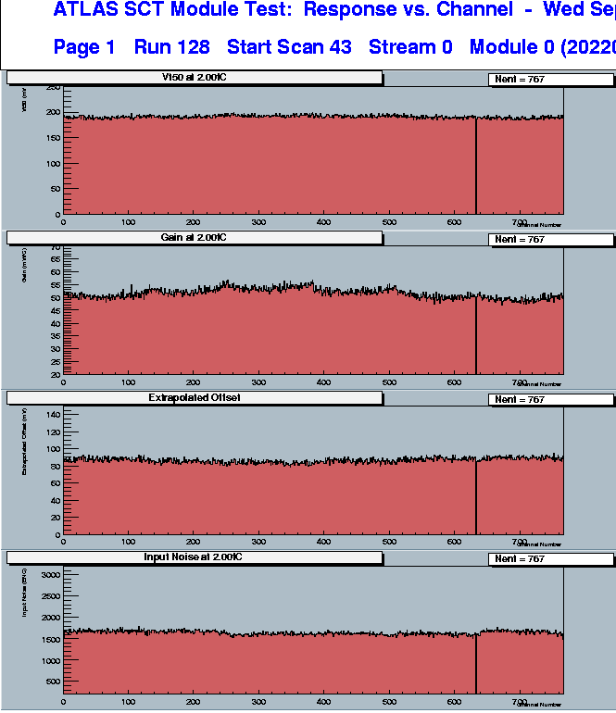
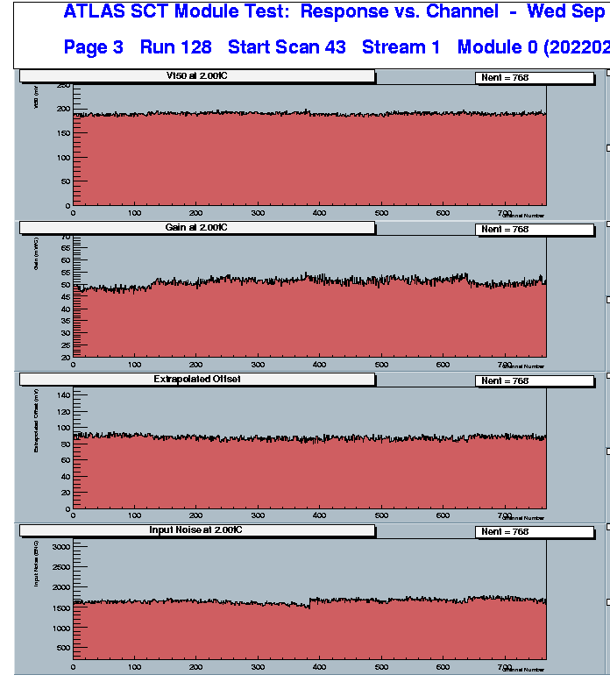

The noise occupancy exhibited the typical distortions in the s-curves as measured in some forward institutes. Note the module was trimmed high at Glasgow due to one channel with trim offset problems. This channel was masked during tests at CERN.

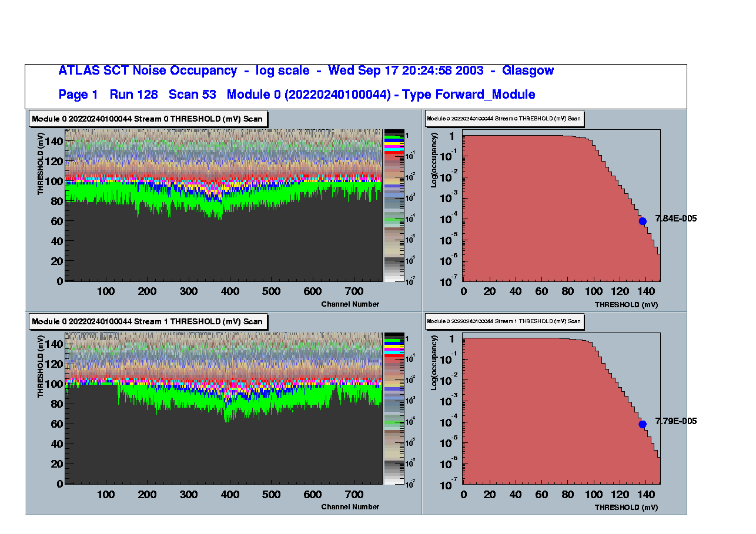
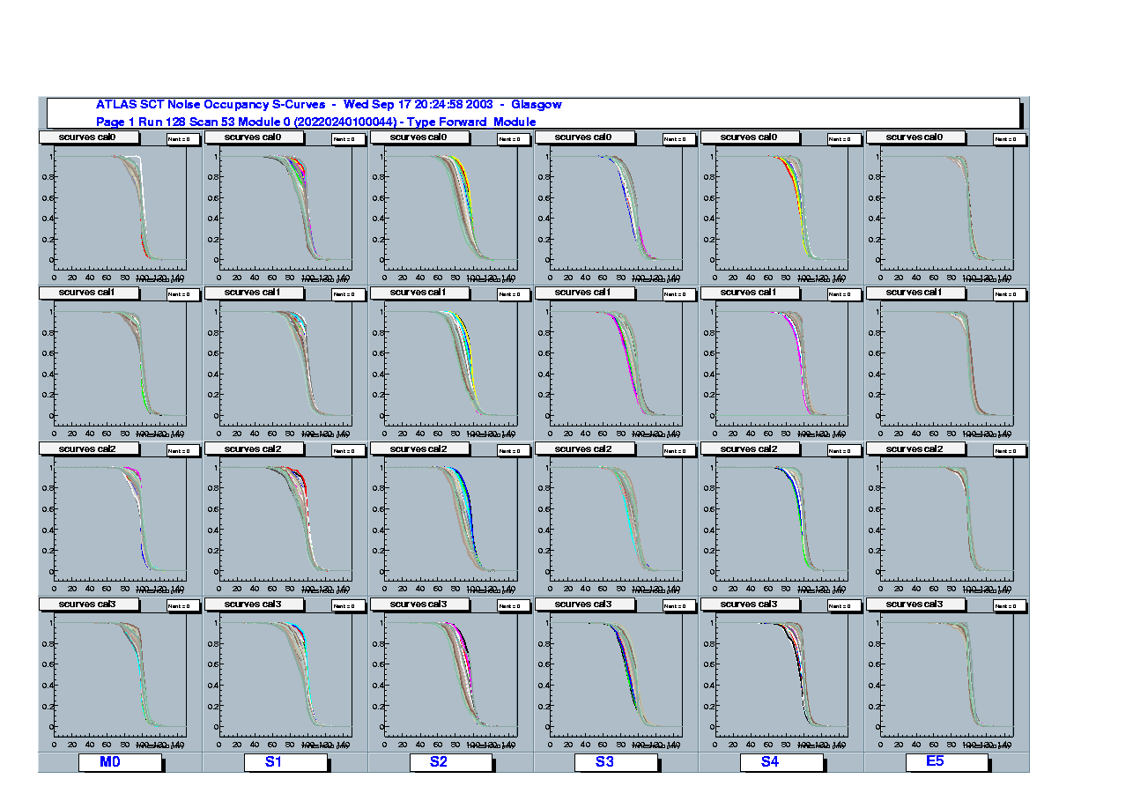
chip M0 chip S1

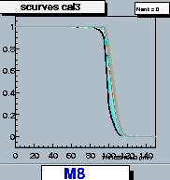chip M8

Measured in CERN in the environmental chamber with a lot of care to the settings of Strobe delay made no significant difference to the shape of the s-curves and the level of the noise of the module.

It was found that the noise of the module was reduced by turning off the front end of one chip (Shaper and Pre-amp set to 0.0) by about 100 electrons. Average noise of module was 1568 with S1 turned off, T=8C. Three different chips were tried (S1, S4 and S10 ) and all produced the same effect. Noise of chip S11 remained high at 1700 electrons.
The gain of the chips was slightly reduced but this could be timing settings. Measured at CERN by 3pt gain: Average originally = 56.7 excluding S11 (S11=53.8) with one chip off, average = 53.9, excluding S11 (S11=50.3).

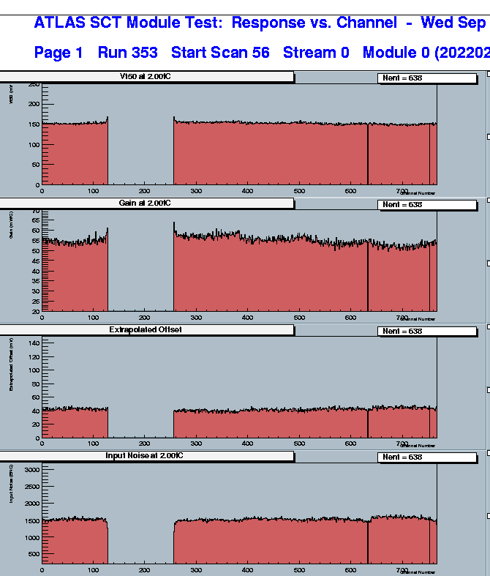

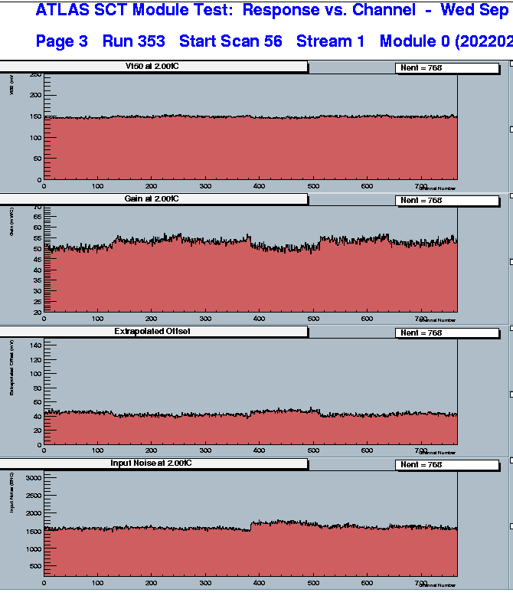

Turning off a chip did not noticeably alter the noise occupancy of the module.

As these electrical testes are performed in a clean room inside a light tight enclosure (environmental chamber) the effect of removing the metal covers of the Valencia test box could be studied.

Removing the top lib of the test box had a dramatic effect on the overall noise and the shape of the noise occupancy plots and s-curves.
The average noise of the module fell to 1458 (including chip S11, which has a noise of 1595), T=9C, link0=1444, link1=1473.

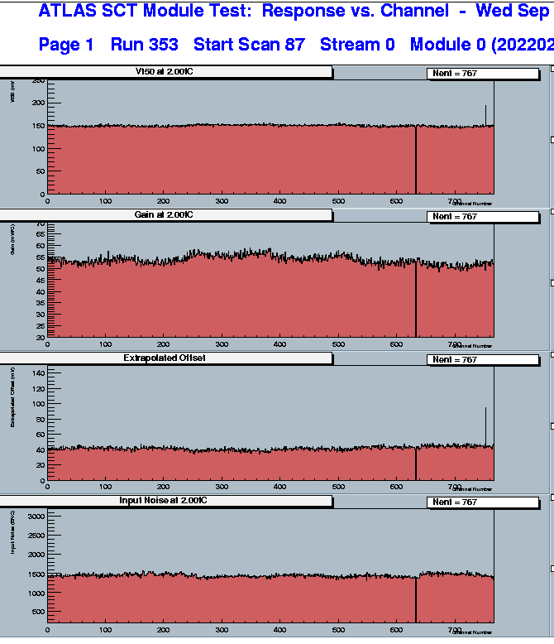

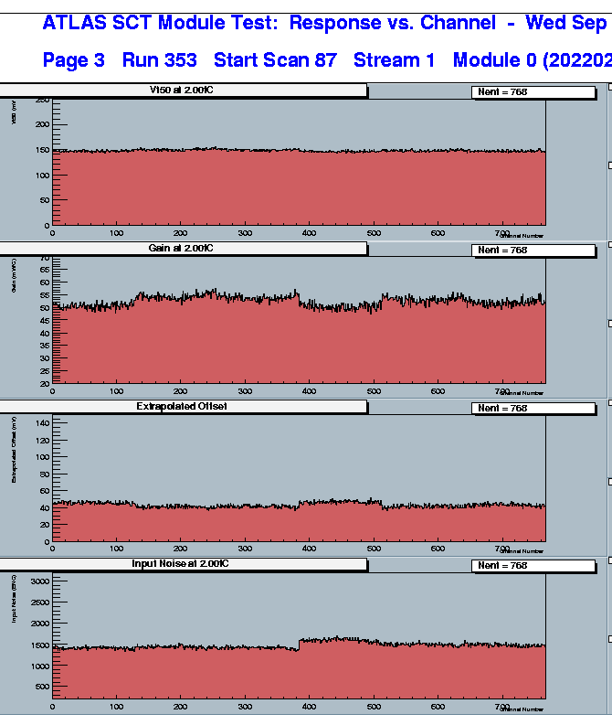

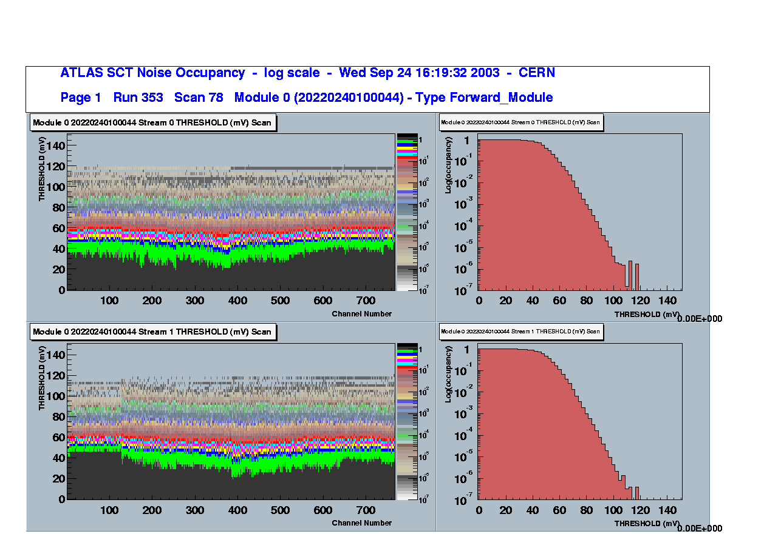

Note this module is running at 4C for this measurement only.
The S-curves across the module start to look better.

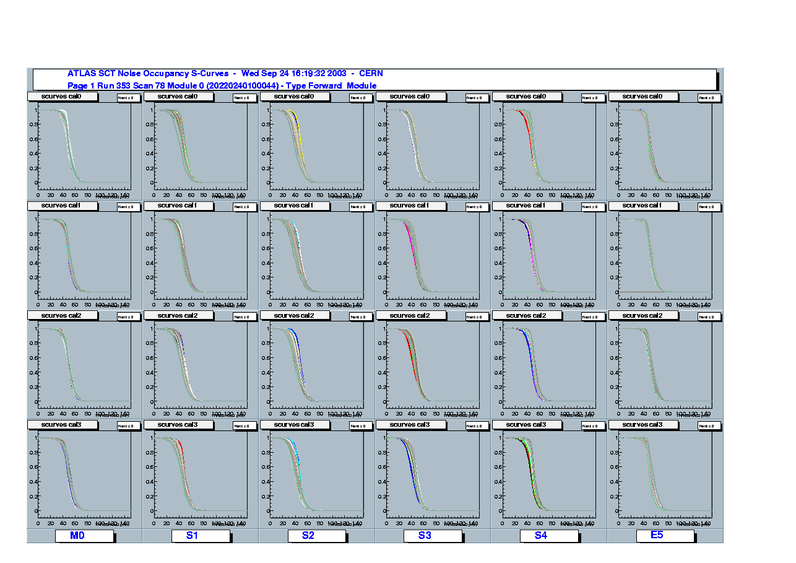
chipM0 chip S1

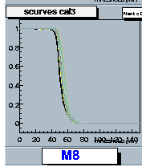chip M8

The bottom lid was then removed. The module box is sitting on a piece of paper on top of a metal tray that is connected to the environmental chamber. The electrical connection from the test box to this tray and the rest of the chamber can be improved. As the box lids have been removed the module has become more susceptible to switching currents in the environmental chamber, which are manifested as horizontal lines in the No plot. These should be ignored as they can be removed and it is the improvement in the s-curves ACROSS the module that is important.

The noise across the module was still reduced from the lids on case, to only 1491 electrons (including S11, which has a noise of 1552); link0=1462,link1=1521.

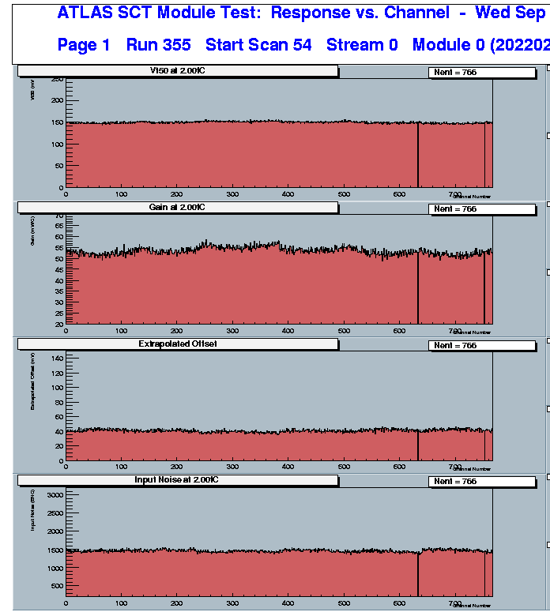

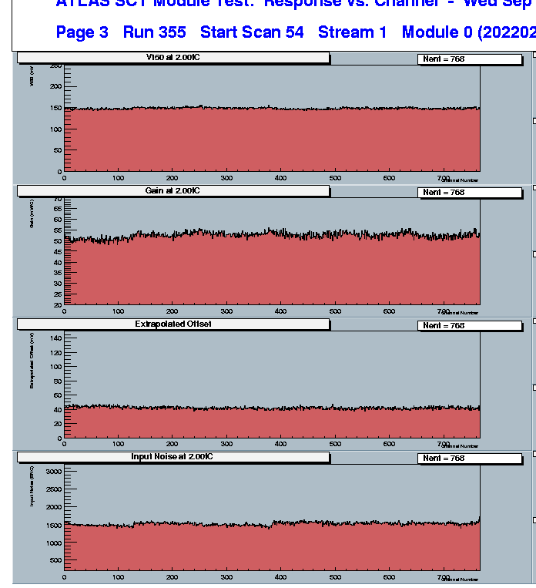

The Noise Occupancy across the module is now very flat and the s-curves are improved further.

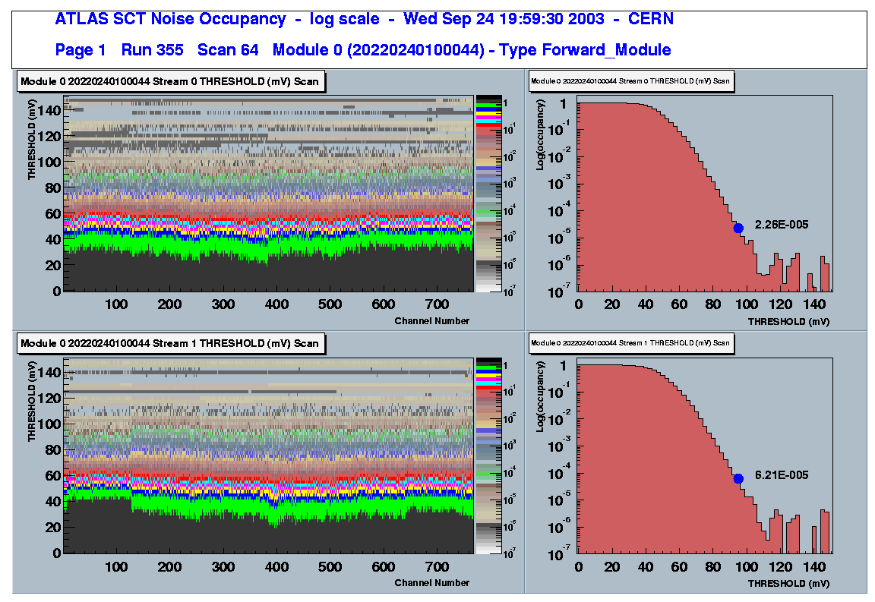

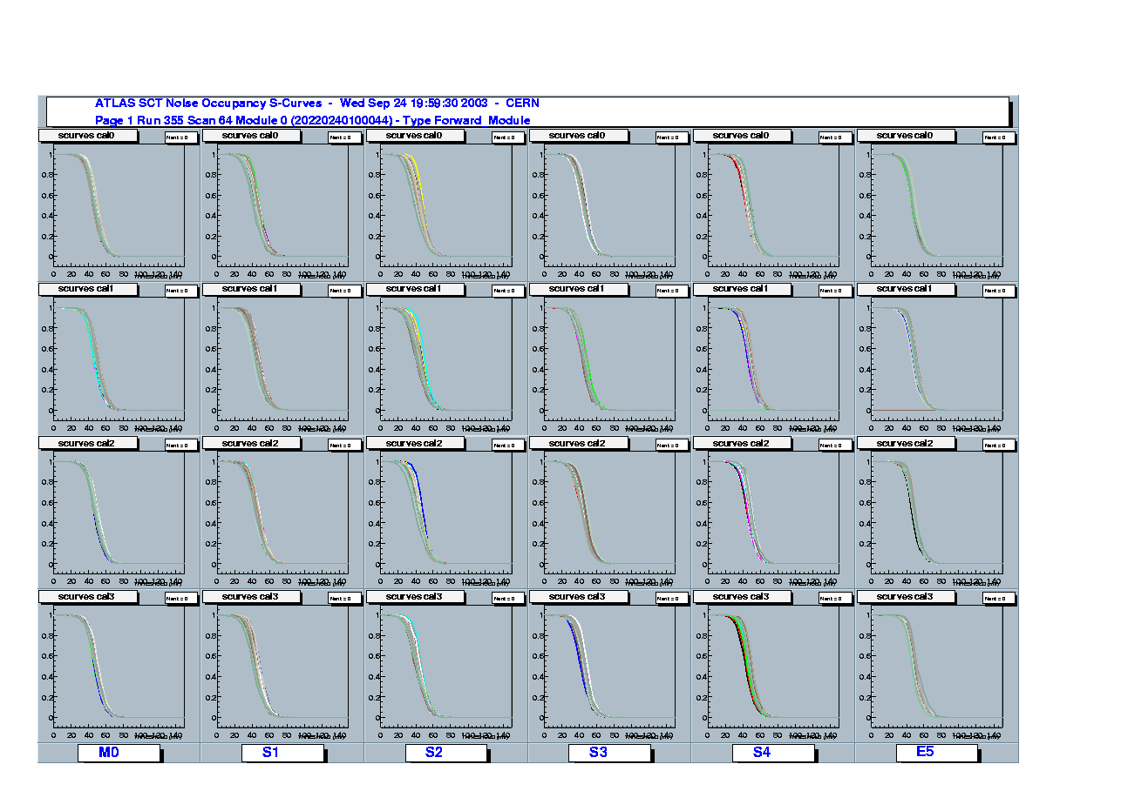
chip M0 chip S1

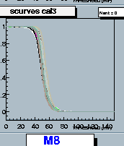chip M8

The close proximity of the lids of the Valencia test box to the module and the lack of a good ground connection between the lids and the metal of the box (to which the module is connected) has been shown to be detrimental to the operation of this module. The overall level of noise, as measured from both 3pt gain and RC scans, was reduced by more than 200electrons by removing the lids. The shape of the s-curves is improved across the module. The fall in the s-curves before Vth50% in the chips closest to the cooling block is reduced and the discontinuity in the s-curves is removed.
The lids can act as a method of coupling noise from the hybrid digital functionality back into the front-end via the detector planes. Improvements maybe observed if the lids were correctly grounded to the box body or if they did not form an electrical path between the hybrid and the amplifier front ends and the detectors.

