Spine 417

This is an example of a spine that failed our QA because of missing glue in the cooling contact area. Visual inspection of the hybrid-end cooling area from the AlN side shows a dark band along the edge of the TPG overlap.

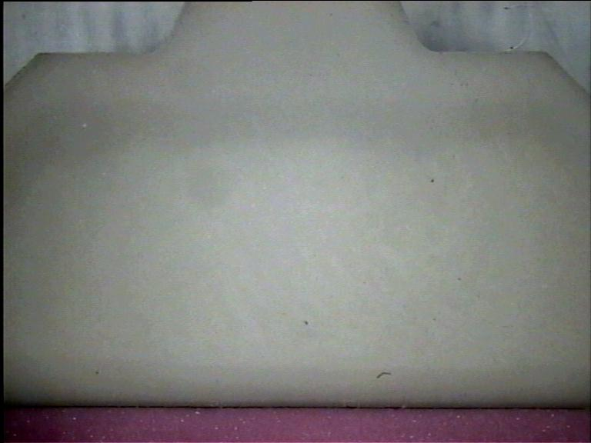

It is not easy to know how wide this band is or whether it is really due to missing glue. However, by cutting a feeler from a piece of aluminium foil it is possible to feel the depth of the glue gap. It turns out to be deeper than one would guess from the width of the dark band; about 2 mm on average and 2.3 mm at the point shown in the photo below. This means that the total unglued area could be as high as the 26 mm^2 limit that I derived from thermal simulation, so the spine should be rejected.
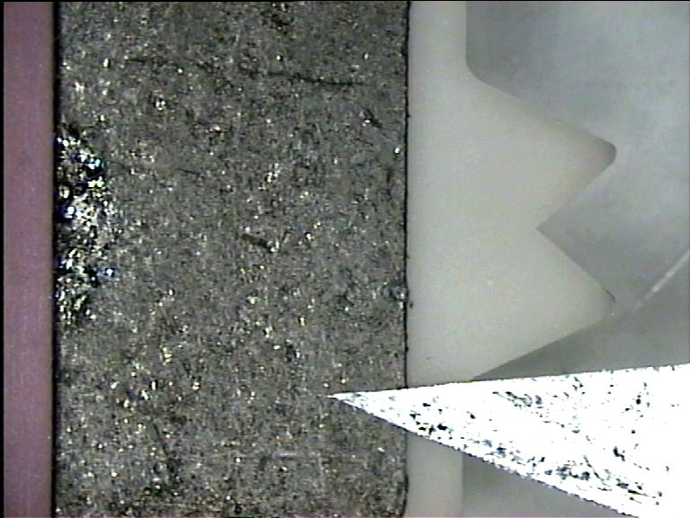
Al foil feeler with spine.

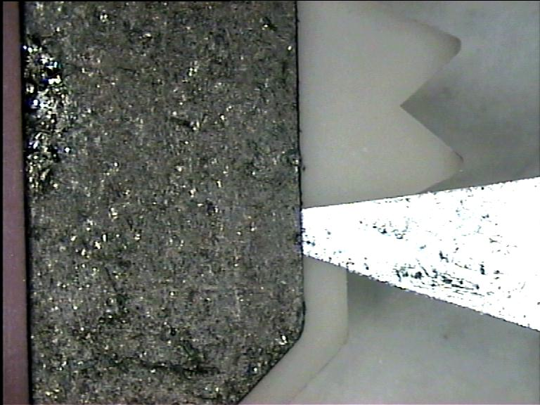
Al foil feeler inserted in glue gap.

