Spine inspection check-sheet

Date |  | Atlas serial number | 20220
Initials |  | Manufacturer's number
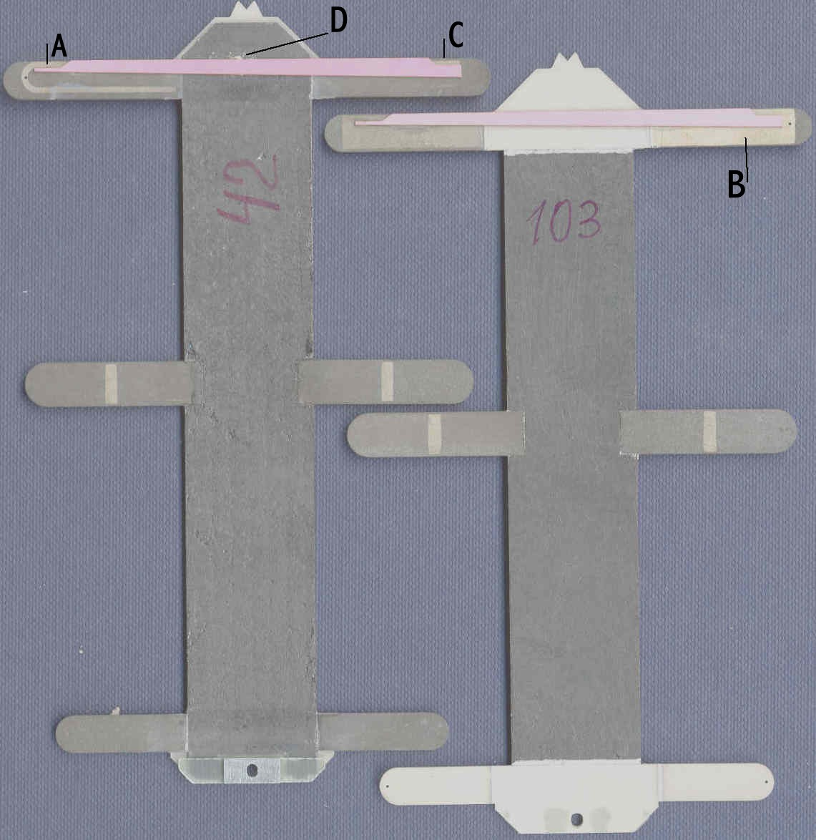
 |  |  | Front |  |  | Back
 |  | Done | Fixed | Failed | Done | Fixed | Failed
1 | Cooling contact area clean
2 | Glue coverage in contact area
3 | AlN not cracked or broken
4 | TPG not cracked or folded
5 | No loose flakes of TPG
6 | No excess material in detectors area
7 | No excess glue in HV tabs area
8 | No Z level steps between AlN and TPG
9 | Spacer aligned
10 | Full length of slot visible from back
 | Resistance (Ohms) | C to D |  | A to B |  | A to C

