Spines Visual Inspection

This document describes how to inspect spines by looking for known types of faults. At present there are 11 such faults; as we get more experience the list might grow.

Equipment
Inspection should normally be done under the stereo microscope at lowest magnification. At this setting the field of view is a circle of about 18 mm diameter, which allows the TPG part of the spine to be scanned in two sweeps and all other parts in a single sweep. Of course, when a fault is found it may be useful to turn up the magnification. Any unusual or difficult-to-decide cases should be photographed. When searching for gaps in the glue coverage between AlN and TPG (section 2) it is best not to use the microscope.
Some types of fault are possible to fix by removing excess material. So the scanner should be equipped with tweezers, scalpel, sticky buds, air blower, alcohol, etc.

Working method
The idea is to go through each heading on the visual inspection check-sheet and check the spine for one feature at a time. If there is no fault just tick ‘done’ and go to the next feature. If there is a fault which may be fixable, try to fix it immediately and tick the ‘fixed’ box. If the fix failed or there was no possibility of fixing, tick the ‘failed’ box. Carry on and check all the features even if the spine has already failed – this is useful for gathering statistics. The positions of all faults should be drawn on the check-sheet picture.

Features to check

1. Cooling contact area clean
The cooling contact areas need to be clean; otherwise the flatness of the module or its thermal contact with the block will be spoiled. In the past we have found spines with small drops of glue on the cooling area. It has always been possible to remove them with a scalpel. It is also worth removing any pieces of dust or fibres from this area, even if they are only a few microns across. Figures 1 and 2 show the extent of the cooling areas.

2. Glue coverage in contact area
Parts of the cooling contact areas are made from TPG laminated onto AlN with a layer of glue. The glue coverage has to be close to 100% otherwise the thermal performance is harmed. Spines have been found with holes in the glue coverage, which can be seen through the translucent AlN if the lighting is right (Figure 2). If there is a hole in the glue it should be sketched on the check-sheet picture and its area should be estimated.
Inner spines. The effect of a glue hole depends on its position, as shown in Figure 3. The spine should be rejected if there is a hole of more than 13 mm² in region B or a hole of more than 15 mm² in region A, or a hole of more than 20 mm² in region C.
Middle and Outer spines. Although there is some dependence on position it is not so critical as for inner modules. So the procedure is to add up the area of any glue holes which overlap the cooling blocks at both ends of the spine. The spine should be rejected if this area exceeds 26 mm².

3. AlN not cracked or broken.
Any crack in the full thickness parts of the AlN generally leads to a breakage and in this case the spine is clearly rejected. Many early spines had cracks in the AlN part of the AlN/TPG laminated area (Figures 4 and 5); such spines should normally be rejected. They should certainly be rejected if the crack goes into the cooling contact area, or if it is more than a few mm long, or if it leaves a part of the AlN completely detached from the rest.

4. TPG not cracked or folded.
A certain amount of damage to the TPG is acceptable because the TPG part of the spine is rather over-designed; the main obstacles to heat flow are elsewhere in the module. However a crack such as that shown in Figure 6, which crosses more than a few mm of the TPG, will harm the thermal performance of the spine and so must be rejected.

5. No loose flakes of TPG.
Loose flakes of TPG can cause electrical shorts, either immediately in the same module or much later if they fall onto some other module. Check that there are no loose flakes either on the long edges of the spine or the main surfaces (unlikely because this is encapsulated). A more likely problem area is on the front side under the spacer, where the covering has been removed to make electrical contact, as shown in Figure 7. Carefully check that the 0.5mm clearance between the TPG edge and the AlN edge at the cooling areas is free of TPG (Figures 7 and 8).
Any faults of this type are usually fixable.

6. No excess material in detector area.
Check that nothing will obstruct the detectors from going into their proper place. Such obstructions could be:
- Glue or bits of TPG which project out of the spine surface, as in Figure 9. If they are more than 40 microns thick they could cause a problem.
- Excess glue along the edge of the spacers. The nominal clearance between the spacer and the detectors is 0.5 mm (Figure 10).
- Excess glue near the far-end washer. The nominal clearance between the washer and the detectors is only 200 microns on outer modules (Figure 11). This clearance is much more generous on middle and inner modules.

7. No excess glue in the HV tabs area.
There is a clearance of about 200 microns between the HV tabs and the recesses where they fit into the spacer, as shown in Figure 10. Check that this space its not obstructed by the spacer glue.

8. No Z level steps between AlN and TPG.
Two spines have been found with large steps in level between the TPG and an adjacent AlN part. It is probably a sign of a bad glue joint and locally the spine will be outside the thickness specification. So far both cases have been at the far end (Figure 12). Look for steps at all TPG/AlN joints and if any seem unusually large compare them with a standard 50 micron step and reject if they are greater.

9. Spacers aligned.
The spacers should be aligned with the edge of the wings to within 200 microns (Figure 10), otherwise they risk clashing with the detectors or the HV tabs (section 6).

10. Full length of slot visible from back.
When viewed perpendicularly from the back, the full length of the precision slot on the aluminium washer should be visible through holes in the AlN and FR4 parts.

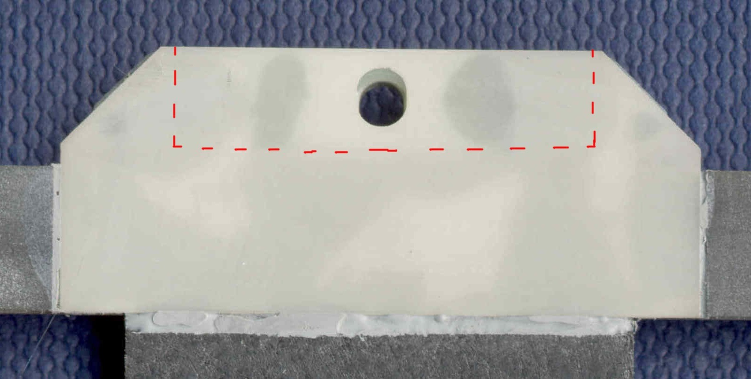
Figure1. The far end cooling contact area, which must be clean.

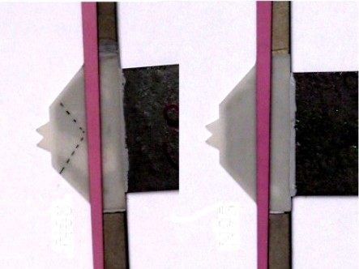
Figure 2. The hybrid end of the spine, showing the cooling contact area which must be clean, and the appearance of gaps in the glue coverage in the example on the left.
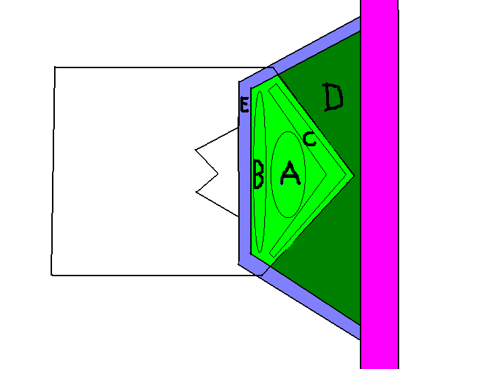
Figure 3. Gaps in the glue coverage on the hybrid-end cooling area should be classified according to whether they are mainly in regions A, B or C.

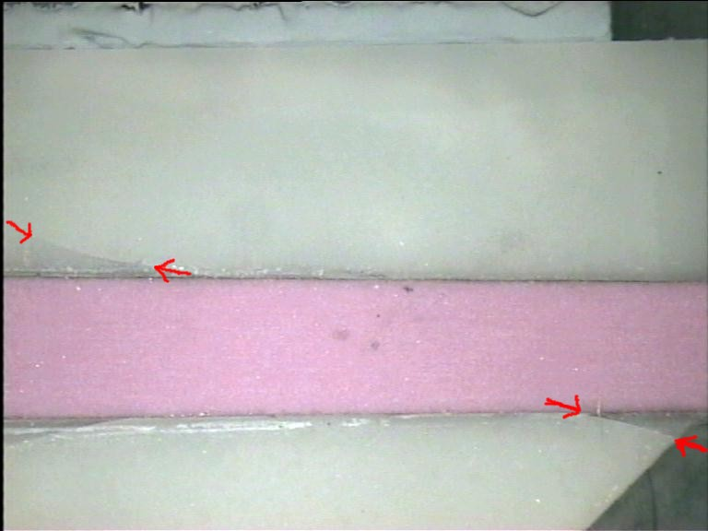
Figure 4. A serious crack in the AlN at the hybrid end. It is partially hidden under the spacer but it crosses a large fraction of the spine width.

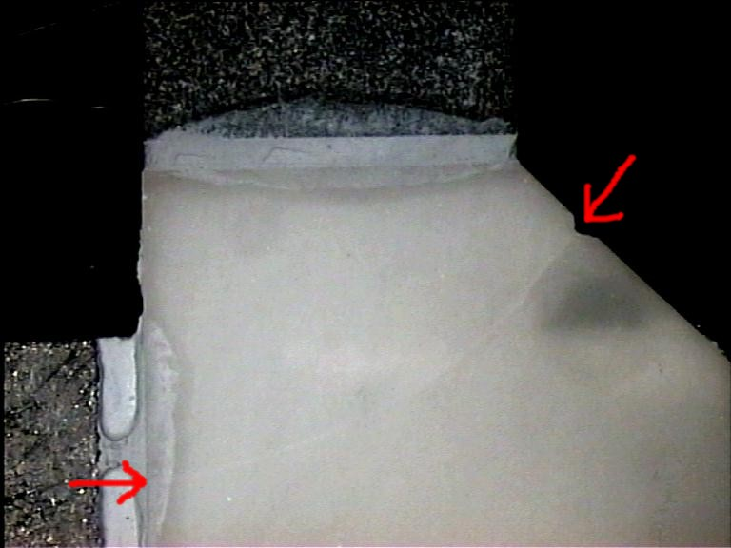
Figure 5. A less serious crack in the far-end AlN. It may lead to some mechanical weakness but its thermal effect will be small.

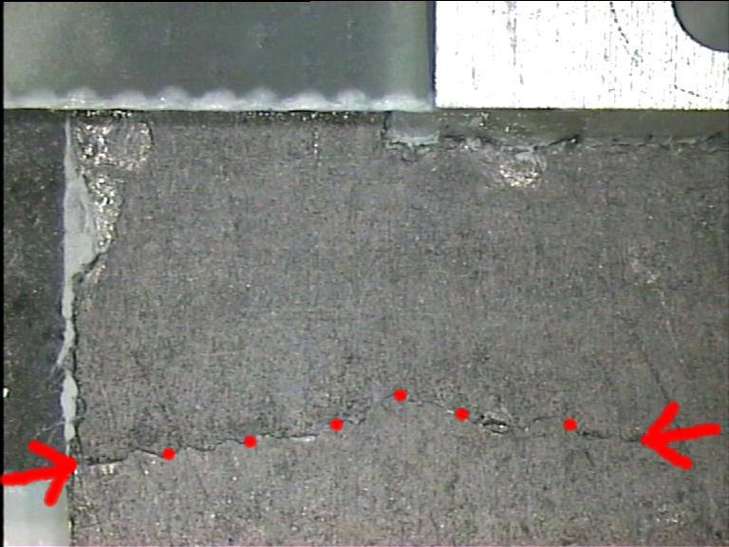
Figure 6. A serious crack in the TPG at the point where it is thinned down at the far end.

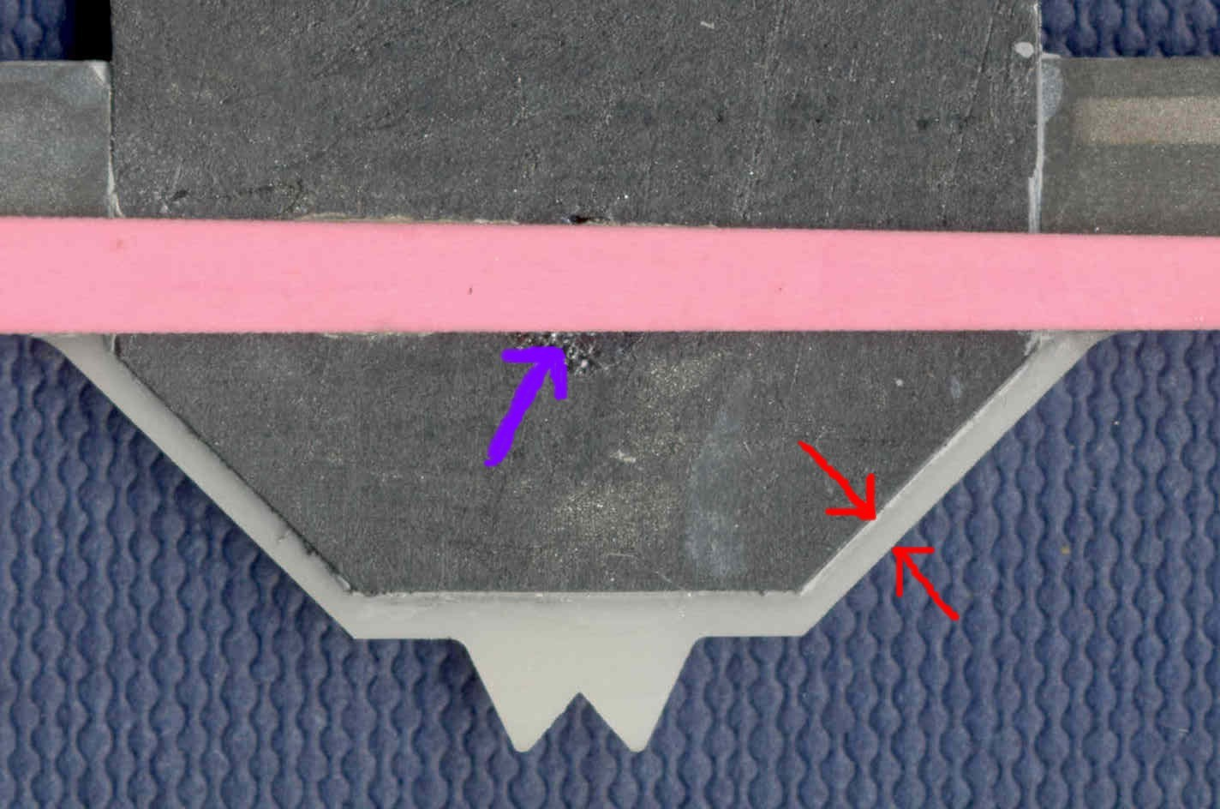
Figure 7. The blue arrow shows the area where the coating is removed from the TPG to make electrical contact, so there is a risk of loose flakes. The red arrows show the clearance between the edge of the TPG and the edge of the AlN. The clearance must be at least 0.5 mm.

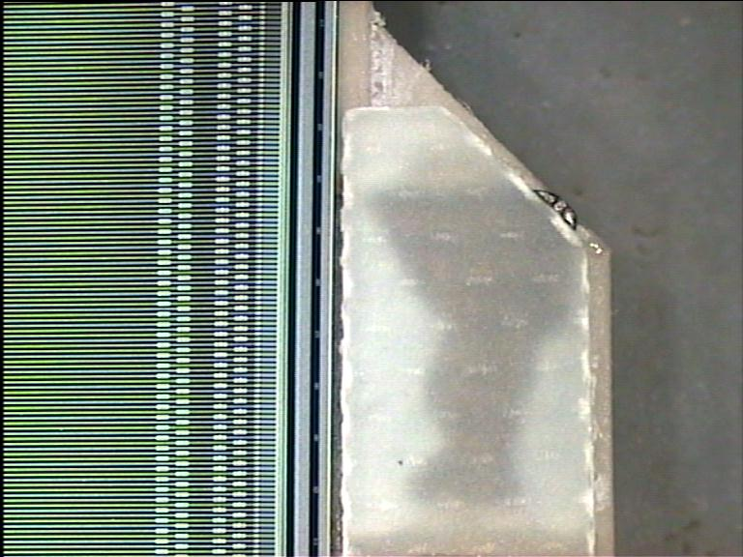
Figure 8. It is not possible to check that the 0.5 mm clearance is respected at the far end because the washer is in the way. But if any TPG sticks out a long way it may be visible, as in this case. Any projecting TPG should be cut back as far as possible.

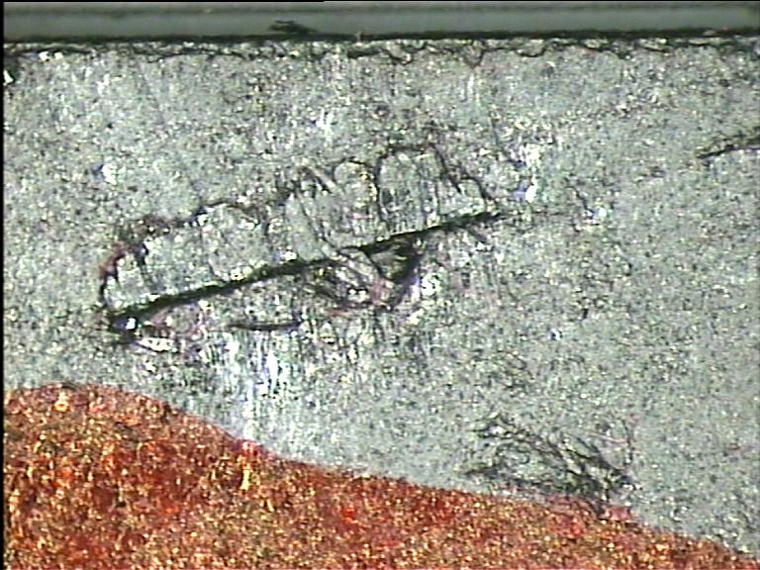
Figure 9. A bit of TPG stuck on to the spine by the parylene coating. It puts the spine out of thickness specification in this region and so must be removed.

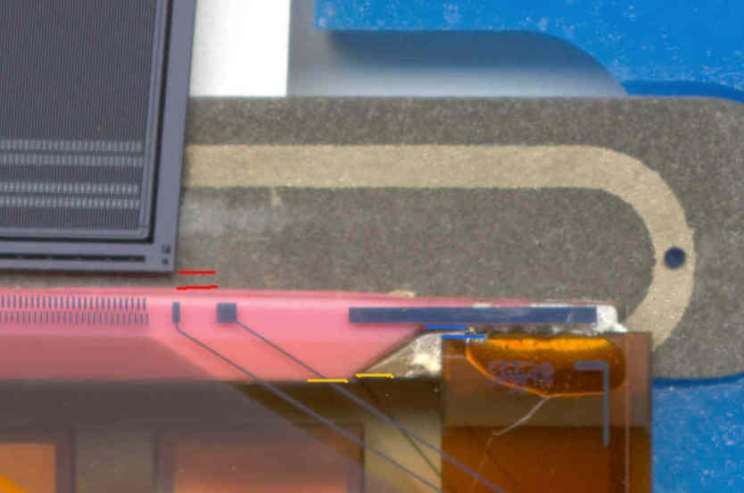
Figure 10. The 0.5 mm clearance between detectors and spacer (red lines) and the 0.2mm clearance between HV tab and spacer (blue lines). These clearances can only be maintained if the spacer is well aligned with the edge of the wing (yellow lines).

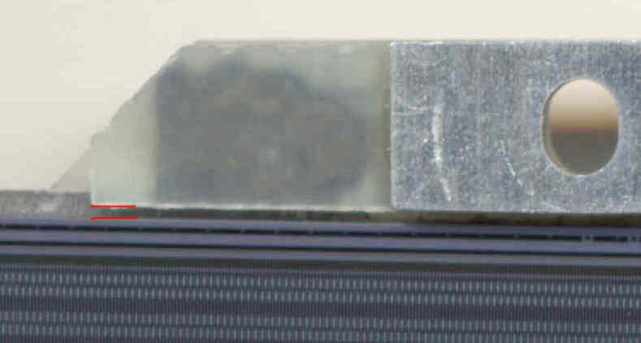
Figure 11. Clearance between far-end washer and detectors is 0.2mm on outer modules.

