SUMMARY OF DEFECTS ON THE SPINES

20220990290426 (Mfr Serial Nº:115)

It has a bowing along TPG of 1.25 mm. (That’s the reason to be returned)
It also has 0.06 mm step between TPG – AlN (middle wing).

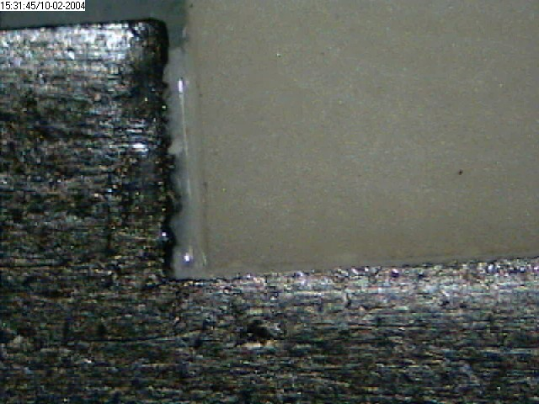
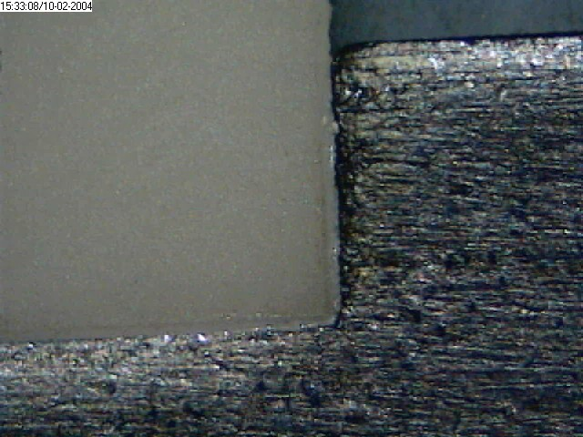

20220990290429 (Mfr Serial Nº:118)

It has a step of 0.11 mm between TPG – AlN (middle wing). That’s higher than the 0.1mm space left for the glue of detectors to spine.
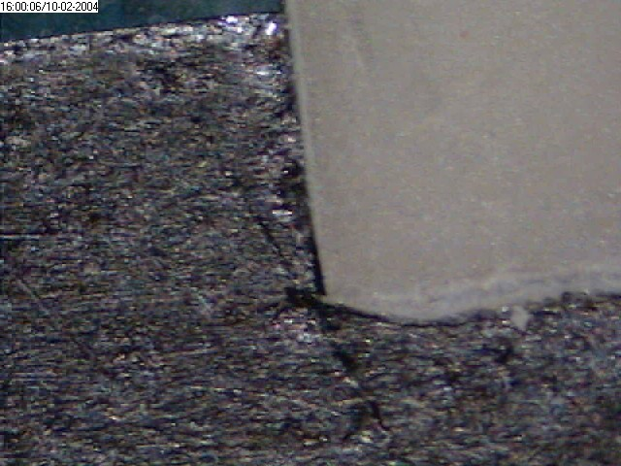
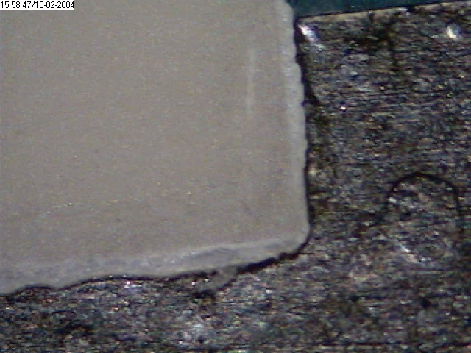

20220990290432 (Mfr Serial Nº:121)

There is NO electrical contact between conducting trace between the Front side trace and the conducting area in the Back side of the spine.

Note: For measuring the bowing of the spine we just place it free onto a Turn Plate and using an auto focusing routine on a Z axis, we measure Z values on 10 points along the TPG. The bowing is defined as the difference between the maximum and minimum measured values.

