REQUEST FOR PROCUREMENT

Project No.: | 2731p

Institute name: |  |  |  |  | IHEP |  |  |  |  |  |  | Request number: |  |  |  | 019
Full postal address:
Phone/Fax/E-mail: |  |  |  |  | (27)747823, (27)713289 holodenko@mail.ihep.ru, holodenko@mx.ihep.su |  |  |  |  |  |  | Funds available:
Contact person: |  |  |  |  | Kholodenko Anatoli
Please indicate if equipment is in the Work Plan: |  |  |  |  |  | ⊗ Yes
 |  |  |  |  |  | No | Clearance of Senior Project Manager (SPM):__________________
Please indicate if shipment is essential to your area: |  |  |  |  |  | Yes x No
INSTRUCTIONS: |  |  | - (a) Please, submit separate sheets for items specified in the Work Plan and those not specified  - (b) Your attention is drawn to complete only the shaded fields  - (с) Item Number has to correspond to the number assigned in the Work Plan if applicable
ID | Equip. Index Code | Item No. |  | Description-Specification/suggested suppliers |  |  |  |  | Qnt |  | Est. Unit Price (US$) |  |  | Amount (US$) | Date needed |  |  | P.O.No.
 |  |  |  | Shipping of the ready spines to CERN  Quantity of the spines-213 units,  Package quantity: 1 box  Weight: brutto 17 kg  The Recipient of goods is:  Jurgen ZIMMER,  Tel: 7680772683(from outside: +41227676807)  GSM:164424 (from outside:+41764874424)  E-mail: Jurgen.Zimmer@cern.ch  Experiment: ATLAS  FAX: + 41 22 7678350  European Organization for Nuclear Research,  CERN Meyrin, CH1211, Geneva 23  Switzerland. |  |  |  |  | 1 box |  |  |  |  |  | November 2004,  as soon as possible

Clearance of funds (FO) | For use only in PO | Remarks
Date: | Received:
Approved: | Action officer:
Project Manager (PM): | A.Kholodenko | Date: | 26.11.2004
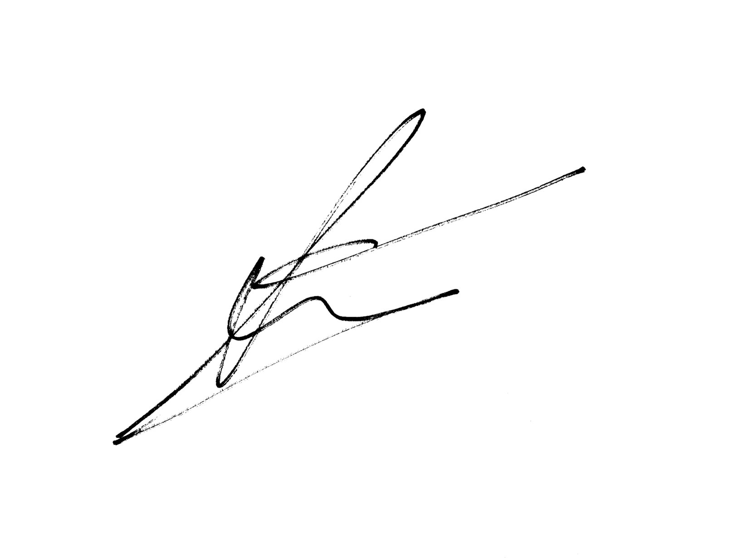
FORM PR-3E from 7/97

