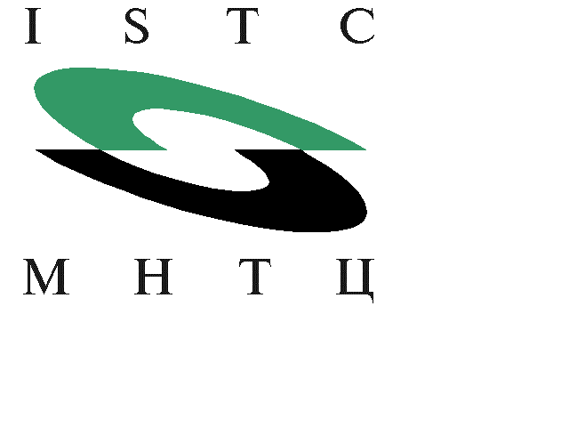
ADDENDUM
TO
MEMORANDUM OF AGREEMENT #2731

The International Science and Technology Center (the “Center’), Russia, and European Organization For Nuclear Research (the "Partner"), regarding the increase of the scope of Project Agreement #2731, have agreed as follows:

- On the basis of Addendum to Project #2731 signed between the Center, the Partner and the State Research Center of the Russian Federation – the Institute for High Energy Physics (the “Institute”), which increases the Project cost, Partner shall additionally pay to the Center US$9,500.

- The payment by Partner shall be made within ten (10) working days after receipt of an invoice by bank transfer to the Center’s account Number 04-838-214 at the Deutsche Bank Trust Company Americas.

- Other terms and conditions of the MOA #2731, not modified by the Addendum, remain in effect.

Done in the English language in two copies.

For the Center: For Partner:

(Name and Title) (Name and Title)
Norbert Jousten
Executive Director
Date: Date:

