Richard Bates
SCT responsible for Endcap spine production
CERN
CH-1224
Switzerland

Dear Anatoli Kholodenko,

I agree to the financial amendment to the ISTC agreement between ATLAS and IHEP/NIIGraphite for the production of TPG for the ATLAS Endcap spines. These changes refer to the spend profile of the collaborators and not to the total cost of the project.

Yours Sincerely

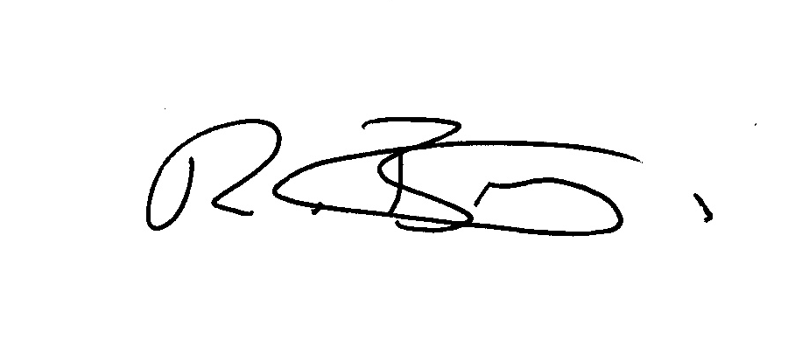

Dr R. Bates

